René Guénon and the Primordial Tradition
ON FEBRUARY 3, 2016 BY SIR KNIGHT JEDEDIAH FRENCHIN ESOTERICISM, FREEMASONRY

Search
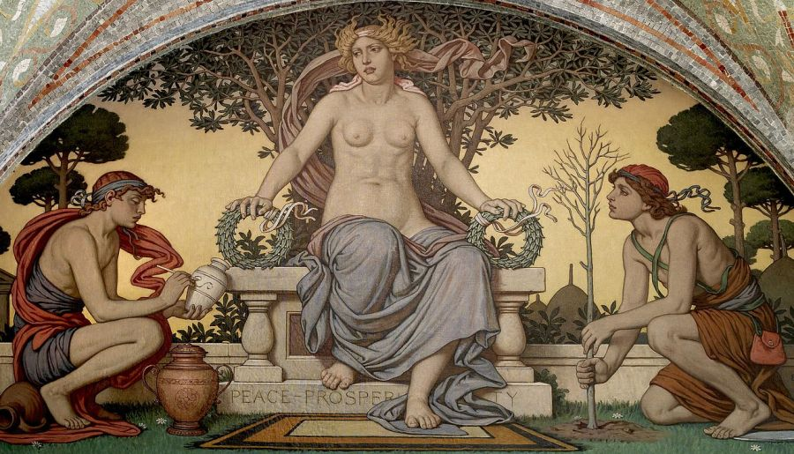
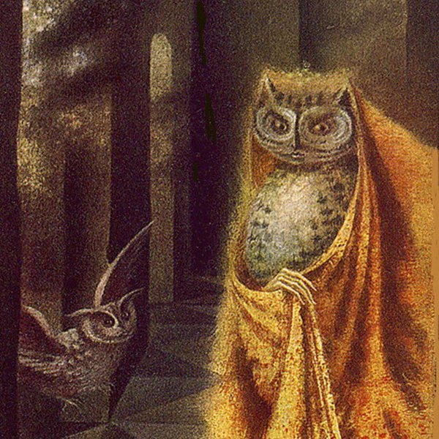The following is a brief synopsis and some personal remarks on the book Rene Guenon and the Future of the West (1987) by Robin Waterfield.
Rene Guenon was born November 15, 1886 in Blois, Loir-et-Cher, France to parents who were landowners, who counted on their vineyards and wine-growing skills to sustain their livelihood. Guenon went to a Catholic school and excelled at mathematics and philosophy.
He was singled out by his teachers for having an innate ability to teach religion, which he later did, though he never accomplished his PhD dissertation on Hinduism because it did not conform to the current scholarly standards. The dissertation was subsequently published independently and became Introduction Générale à l’Etude des doctrines Hindoues (1921), Guenon’s first full-length book.
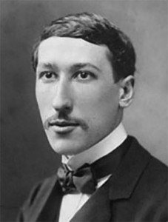As a young student, though he maintained his Roman Catholic beliefs, he experienced a period of spiritual seeking, in which he joined the Theosophical Society, Papus’ Martinist Order, and a Freemasonic lodge. Additionally, he joined a Gnostic church and attempted to inaugurate a new Templar Order. He was later disillusioned with all these occult groups, save Freemasonry, claiming they did not represent the true path to religious experience, toward what he called the Ultimate Reality. He eventually quit them all.
Following this period, he continued teaching and writing for Les Etudes Traditionnelles, a Traditional studies journal he was publishing, also writing for Catholic publications and working as a teacher. During this time, he started developing many of his ideas about the Primordial Tradition and was initiated into a Sufi order. Becoming disillusioned altogether with France and the modern West in general (though he never turned his back on the West), he left France for Egypt indefinitely. He died in 1951.
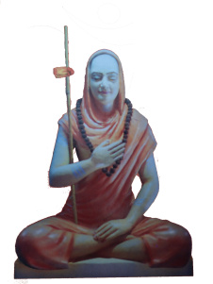His spiritual ideas are manifold and complex. At the foundation is the idea of Tradition, with a capital T, never pluralized, which represents the path or “tree branch” of a certain group or people on the main trunk of the Primordial Tradition. Guenon felt Tradition was extremely important because it was the only way to reconnect with the Ultimate Reality, which was the perennial philosophy, a true wisdom. From this basic concept, he developed his negative attitudes toward occultism and theosophy, seeing them as amalgamations and newly formed constructs, a product of humanity’s egoistic obsession with progress and originality—and which actually prevented the spiritual seeker from gaining a genuine confrontation and awareness of the Ultimate Reality. For, he said, the only way to experience that reality, called moksha or Beatific Vision, was to comprehend the unity not only of all religions, but of being in general. In short, a non-dualistic epistemology, which corresponds to his affinity for Advaita Vedanta. The total awareness of this unified state he referred to as “pure intellectuality,” in opposition to the reason-based intelligence of the West, which he condemned as materialistic.
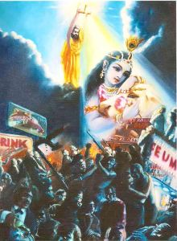Guenon saw the West as having confused the notion of time, into a linear concept from the original cyclical. Drawing on traditional Vedanta, he saw the notion of time as occurring in kalpas, and within in those yugas, spiral units of time in which whole ages arose and fell, lived and died. The modern age that was taking place was the Kali Yuga, the yuga in which everything sacred and divine had been thrown into confusion, creating a veritable Dark Age. He referred to the Kali Yuga as the step closest to the final dissolution, in which the unity of the Divine Reality, and our connection to it as human beings, was most disparate. The fundamental cause behind Western decline was materialism. Reason and scientific development had replaced true spirituality and metaphysics. Only the East had retained such esoteric conceptual systems. Thus, it was toward the East that the West most turn if it hoped to reverse its downward descent.
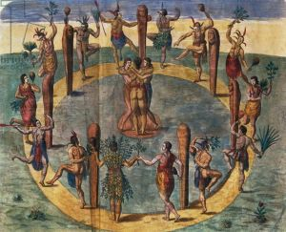For Guenon, the process by which the true primordial religion could be transmitted from one generation to the next generation was called initiation. Every traditional society had used this process to bestow upon the selected members a true spiritual knowledge of the Ultimate Realty. Such rituals also served as rites of passage through stages of maturity. Initiation, Guenon decried, was what the West most lacked, which constituted another crucial aspect of its decline. Whatever rites the West retained were either misunderstood or altogether forgotten. Even the Christian initiations such as baptism were now treated as platitudes. The various occult societies that had sprung up in the 18th and 19thcenturies in the West were, for Guenon, forms of counter-initiation, owing to the fact that they tended to be conglomerates and mixtures of all sorts of religious and esoteric systems, e.g. Theosophy.
Via the initiation process symbols—words attached as signifiers to the signified—were employed as a bridge from the illusory reality to the Ultimate Reality, metaphysical and transcendent. Words and symbols became necessary because the Ultimate Reality was ineffable and words were incapable of grasping it—such as, for instance, the Tetragrammaton.
One might think, then, that Guenon would also be adverse to Freemasonry, but this was not so. He believed Masonry had safeguarded much traditional wisdom, even if its membership and internal “scholars” had no understanding of it anymore. The two traditional streams that Masonry had most directly protected were Templarism and Rosicrucianism. He also felt that France and Germany, more so than Britain and the United States, had retained some awareness of this fact.
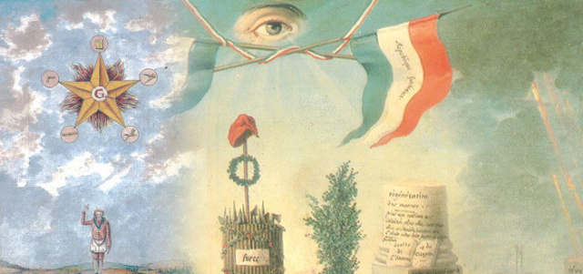
Affinity for Masonry is not to say that Guenon thought poorly of the Catholic Church. Until the end of his life he believed that Catholicism—along with Islam, Judaism, Hinduism, etc.—offered a genuine traditional path to an encounter with the Ultimate Reality. But for all of these religions he maintained that both an exoteric adoption of the tradition was required along with an esoteric transmission of its inner truth in order for the initiation process to be a success. Again, we can see why Theosophy and Martinism would, for Guenon, seem so repugnant.
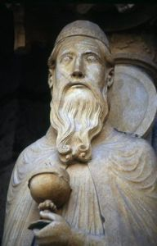Finally, all hope for the future was not lost. Guenon felt he had located the Primordial Tradition itself in the Biblical figure of Melchizedek, the High Priest of Salem (Genesis 14), who initiated Abraham with bread and wine (two staples of initiatory rites). Melchizedek served as the unifying principle between Judaism, Christianity, and Islam. Such a triune covenant could serve as the basis for a future Western society united in Tradition.
This society could look to the Eastern traditions in order to recover their lost esoteric knowledge of the Ultimate Reality. This vision, for Guenon, represented the only possible route that the West could take if it hoped to survive. All other routes led to what he termed “the final dissolution.”
