**The Villa of the Mysteries**

[**DECEMBER 19, 2015**](https://skfrench.wordpress.com/2015/12/19/the-villa-of-the-mysteries/)**BY**[**SIR KNIGHT JEDEDIAH FRENCH**](https://skfrench.wordpress.com/author/sirknightjedediahfrench/)**IN**[**FREEMASONRY**](https://skfrench.wordpress.com/category/freemasonry/)**,**[**MYSTERY RELIGIONS**](https://skfrench.wordpress.com/category/mystery-religions/)**,**[**RITUAL**](https://skfrench.wordpress.com/category/ritual/)

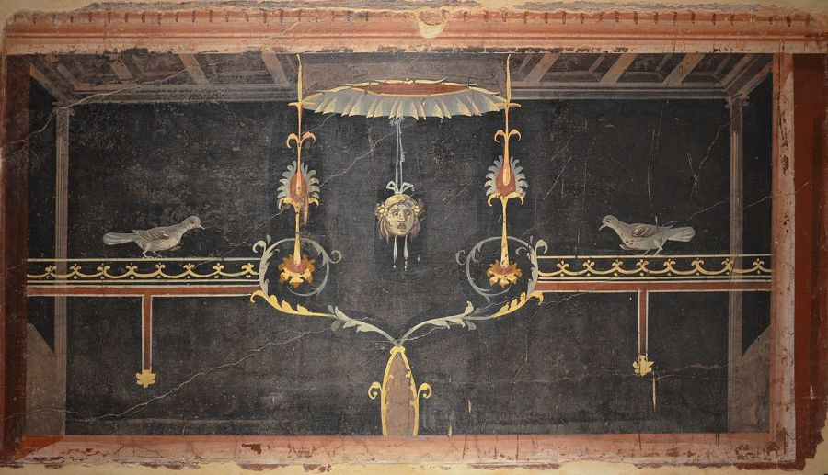

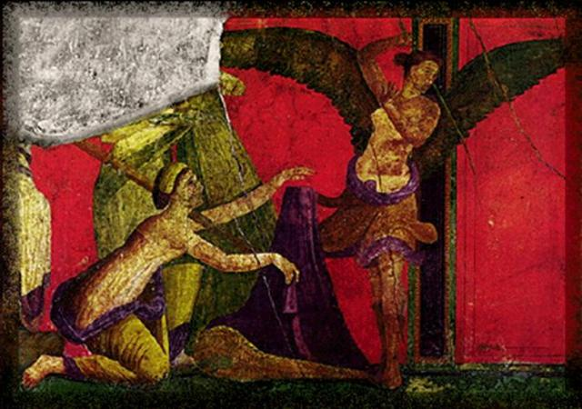**The**[**Villa of the Mysteries**](https://en.wikipedia.org/wiki/Villa_of_the_Mysteries)**or *Villa dei Misteri*** is a well-preserved Roman Villa in Pompeii originally dating from the 2nd century BC. The present layout is thought to be set somewhere between 70 and 60 BC, and the frescoes in the initiation chamber may date to around ca. 60 AD. The villa suffered only minor damage from the eruption of Vesuvius in 79 AD. The room in the villa known as the initiation chamber is decorated with two dozen life-size figures engaged in what is usually considered to be an [initiation ritual](https://en.wikipedia.org/wiki/Initiation) into the mysteries of [Dionysus](https://en.wikipedia.org/wiki/Dionysus).

Eschewing what scholars generally dispute about the initiatic frescoes in the Villa, for there is no way to definitively interpret them, it is useful to analyze them through the lens of the spiritual technology of the [ancient mysteries](https://en.wikipedia.org/wiki/Greco-Roman_mysteries) as we have come to understand them. This is particularly important for Freemasons, whose ceremonies, if not directly descend from, are heavily influenced by mystery religion initiations. A book entitled *The Greek Origin of Freemasonry* (1955), published by Freemason J.N. Casavis, is a good place to start in gaining an understanding of the role Greek mystery religions play within Freemasonry. Casavis argues that Freemasonry has its roots in the mystery religions of ancient Greece, that it can trace its lineage back to the [Hermaic](https://en.wikipedia.org/wiki/Hermes" \t "_blank) rites (3360 BC), to the [Cabeirian](https://en.wikipedia.org/wiki/Cabeiri" \t "_blank) mysteries (3000 BC), to [Orphism](https://en.wikipedia.org/wiki/Orphism_%28religion%29) (2400 BC), to the Dionysiac (1497 BC), and finally through the Artificers and [Roman Colleges](https://en.wikipedia.org/wiki/Collegium_%28ancient_Rome%29) (1076-719 BC). Casavis provides pictures of ancient votive offerings who appear to be posed in the penal signs of modern-day Freemasonry. I have no idea where Casavis obtained these photographs, but I have never encountered such a thing anywhere else. My point, however, is that by examining the mystery rites which took place in the Villa of the Mysteries, we can gain a better understanding of Freemasonry and its intended purposes.

[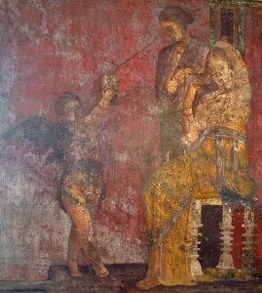](https://skfrench.files.wordpress.com/2015/12/mirror.png)The first wall of the initiation chamber in the Villa of the Mysteries (sometimes thought to be the last wall) shows a woman looking into a hand mirror, tending to her long hair and being assisted by another woman. The mirror is not merely meant that she wishes to look pretty, since hand mirrors have often served as a symbol of the mysteries. (For instance, Isis in Book XI of Apuleius’ [*Golden Ass*](https://en.wikipedia.org/wiki/The_Golden_Ass).) The mirror is a symbol of looking inward. As soon as the initiate in the villa looks into the mirror, looking into herself, the remaining walls represent what she is to find there.

[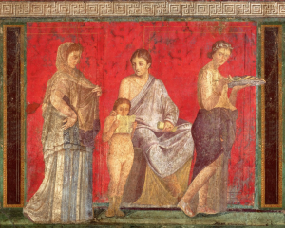](https://skfrench.files.wordpress.com/2015/12/child.png)The inner depths and the initiatic ascent to the heights (regeneration) are lavishly represented in the following symbols: a scared naked child reading a scroll (vulnerability), a purification rite with Silenus looking on (the beginning of cleaning up the inner and facing the animalistic self), then a woman fleeing scared as another figure holds up a scary Dionysus mask (expressing the terror felt when the mask or outer illusion of self falls away).

[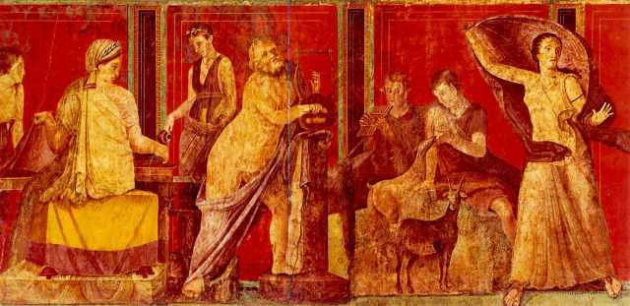](https://skfrench.files.wordpress.com/2015/12/sileni.png)

[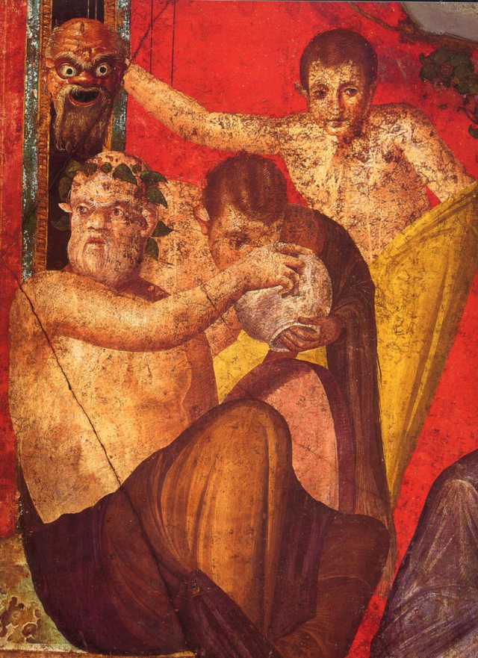](https://skfrench.files.wordpress.com/2015/12/mask.png) [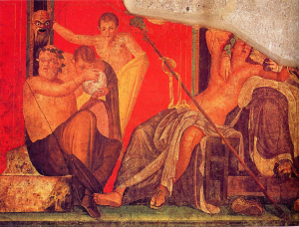](https://skfrench.files.wordpress.com/2015/12/god.png) There is then the representation of a drunk, lounging Dionysus in the lap of [Ariadne](https://en.wikipedia.org/wiki/Ariadne)—some scholars identify this female figure as [Semele](https://en.wikipedia.org/wiki/Semele), but there is no way to be certain, as the entire upper half is missing—the latter being associated with labyrinths and mazes, the message of which is clear: through the labyrinth of the inner self is to be found the god within, Dionysus.

[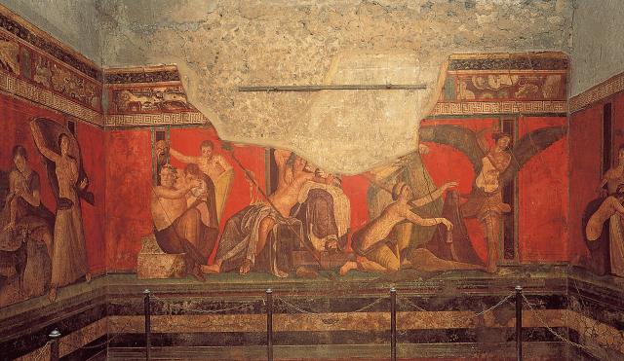](https://skfrench.files.wordpress.com/2015/12/full.png)

In the vicinity of Dionysus, there are figures drinking out of bowls and other vessels, possibly containing wine or *[kykeon](https://en.wikipedia.org/wiki/Kykeon" \t "_blank)*, which is to symbolize the [Communion](https://en.wikipedia.org/wiki/Communion_%28Christian%29) aspect of the rites. Finally, a winged figure is shown whipping a cringing woman, then a window where light pours in terminates the narrative, the latter representing the light of immortality of the spirit. The winged being, meanwhile, is whipping the candidate’s inner self through her life, vainly trying to wake her up to the truth, that she bears the god Dionysus within her. However only Dionysian initiation could accomplish that realization in the proper way.

[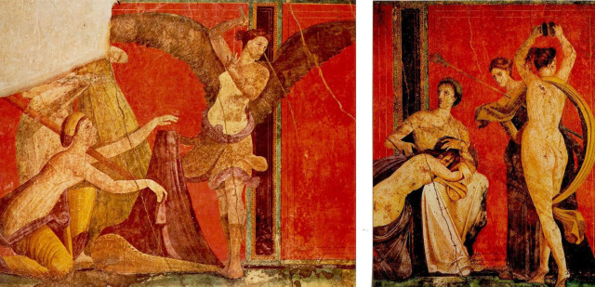](https://skfrench.files.wordpress.com/2015/12/wing.jpg)

[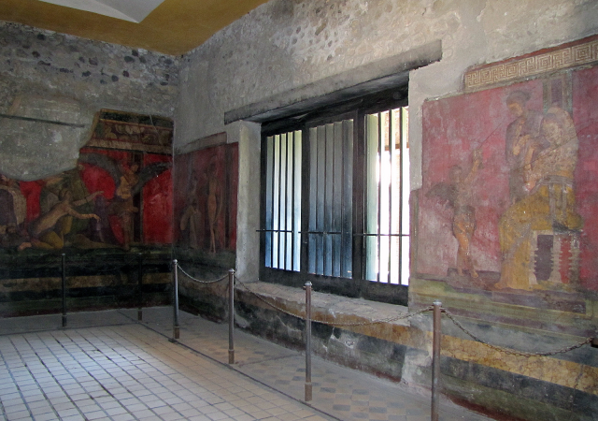](https://skfrench.files.wordpress.com/2015/12/done.png)