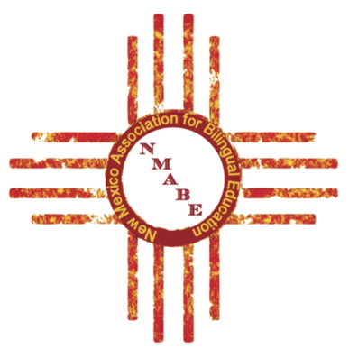
New Mexico Association for Bilingual Education
Phone 505-803-7120
nmabe.nm@gmailcom
www.nmabe.org

TO: Bilingual Directors/Coordinators and District Spelling Bee Coordinators/Sponsors

FROM: Jesús Moncada
NMABE Treasurer

DATE: January 18, 2018

RE: 2018 NMABE State Spanish Spelling Bee

In preparation for the 2018 State Spanish Spelling Bee, please use the 2017 booklet to prepare for the competition in April.

As usual, there will be a $150 fee per district/charter school. The NMABE State Spanish Spelling Bee will be held on Saturday, April 21, 2018 at the National Hispanic Cultural Center in Albuquerque. Registration for the event will begin at 8:30 am and the event will begin promptly at 9:30 am. There will be a special events luncheon honoring the Spanish Spelling Bee participants, their parents, families and sponsors from 12:00-1:30 p.m.

The district information is due in the NMABE office on or before March 23, 2018. Please make plans to host your district spelling bee prior to that date so that you can submit that information to us on time.

Please mail the document to:

NMABE State Spanish Spelling Bee
P. O. Box 6578
Albuquerque, NM 87197
or email nmabe.nm@gmail.com

WE WOULD LIKE TO THANK YOUR SCHOOL DISTRICT FOR THEIR CONTINUED SUPPORT AND PARTICIPATION IN THE STATE SPANISH SPELLING BEE. Please feel free to contact me should you have any questions regarding the NMABE State Spanish Spelling Bee (505) 839-4971 or at nmabe.nm@gmail.com.

NMABE
2018 STATE SPANISH SPELLING BEE

NAME OF DISTRICT: _________________________________________________________

DISTRICT MAILING ADDRESS: _________________________________________________

CITY, STATE AND ZIP: _______________________________

DISTRICT SPELLING BEE COORDINATOR: __________________________________

E-MAIL (required): __________________________________________________

DISTRICT SPELLING BEE SPONSOR: ____________________________________________
(This person will be the only one that can challenge during the competition, RULE 4-E)

E-MAIL (required): ______________________________________

Please attach your $150 payment. Check # PO #

Payment must be received prior to the event date. Please make sure to make this payment so that your student
will be able to participate.

A picture is also requested for the Spelling Bee program.

DISTRICT WINNER: ____________ Male _________________________

GRADE LEVEL NAME OF SCHOOL: ______________________________

PARENT’S NAME: ________________________________

PARENT ADDRESS: _____________________________

CITY, STATE AND ZIP: __________________________

PHONE NUMBER: ________________________

E MAIL ADDRESS ____________________________-

DISTRICT ALTERNATE NAME: _________________________________
(Will not participate in the State Spelling Bee unless the district winner is unable to)

GRADE LEVEL: NAME OF SCHOOL: _________________________________

PARENT’S NAME: _______________________________

PARENT ADDRESS: _____________________________

CITY, STATE AND ZIP: ___________________________

PHONE NUMBER: ______________________________

E MAIL ADDRESS: ______________________________

Please submit by March 23, 2018 to:
NMABE State Spanish Spelling Bee
P. O. Box 6578
Albuquerque, NM 87197 or email to: nmabe.nm@gmail.com

NEW MEXICO ASSOCIATION FOR BILINGUAL EDUCATION
ASOCIACIÓN DE EDUCACIÓN BILINGÜE DE NUEVO MÉXICO
CONCURSO DE DELETREO EN ESPAÑOL
SPANISH SPELLING BEE COMPETITION
SÁBADO, 21 de ABRIL, 2018
SATURDAY, APRIL 21, 2018
NATIONAL HISPANIC CULTURAL CENTER
ALBUQUERQUE, NEW MEXICO

8:30a.m-9:10 a.m.
Inscripción de Participantes en el Concurso de Deletreo
Registration of Spelling Bee Participants

9:10 a.m-9:25 a.m.
Participantes del Concurso toman su asiento
Spelling Bee Participants take their seat

9:30a.m-12:00 p.m.
Concurso de Deletreo y Presentación de Premios
Spelling Bee & Presentation of Awards

12:00-1:30 p.m.
Almuerzo para los Participantes y Padres
Luncheon for Participants & Parents

