FIRE SAFETY PLAN


Algoma Manor Nursing Home
145 Dawson Street - Thessalon, Ontario – P0R 1L0

- Introduction
- Emergency Contact Numbers
- Building Information
  - Occupancy
  - Designated Fire Route Access
  - Heating
  - Domestic Water
  - Power
  - Fire Alarm System
  - Sprinkler Systems
  - Standpipe Systems
  - Fixed Extinguishing System for Commercial Cooking Equipment
  - Portable Fire Extinguishers
  - Emergency Lighting
  - Emergency Power
  - Generators
  - Electromagnetic Locking Devices
  - SDS Locations
  - Elevators
  - First Aid Kit
  - Location of Fire Plan
- General Fire Instructions
  - How the Fire Alarm System Operates
  - What You Should Do When the Fire Alarm Sounds
  - What You Should Do in Case You Discover a Fire
  - Evacuating the Building
  - Emergency Response Plan Search Procedures
  - False Alarms
  - Fire Drills
  - Fire Extinguishment, Control and Confinement
  - Control of Fire Hazards
- Instructions and Responsibilities
  - General Instructions to All Staff, Faculty and Students
  - Roles and Responsibilities of RN Charge Nurse
  - Roles and Responsibilities of RPN
  - Roles and Responsibilities of PSW/HCA/Assists/Support/BSO
  - Roles and Responsibilities Restorative/Physio
  - Roles and Responsibilities of Laundry Dept.
  - Roles and Responsibilities of Kitchen/Dietary Dept.
  - Roles and Responsibilities of Housekeeping Dept.
  - Roles and Responsibilities of Administration/Office Dept.
  - Roles and Responsibilities of Activities
  - Roles and Responsibilities of Volunteers/Contract Worker
  - Roles and Responsibilities of Hairdresser/Dental Hygienist
- Training
  - Fire Extinguisher Training
  - Fire Drills Procedure
  - Fire Drills on Nights Procedure and checklist
  - Fire Safety Checklist – All Staff
  - Emergency Directions as Posted at Each Fire Pull Station
  - Fire Safety Plan/Emergency Plan
- Fire Plan Administration
  - Orientation Seminars
- Maintenance and Inspections
Appendix A Site Plan
Appendix B Maintenance & Inspection Responsibilities
Appendix C Floor Plans
Appendix D Alternative Measures for Interruptions to Occupant Fire Safety
Appendix E Fire Safety Plan Review Record

1.0 Introduction
Safety and concern for the care and welfare of all our Residents, Visitors and Employees to our long-term care facility is of utmost priority to Algoma Manor.
We have a responsibility for protecting life and property from the effects of fire, and other emergencies. Most unfortunate incidents are caused by delay, indecision, and lack of awareness of responsibilities. For this reason, the Algoma Manor has developed a workable fire safety program in consultation with the Thessalon Fire Department as part of a detailed Emergency Response Plan.
We request that you take a few minutes to carefully review and understand the following instructions. In following this system, the risk of serious loss or damage can be greatly reduced.
Hard copies of the FIRE SAFETY PLAN can be found at the Main Fire Alarm Panel (Front Foyer), Cable/Telephone Room and in all departments. Building floor plans are posted on each floor, at exits and stairwells, indicating exit routes for evacuation. Should you have any questions or concerns, please contact the Administrator (705-842-2840 Ext. 135)
It is crucial that all Staff is knowledgeable of our established Emergency Response Plan, and the developed programs related to Fire Procedures, Fire Prevention, Fire Protection and Fire Training. In accordance with the policy of Algoma Manor, all Staff will be provided with initial and ongoing training related to fire safety.
When fire strikes, the immediate actions taken by the person discovering the fire, and those responding to the emergency, usually make the difference between the containment of the fire and catastrophe.
It is with this thought in mind that we established emergency preparedness policies and procedures to protect our Residents, Staff, Visitors, Volunteers, and property from fire. To make this plan work efficiently, it requires the co-operation, enthusiasm, and interest of all Staff.
A well-thought-out fire emergency plan which is published for all Employees to read is not enough; it also requires constant practice and training in order that the plan can be implemented without delay when the emergency occurs.
It is the responsibility of each Employee of Algoma Manor to ensure that they are knowledgeable and fully understand the contents of this manual.
Thank you for your ongoing commitment to fire safety at Algoma Manor Nursing Home.

2.0 Emergency Contact Numbers
The Building is managed by the Board of Management of Algoma Manor.
A Services List and Emergency/Non-Emergency Phone Numbers follow.

HOME MANAGEMENT | EMERGENCY NUMBER/EMAIL | NON-EMERGENCY
Administrator/CEO  - Pam Ficociello | C- 705-989-9132  Pamela.Ficociello@algomamanor.com | 705-842-2840 ext. 135
Medical Director/NP  - Allison Pettenuzzo | alison.pettenuzzo@algomamanor.com | 249-889-8812 ext.100
Director of Care  - Danielle Heubner | Danielle.Heubner@algomamanor.com | 705-842-2840 ext. 137  wireless 164
Director of Administrative Services  - Jenny Daoust | Jenny.Daoust@algomamanor.com | 705-842-2840 ext.134
Behavior Support and Quality Coordinator  - Candice Baltus | Candice.baltus@algomamanor.com | 705-842-2840 ext. 136
Environmental Services Manager/Dietary Services  - Tina Peppler  - Stepehen Hnetinka | Tina.Peppler@algomamanor.com  Stephen.Hnetinka@algomamanor.com | 705-842-2840 ext.132  wireless 175
RAI MDS  - Dawna-Lynn Johnston | Dawna-Lynn@algomamanor.com | 705-842-2840 ext. 172
Director of Finance and Health Services  - Jen Fogal | Jennifer.Fogal@algommanor.com | 705-842-2840 ext. 133
Scheduler and Safety Analyst  - Kim Bos | Kimberly.Bos@algomamanor.com | 705-842-2840 ext. 165
Office Manager  - Tiina Backstrom | Tiina.Backstrom@algomamanor.com | 705-842-2840 ext 162
Food Services Supervisor  - Shannon Graham | Shannon.Graham@algomamanor.com | 705-842-2840 ext 154  wireless 183
Police | 911 | 1-888-310-1122
Fire/Ambulance | 911
Algoma Public Health/Infection Control | mtremblay@algomapublichealth.com  705-856-7208 ext. 6016
Ontario Poison Centre | 1-800-268-9017
Thessalon Hospital | 705-842-2214
MINISTRY OF HEALTH & LONG-TERM CARE | On call person after hours  1-800-268-6060

3.0 Building Information
3.1 Occupancy
The Algoma Manor is a Care Occupancy Type - Group B Division 2 – Long Term Care.
First Level consists of: Main Lobby, Tuck Shop, Chapel, offices, Kitchen with 1 Servery, Laundry, Maintenance Department, Receiving, Locker Rooms, Storage, Staff Lounge, 32 Resident Rooms and Mechanical and Electrical Rooms.
Second Level consists of: Offices, Common Rooms, 1 Kitchen Servery, Hairdressing/Dental Hygienist, Physiotherapist/restorative room and 64 Resident Rooms.
The total Resident Occupant Load is 96 Residents consisting of: 24 Private Resident Rooms, 24 Semi-Private Resident Rooms, and 24 Basic Rooms.
The number of staff in the building varies depending on shift, 24-hour staffing in the building.
3.2 Designated Fire Route Access (See Appendix A – Site Plan)
Municipal Fire Hydrants
- 1 @ west side of building at Dawson Street
- 1 @ northwest of lot
Private Fire Hydrants
- 1 @ southeast corner of building at entrance
- 1 @ northeast corner of building outside of receiving bay
Siamese Hose Connector
- 1 @ eastside at loading bay door
Lock Box Locations
- 1 @ Outside Main Entrance (front foyer)

3.3 Heating
- Natural Gas (boilers, gas fired – hot water hydronic radiant heat, kitchen range)
- Main Gas Shut-Off
North side of building outside cable/tel. room, shutoff wrench (red) on wall by back service entrance.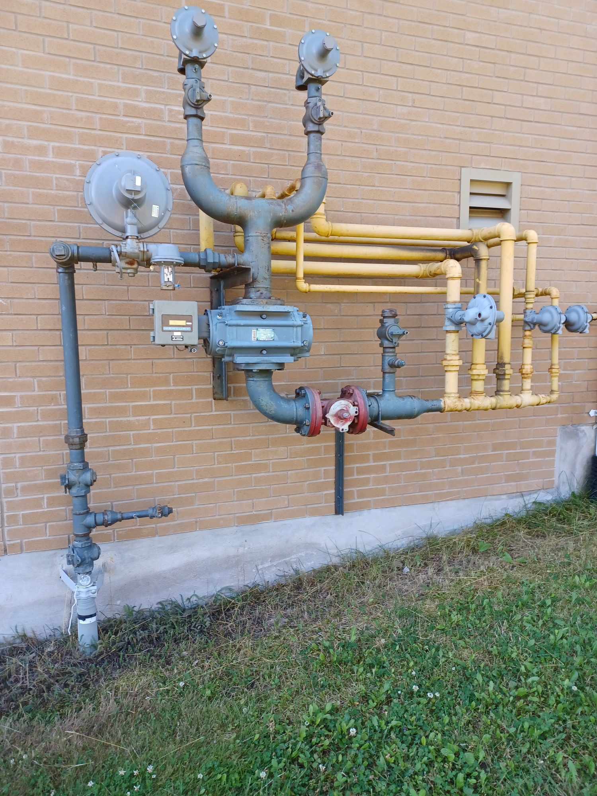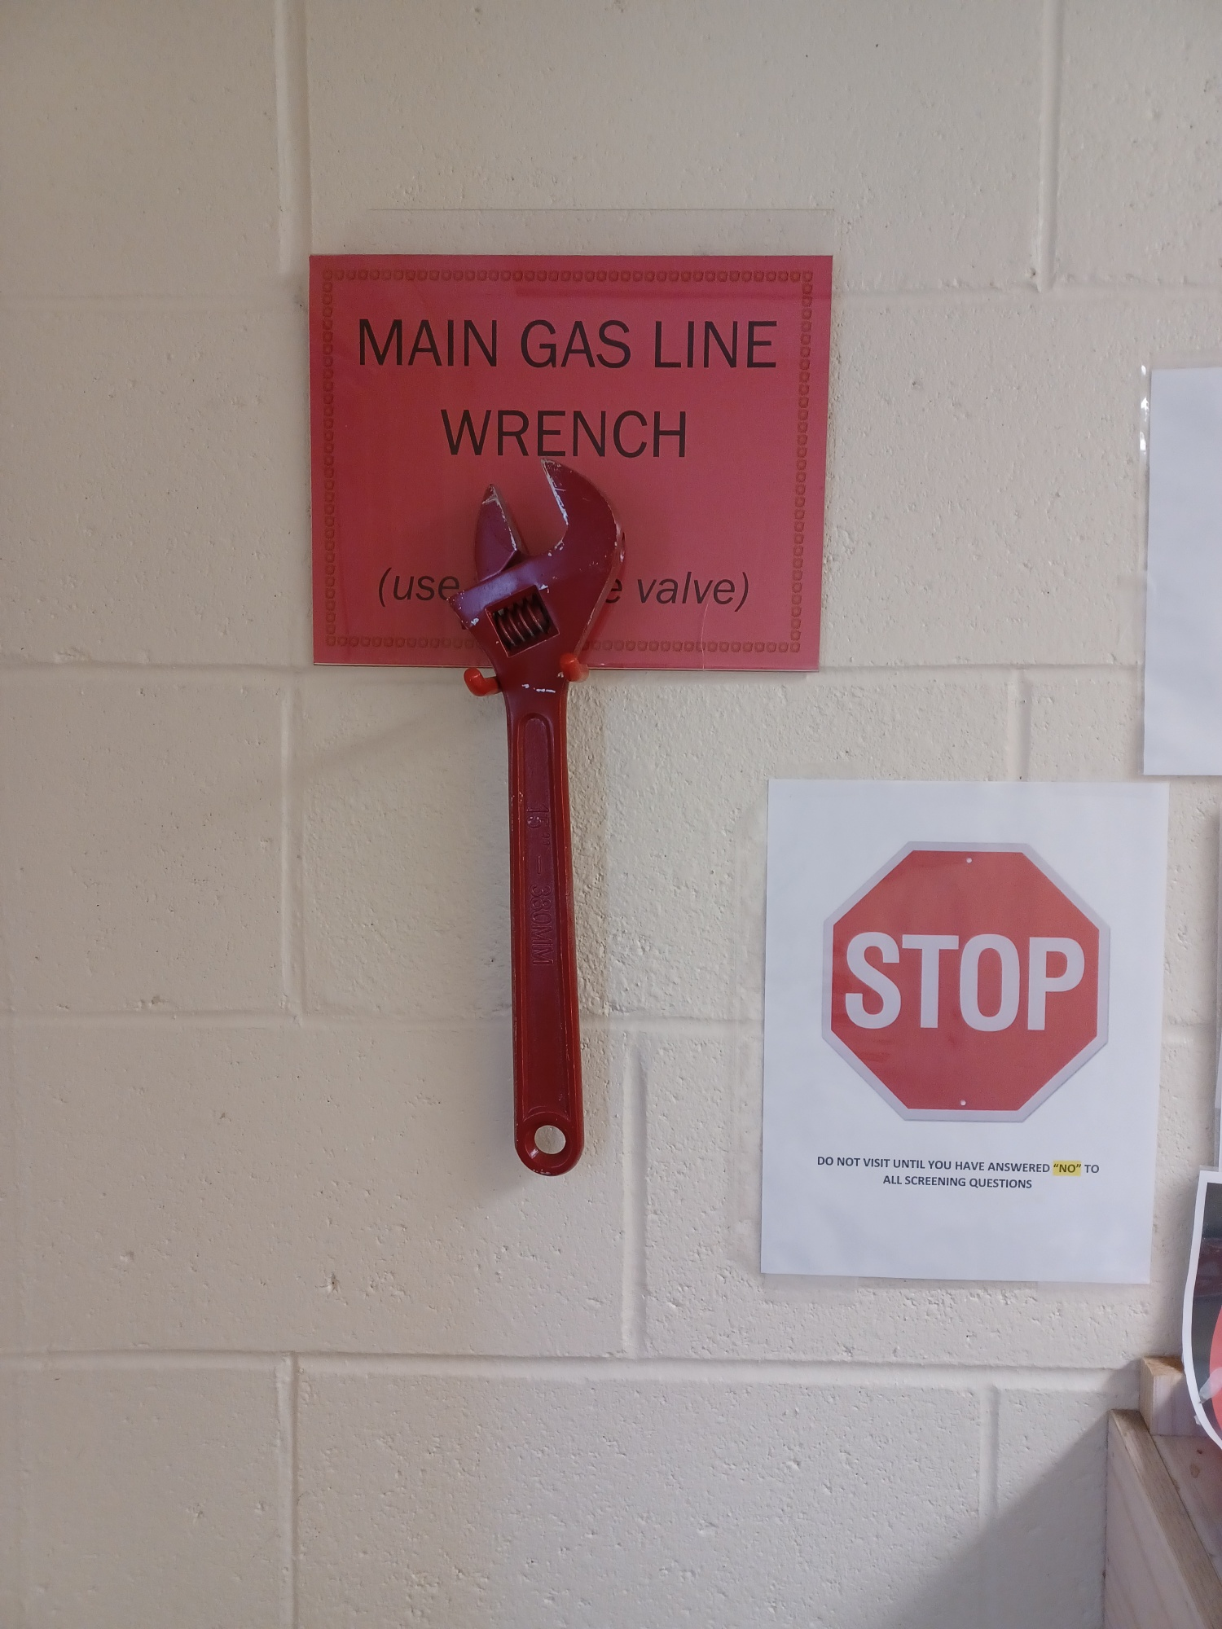

3.4 Domestic Water
- Main domestic Water Shut-Off: 1 location.
  - Garbage Room north wall beside compactor (service area)

3.5 Power
- Main Shut Off:
  - Electrical Room north wall (service area)

3.6 Fire Alarm System
Make: GE Edwards
Model: EST-3

Annunciator Panel Location:
- Front Foyer, IT room, Service Entrance, Spruce side entrance
Devices:
- Smoke & Heat Detectors, pull stations, bells, Strobes “DO NOT ENTER” illuminated sign at link.

The system is a Two Stage Fire Alarm System.
The first state is “alert’ and the second is “alarm”.
When one bell zone goes into alarm, the remaining bell zones go into alert. The bell zones are as follows:
- First Floor North
- First Floor South
- First Floor East
- Second Floor North
- Second Floor South
- Second Floor East

3.7 Sprinkler Systems
Type: Wet (system connected to fire alarm system)
Dry- attic
Shut-Off valves: Wet – Fire Protection Room

3.8 Standpipe systems
Location of Shut-Off: N/A
Connection: N/A

3.9 Fixed Extinguishing System for Commercial Cooking Equipment
Type: ANSUL R/102 (connected to fire alarm system)
Fuel Source: Natural Gas and Electric
Appliance Shut-Off: Kitchen
(If system does not activate use the manual activation pull is located by the kitchen exit door.)

3.10 Portable Fire Extinguishers (appendix C)
Type: ABC, 5lb and 10lb (locations – see appendix C, floor plan)
- Class K Wet Chemical

- Class A Ordinary Combustibles Multipurpose ABC
(Wood, paper, cardboard) Water A

- Class B Flammable & Combustible Multipurpose ABC
Liquids and Gases Dry Chemical BC

- Class C Energized Electrical Multipurpose ABC
Dry Chemical BC
Carbon Dioxide CO2

3.11 Emergency Lighting
- The entire facility is equipped with emergency lighting.

3.12 Emergency Power
- The facility is equipped with emergency power that is provided by one diesel generator. Red wall plugs are tied into generator power.

3.13 Generators
Fuel Supply Location: North side of manor, West of Generator off Dawson St.
Transfer Switch Location: Electrical Room
Equipment Powered by Generator: Emergency Lighting, Elevator, Servers for Computers/Phones, Boilers and Pumps, Kitchen/laundry equipment.

3.14 Electromagnetic Locking Devices
- Corridor fire separation doors, emergency exit doors

3.15 SDS Location
- A copy is kept by the Health and Safety Board in the back service hallway.

3.16 Elevator
Number of elevators: 1
Number of Fire Fighter Elevators: 0
Recall: Manual Switch (key operated to floor location called)
Location of Elevator: 1st floor by stairwell and washrooms, 2nd floor between Administration and Resident wings, Tranquil Tamarack and Peaceful Pine

Location of Operating Keys: Fire Safety Emergency Box- front lobby, Maintenance Department, Office Manager Key Box
If the elevator locks out during smoke detection it can be activated by opening the Firefighter Panel inside the elevator, inserting the key, turning to ON and using the buttons to direct.

3.17 First Aid Kit
- Main Nursing Office-Second floor

3.18 Location of Fire Safety Plan
Fire Plan will be located at the designated areas:
-Fire Department -Evacuation box (receiving)
-Front Lobby -Unit Nursing Stations x3
-Administration Office -Charge Nurse Office
-Foyer- Front Entrance Emergency Box -Laundry Department
-Maintenance Office -Dietary Department (kitchen)

4.0 General Fire Instructions
4.1 How the Fire Alarm System Operates
STAGE 1 (Alert):
- Slow strokes or alarm bells.
- Twenty strokes per minute.
- Activated by:
  - Manually pulling the handle of the fire pull station.
  - Smoke or heat sufficient to set off the alarm.
Fans shut down fire doors automatically close and all mag doors release.
STAGE 2 (Evacuation):
- Fast strokes or alarm bells.
- Activated by:
  - Manually inserting metal key at pull station.
  - Insert firmly until engaged and turn clockwise until you hear a click causing a change from slow to fast alarm.
  - Automatically after five (5) minutes will go to fast alarm.
Upon hearing the fast alarm, be prepared to evacuate pending instructions.
Testing of the fire alarm system is required at periodic intervals. Treat every fire alarm as a genuine emergency.

4.2 What You Should Do When the Fire Alarm Sounds
If the fire alarm system sounds intermittently, this is a FIRE ALERT. Fire Rolls and Procedures should be implemented.
IF the fire alarm sounds continuously, Evacuation Rolls and Procedures are activated. Do not use the elevators as you could be trapped if the power fails or is switched off.
When an alarm sounds, do not assume that it is a false alarm. Follow Fire Rolls and Procedures.
Staff members should refer to the pertinent sections of this procedure for specific instructions for their work situation.

4.3 What You Should do In Case You Discover a Fire
Proceed to the nearest manual fire alarm pull station and sound the fire alarm. Locations posted on a map by each fire door. Safely remove anyone that is in immediate danger if able.
Do not attempt to fight the fire unless you are trained and confident to do so and are not endangered. Do not spend more than one minute attempting to put out the fire.
If the fire is beyond your control, evacuate the immediate area and follow Fire Rolls and Procedures responsibilities.
Note: Be cautious as there are various kinds of fires requiring different types of extinguishers. All Staff and Visitors should familiarize themselves with the locations of the manual fire alarm pull stations, fire extinguishers and building exit to avoid confusion when an emergency occurs.

4.4 Evacuating the Building (appendix A, Site Plan)
When the bell sounds continuously, follow directions from the Unit Team Leader (RPN) or designate. Know your Rolls and Procedures responsibilities.
All employees working will be responsible for ensuring …
- All areas are searched, and evacuation tags are utilized to identify where residents remain.
- All equipment is switched off.
- Windows are closed and doors are shut but not locked (unless the area needs to be secured and the fire is not in the area).
In the Event of an Evacuation
In the event of an emergency necessitating an evacuation, the initial evacuation will normally require the horizontal relocation of Residents, Staff, and other occupants from affected areas to an adjacent safer area.
Control Area
Unless otherwise announced the Main Administration Office shall be set up as the Incident Command Post.
If it becomes necessary to evacuate the facility, occupants will be evacuated to the safe zone determined at the time of the emergency and dependent upon the nature of the disaster, the affected location within the building and the external environment, such as wind direction, smoke, weather etc. The location determined will not obstruct responding emergency personnel and will be sufficiently far from the building that occupants will not be hurt by smoke, falling glass or other debris.
Where possible, avoid using the main entrance as an evacuation exit to facilitate the arrival of emergency response teams.
Inside holding area in the ADSAB building- class room, hallways, boardroom, sitting areas.
Outside Designated Safe Zone/Evacuation Exit Routes are as follows: Appendix A
- hospital overhang for emergency concerns
- or roundabout for non-emergency
Meeting points may be changed based upon the evacuation exit routes.
Ambulance and secondary transportation will be used to move Residents to other pre-arranged sites – noted as Transfer Sites, refer to Evacuation Plan.
Incident Commander (RN/Administrator/Designate – Will wear an ORANGE VEST to be identified quickly.
The Incident Commander is authorized to co-ordinate all activity and take all necessary actions to deal with the incident.
The Incident Commander will assist the Fire Department upon their arrival with the management of the incident. Incident command can be transferred to the Fire Department upon arrival, if required.

4.5 Emergency Response Plan Search Procedures Search maps/Floor Plans -Appendix C
The following is a condensed version of the Search Procedures; please refer to the Evacuation Plan.
This procedure is to assist you in case a thorough search is needed of Algoma Manor Nursing Home for the purposes of locating a missing person or due to disaster or fire.
The Incident Commander will put a thorough search into effect when need arises.
The Incident Commander will take a head count after the evacuation. All staff will assist in identifying the names and last known locations of anyone not accounted for and pass them to the supervisor in charge.
NOTE: In a fire situation with smoke involvement, only properly equipped Fire Department Personnel will conduct the search.
Procedure:
- Room search is conducted in an orderly manner – always search from the left to the right of the room. Search wardrobe, bathroom, under/on the bed, behind chairs, behind curtains.
- Remove all Residents from room if evacuation is indicated.
- Once searched, close the door and place evacuation tag on door in upright position (White covering red) to indicate that it has been searched and Residents are not in room.
- The persons assigned to activity areas, service areas (laundry area) must thoroughly search every possible room or space. Remember to look under tables, behind doors or in storage areas. Record on search maps areas checked.
- All search information must be given to the Incident Commander.

Returning to the Evacuated Facility The following is a condensed version.
Unless otherwise announced, the Administration Office shall be set up as the Incident Command Post.
Administrator and/or designate shall:
- Ensure that the building has been inspected for re-entry.
- Must be inspected and approved for Resident re-occupancy by the appropriate authorities, i.e.: Fire Department Official, Police Department etc.
- Check all operation equipment with the Environmental Supervisor/Maintenance Department, ensuring the safe operation of all equipment.
- Ensure that the building is environmentally comfortable for occupancy.
- Notify the Ministry of Health and Long-Term Care, and any other applicable stakeholders of re-entry plan.
- Have a debriefing to evaluate and improve the process.
Director of Nursing and/or designate shall:
- Arrange to notify families re: time and date of return.
- Arrange to schedule readmission of Residents who have been with families last.
- Assign responsibility to notify Attending Physicians/NP of return.
- Maintain close contact with direct care Staff and Residents.
- Responsible for returning traffic.
- Maintain lists of Residents and equipment to be returned.
- Assign responsibility for safe return of Residents and equipment to appropriate Staff members.
- Check and identify Residents as they disembark from the various means of transportation.

Director of Dietary Services shall
- Arrange for meals/nourishment etc. for returning Residents.
Environmental Manager shall

- Arrange for all necessary linens/cleaning etc. to be available.
All Staff shall:

- Assist with the safe return of all Residents and equipment.
- Work together to establish routine as soon as possible.

4.6 False Alarms
A False Alarm will not only disrupt the activities of Algoma Manor but will also result in the dispatch of the firefighting equipment to the facility by the Fire Department. Anyone witnessing the initiation of a False Alarm should notify the Main Office and/or a Charge Nurse immediately. The operation of a Fire Alarm in the absence of a fire is an offence under Section 393 of the Criminal Code which states:
Everyone who willfully, without reasonable cause, by outcry, ringing bells, using a fire alarm, telephone, or telegraph or in any other manner makes or circulates or causes to be made or circulated and alarm of fire, is guilty of:
- an indictable offence and is liable to imprisonment for two years, or
- an offence punishable on summary conviction

4.7 Fire Drills
In order that Safety Officials may evaluate evacuation procedures, treat every Fire Drill as if it were a genuine emergency.
- Evacuations will be conducted a minimum of once every two years. The Evacuation will be conducted in co-operation with the Fire Department.
- Fire Drills will be held each shift once a month.
Note: Failure to respond and react to a Fire Drill in the correct manner or refusal to evacuate will lead to disciplinary action.

4.8 Fire Extinguishment, Control and Confinement
In the event of a small fire, ensure that the fire alarm and the emergency procedures have been activated.
Portable Fire Extinguishers

There are portable fire extinguishers throughout Algoma Manor. Multipurpose ABC rated dry chemical fire extinguishers are present in all locations. Staff shall be aware of their locations, ratings, and basic operation. Only use if you are trained.

Operation instructions for Portable Fire Extinguishers

P ……... Pull the safety pin.
A ……... Aim at the base of the Fire.
S ……... Squeeze handle.
S ……... Sweep nozzle back and forth.

Maintain a clear path to exit from the hazard if required. Keep the fire in front of you and the exit directly behind you.
Always call the Fire Department for follow up after a fire has occurred even if you feel it is out. The Fire Department has specialized tools to check inside walls and confined areas to ensure the fire is out.

4.9 Control of Fire Hazards
To avoid a fire and unsafe conditions in the building, staff shall:
- Keep exits, landings, and hallways clear of obstructions, pushing equipment to one side only, if it cannot be removed from hallway.
- Keep exits and hallways always clear of combustible materials.
- Displays at the main entrance shall be of limited combustible materials; designed and maintained so as not to create a fire hazard. (e.g., NO LIVE CHRISTMAS TREES – NO HAY BALES)
- Artwork and displays in the corridors shall:
- Not cause obstructions/ Not be arranged in a manner to create a fire hazard.
- Follow refuse guidelines. Refuse/garbage bins are permitted in the hallways with approved lids.
- Keep fire doors closed (doors separating hallway and service/ storage rooms). Except for fire doors that are held open with magnetic devices that release on activation of the fire alarm.
- Ensure occupant load in the common areas is not exceeded.
- During presentations and events, attention must be given so that there are no fire hazards.
- Refrain from using unsafe cooking practices, do not leave cooking unattended.
- Do not use any damaged electrical equipment or electrical cords.
- Do not allow any propane (BBQ’s) to be stored inside the facility.
- Ensure that unsafe chemicals and other flammable products are stored and dispensed in designated safe locations.
- Shop Area: Proper safe storage of flammable products. Ensure rags are disposed of in proper containers. Ensure dust and collection systems are checked and cleaned regularly.
- Kitchen: Ensure that overhead hoods are checked, and hazardous accumulations are cleaned as necessary.
- Janitorial or Cleaning Products: Shall be stored in safe and locked secure locations.

5.0 INSTRUCTIONS AND RESPONSIBILITIES
5.1 General Instructions to All Staff
In case of a fire alarm being activated, it is essential that all Staff be aware of their specific duties and responsibilities.
Before crossing into the link all staff must observe the “DO NOT ENTER” sign at the link entrance, to ensure it is not illuminated. If it is illuminated, it indicates a fire situation in the building next door. DO NOT CROSS and inform the Charge Nurse immediately.
In very general terms, your major responsibility is to ensure the safety and orderly evacuation of Residents and Visitors.
Communication
- During Code Red/Evacuation will be the Motorola Walkie Talkies (WT), Channel 1. Location of WT: Environmental Supervisor Office, Front Lobby Desk, Pine/Tamarack/Spruce Nursing station, Maintenance Shop, Charge Nurse Office, and kitchen.
Need to know
- Be aware of the locations of the designated safety zones if evacuation is necessary.
(Site Map attachment A)
- Elevators are not to be used during a fire emergency unless directed by Fire Department.
- Where possible avoid using the main entrance as an evacuation exit to facilitate the arrival of emergency response teams.
- Locations of all fire pull stations; fire exits and extinguishers; always ensure that they free of obstructions.
- RN in Charge has full responsibility unless assumed by the Administrator or Fire Department.
- All Algoma Manor staff need to be aware of the locations of the designated safety zones. See attached map.
- How to use evacuation tags.
- The location of the fire alarm annunciator panel in each RHA Nursing Station.
- All security locked doors automatically unlock when the alarm has been activated.
- Balconies are NOT to be used as an area of evacuation.

Remember in a fire situation to

- Stay low to the floor.
- Check the heat of the door with the back of your hand-if it is hot do not open it if it is cool, enter for rescue purposes only.
- If the area is full of smoke, do not enter.
- Always keep yourself between the exit and the fire.
- Remain calm.
Order of site evacuation

- Site: evacuation from the room of origin of an emergency (e.g., during a fire).
- Horizontal: evacuation beyond corridor fire doors and / or to an adjacent wing.
- Vertical: evacuation to a lower floor.
- Premises: evacuation of the entire home.
Order of resident evacuation

- Ambulatory Residents: many residents can be removed with assistance by one or two staff
Cautions:
  - confused & ambulatory – may get in the way or wander back into the fire area.
  - slow ambulatory – may hinder others, may need to remove in wheelchair.
- Wheelchair Residents: easier to remove than bedridden, may require one staff member to assist.
- Bedridden Residents: use demonstrated lifts and carries, may require two staff members.
- Uncooperative Residents: remain until last, otherwise valuable time lost and may sacrifice others. Ensure that their door is closed and identify the resident name & location to Charge Nurse and Fire Department.

Evacuation Tags Information
Purpose: The purpose of these Red Indicators is to identify if a room has been searched and indicate if the room is empty or someone is in the room during an emergency such as fire.
How to Use:
- After a room has been completely checked and there are no occupants, exit the room and close the door with the red tag covered by the White tag. This will indicate to other personnel that the room is clear and unoccupied.
- If there is a resident left in the room, reassure them, leave the red tag showing to allow easy identification for the fire department.
- If it is semi-private, leave tag down on both doors.
- Close the door.
- Remember the room number and resident to pass information on to Incident Commander (RN)
so, they can alert the fire department of a non-cooperative resident left in a room.

In the event of an evacuation, the tags will identify if someone remains in the room and the fire department can prioritize their evacuation process.

Additional Information for all Departments
Each unit has 3 areas.
#1 Lounge
#2 First hallway
#3 Second hallway

Each of these areas is defined by the fire doors. Each area between the doors is considered a safe zone.
There are also fire doors between the units, and you may have to evacuate into the next unit if that is the only safe route. Remember the safety of the residents is the priority.

If you need to evacuate your responsibility will be the same in each area. If the fire is in the area you are working in, evacuate the immediate area, closing doors and using the evacuation tags only when you have thoroughly searched the room. Continue to evacuate as you retreat from the fire scene, closing doors as you go. The RPN will have arrived at the scene and will direct staff and residents away from the fire. She/he will have contact with the charge nurse and can call for assistance if required.

If you are on the unit where there is a fire but are in a safe zone, you may be directed to go to the fire scene and assist to remove residents, or you may be required to assist the residents that will be coming through the fire doors and transfer them away from the fire area into a safe zone.
If you are on a unit that is not the fire scene you may be directed by the RPN to assist at the fire scene.
Always be aware of the residents, where they are and what direction they need to be heading for evacuation purposes. Remember to keep them calm and comfortable.
Verbal communication (walkie talkie) should only be between the person at the fire scene, the Incident Commander (RN) and anyone they need to contact.

After determining where the fire is you must work together to keep residents safe and calm. Once the Unit RPN attends the fire scene they will be the fire scene coordinator and will oversee directing all personal if there is a fire or an evacuation.

5.2 Role and Responsibility of the Charge Nurse in the event of a Fire Emergency
The person discovering Fire will follow:
R- Remove residents from affected area.
E – Ensure door is closed to confine fire
A – Activate alarm by pulling nearest pull station
C – Call the fire department (Automatically done when pull is activated)
T – Try to extinguish the fire and prepare to evacuate
The Charge Nurse assumes the role of “Incident Commander.”

Upon hearing the alarm

- Page – the area of fire and Code Red X 3, #888. You may identify the fire scene by the enunciator panel or from a call from the fire scene.
- SILENCING THE PANEL BELLS AND BUILDING BELLS This can only be done during a drill. You silence these bells by pushing the ALARM SILENCE and PANEL SILENCE buttons.
- ENSURE ONLY ONE AREA HAS BEEN PULLED To ensure that there is only one area of concern in the building (as there may be more than one fire pull activated), press the UP or DOWN arrow on the “Previous Message Next” button.
- ASSIGN A STAFF MEMBER TO STOP FOOT TRAFFIC AT THE FRONT DOOR, stop visitors and/or meet the Fire Department.
- PUT ON THE VEST (in the fire box) so that you are easily identified.
- STATUS OF FIRE. Fire Scene coordinator (usually RPN) will tell you if the scene is under control or that evacuation assistance is required (send assistance from the lobby pool).
- RESET THE ENUNCIATOR PANEL (Only in the event it is a false alarm) Press “Acknowledge Alarm” then “Reset”
- The fire pull at the scene must be reset before resetting enunciator panel.
- RESET THE MAG DOORS The key insert is below the fire panel. The key is in the fire box.
Insert Key- turn right, turn left, turn right, turn left. The mag locks should reset.
Page “Code Red All Clear” x3

If fire is confirmed – Nights.

- Immediately verify the fire from the closest annunciator panel or from staff on duty.
- When fire location and status is confirmed
Page – area of fire and Code Red X 3, #888.
- If necessary, coordinate staff (pull off the other floors) to ensure residents in immediate danger are moved. Evacuate rooms closest to the fire area to a safe zone.
- Immediately contact Administrator, initiate the call out list or assign the duty to someone else available.
- Once the fire department arrives, they have complete authority over the building and grounds.

Information for the Fire Department:
  - Where is the fire?
  - Is it under control?
  - Is everyone accounted for?

False Alarm
If the alarm is activated, A.T.S. Bell, in Sault Ste. Marie, will automatically dispatch the fire department.
If a resident has activated the alarm and you are 100% sure and there is no fire, you can try to call ATS to let them know this is a false alarm. The phone # is 705-946-8999. The password code is “Algoma.”
Reset the system per procedure. Send Maintenance an email and they will reset the HVAC when they get on shift

5.3 Roles and Responsibilities of the RPN

The person discovering Fire will follow:
R- Remove residents from affected area
E – Ensure door is closed to confine fire
A – Activate alarm by pulling nearest pull station
C – Call the fire department (Automatically done when pull is activated)
T – Try to extinguish the fire and prepare to evacuate

When the alarm is activated Motorola walkie talkies will be used on channel 1.

Upon hearing the alarm

Listen for the “CODE RED” Page to identify area of fire.

Return to unit immediately if on break or away from your assigned home area. After determining where the fire is you must work together to keep residents safe and calm. If you are able, you will go immediately to the scene of the fire and take control by contacting the Incident Commander and directing staff and residents to safety. You may request assistance from the Incident Commander.

5.4 Roles and Responsibilities of PSW/HCA/Assists/Support/BSO

The person discovering Fire will follow:
R- Remove residents from affected area
E – Ensure door is closed to confine fire
A – Activate alarm by pulling nearest pull station
C – Call the fire department (Automatically done when pull is activated)
T – Try to extinguish the fire and prepare to evacuate

When the alarm is activated Motorola walkie talkies will be used on channel 1.

Upon hearing the alarm

Listen for the “CODE RED Page to identify area of fire.
Return to your unit immediately if on break or away from your assigned home area. After determining where the fire is you must work together to keep residents safe and calm. Once the Unit RPN attends the fire scene they will be the fire scene coordinator and will oversee directing all personnel if there is a fire or an evacuation. The enunciator panel in nurse’s station can also identify the area.

After 6:30 pm, 1 PSW from Spruce will be responsible for assessing the service area and closing all doors.

NIGHTS
If the alarm goes off in your area, immediately assess the scene and evacuate if necessary.
If the alarm is not in your area, you may be requested to assist with evacuating the fire scene.

5.5 Roles and Responsibilities for Physio

The person discovering Fire Cone will follow:
R- Remove residents from affected area
E – Ensure door is closed to confine fire
A – Activate alarm by pulling nearest pull station
C – Call the fire department (Automatically done when pull is activated)
T – Try to extinguish the fire and prepare to evacuate

When the alarm is activated Motorola walkie talkies will be used on channel 1

Upon hearing the alarm

Listen for the “CODE RED” Page to identify area of fire. Go to the fire pool in the lobby immediately if on break. If there are residents in the Restorative Room remain and assist to keep them safe and calm. Follow the instructions of the RPN (or designate). If you are in a unit with a resident remain in that unit assisting where required. After determining where the fire is you must work together to keep residents safe and calm.

5.6 Roles and Responsibilities for Laundry Department

The person discovering Fire will follow:
R- Remove residents from affected area
E – Ensure door is closed to confine fire
A – Activate alarm by pulling nearest pull station
C – Call the fire department (Automatically done when pull is activated)
T – Try to extinguish the fire and prepare to evacuate

When the alarm is activated Motorola walkie talkies will be used on channel 1.

Upon hearing the alarm

Listen for the “CODE RED Page to identify area of fire.
Return to the laundry room immediately if on break or away from your area. Shut equipment down, close doors and proceed to the staff pool (lobby). If you are sent to help on a unit you must work together to keep residents safe and calm and assist where required.

5.7 Roles and Responsibilities of Kitchen/ Dietary Staff

The person discovering Fire will follow:
R- Remove residents from affected area
E – Ensure door is closed to confine fire
A – Activate alarm by pulling nearest pull station
C – Call the fire department (Automatically done when pull is activated)
T – Try to extinguish the fire and prepare to evacuate

When the alarm is activated Motorola walkie talkies will be used on channel 1.

Upon hearing the alarm

Listen for the “CODE RED” Page to identify area of fire.
Return to your work area immediately if on break or away from your area. Turn off all your equipment. 1st Cook is responsible for closing doors in the service area, the rest of the downstairs staff will proceed to the fire pool (lobby) and wait for direction from the Incident Commander or designate in charge. Upstairs servery staff will proceed to Pine to assist or proceed as directed by the RPN. After determining where the fire is you must work together to keep residents safe and calm.

5.8 Roles and Responsibilities for Housekeeping Department

The person discovering Fire Cone will follow:
R- Remove residents from affected area
E – Ensure door is closed to confine fire
A – Activate alarm by pulling nearest pull station
C – Call the fire department (Automatically done when pull is activated)
T – Try to extinguish the fire and prepare to evacuate

When the alarm is activated Motorola walkie talkies will be used on channel 1.

Upon hearing the alarm

Listen for the “CODE RED Page to identify area of fire. Return to your unit immediately if on break or away from your assigned home area. After determining where the fire is you must work together to keep residents safe and calm. Once the Unit RPN attends the fire scene they will be the fire scene coordinator and will oversee directing all personnel if there is a fire or an evacuation.

5.9 Roles and Responsibilities for Administration/Office Department

The person discovering the Fire will follow:
R- Remove residents from affected area
E – Ensure door is closed to confine fire
A – Activate alarm by pulling nearest pull station
C – Call the fire department (Automatically done when pull is activated)
T – Try to extinguish the fire and prepare to evacuate

When the alarm is activated Motorola walkie talkies will be used on channel 1.

Upon hearing the alarm

Listen for the “CODE RED” Page to identify area of fire. If there are residents/family/visitors in the office remain and assist to keep them safe and calm. If there are no visitors or family members in the administrative area you will proceed to the Fire Pool (main lobby area). Follow the instructions of the RN (or designate). If you are on a unit, remain on that unit assisting where required.

5.10 Roles and Responsibilities for Activities Department

The person discovering Fire will follow:
R- Remove residents from affected area
E – Ensure door is closed to confine fire
A – Activate alarm by pulling nearest pull station
C – Call the fire department (Automatically done when pull is activated)
T – Try to extinguish the fire and prepare to evacuate

When the alarm is activated Motorola walkie talkies will be used on channel 1.

Upon hearing the alarm

Listen for the “CODE RED Page to identify area of fire. Return to your unit immediately if on break or away from your assigned home area. If you are participating in an activity remain where you are with the residents. Once the Unit RPN attends the fire scene they will be the fire scene coordinator and will oversee directing all personnel if there is a fire or an evacuation.
After determining where the fire is you must work together to keep residents safe and calm.

5.11 Roles and Responsibilities for Volunteers/Contract Workers

The person discovering Fire will follow:
R- Remove residents from affected area
E – Ensure door is closed to confine fire
A – Activate alarm by pulling nearest pull station
C – Call the fire department (Automatically done when pull is activated)
T – Try to extinguish the fire and prepare to evacuate

Upon hearing the alarm

Listen for the “CODE RED” Page to identify area of fire. If you are on a unit or with a resident remain on that unit assisting where required. If you are transporting a resident from one area to another stop until you hear the Incident Commanders “all clear” page/or receive further instructions. If you are in the lobby remain where you are

After determining where the fire is you must work together to keep residents safe and calm. Once the Unit RPN attends the fire scene they will be the fire scene coordinator and will oversee directing all personal if there is a fire or an evacuation

5.12 Role and Responsibility of the Hairdresser/Dental Hygienist/Foot Care

The person discovering Fire will follow:
R- Remove residents from affected area
E – Ensure door is closed to confine fire
A – Activate alarm by pulling nearest pull station
C – Call the fire department (Automatically done when pull is activated)
T – Try to extinguish the fire and prepare to evacuate

Upon hearing the alarm

Listen for the “CODE RED” Page to identify area of fire. If there are residents in the Hair Salon remain and assist to keep them safe and calm. If there is no one there proceed to the fire pool (lobby). Follow the instructions of the RN (or designate). If you are in a unit with a resident remain on that unit assisting where required. After determining where the fire is you must work together to keep residents safe and calm.

6.0 Training
Fire drills are administered through the Administration Department and are conducted once a month, every shift. All employees of the Algoma Manor staff present during the drills are required to participate and comply with the Emergency Evacuation Orders.
The results of each fire drill, including noted deficiencies, are documented.
On orientation, each new Staff member is provided with in-servicing on the Fire Procedures at Algoma Manor.
The Administrator or delegate maintains records of Staff attendance and participation at Fire Drills and Training. Training records are kept for each Employee (including contracted services and volunteers).
A tour of the home is provided on Orientation to identify all Fire Safety Equipment, location of exits, pull stations, extinguishers, emergency manual location, etc.
It is policy that all Staff in a crisis (internal or external), follow these guidelines:
- All Staff will report to duty as directed by their respective department head or delegate.
- Work schedules will be readjusted as required.
- Previously approved requests for time off may be cancelled for the duration of the emergency.
- All Staff will remain on site unless otherwise approved.
- Only work-related phone calls will be received.
- Information to the press, etc. will only be released by the Administrator or Delegate.

6.1 Fire Extinguisher Training
On-site Fire Extinguisher training may be conducted as part of ongoing training of staff.

6.2 Fire Drills Procedure
- The purpose of the drill is to provide a practiced plan of action for all shifts. All Staff shall participate in at least one drill per year.
- An area will be assigned by the Administrator or delegate to be the mock fire scene.
- Person discovering “THE FIRE” will follow REACT procedure and pull nearest red fire pull station, which activates the alarm. All staff will assume roles and responsibilities.
- RN in Charge will verify with RHA Staff Member or, RPN (Fire Scene Co-coordinator) exact location of fire. Be calm and speak clearly when notifying all home areas of the Code Red and the location of the fire nurse page.
- If on break and you cannot return to your home area, report to the staff pool in the lobby and await directions of the Charge Nurse, Delegate, or the Fire Department.
- Staff will work together to ensure all exit door are monitored so that Residents do not leave unaccompanied and/or assigned to move Residents to an alternate zone.
- RPN (Fire Scene Coordinator) will proceed to location of fire and assume command of the unit by directing staff to evacuate, requesting assistance, or declaring scene under control.
- A person at the fire scene will reset activated device (fire pull station)
- After verification, the RN will reset the enunciator panel and the mag locks and call “All Clear, Code Red” X 3.
- All units will hold a post meeting (conducted by the RPN) and document on the sign in sheet any issues/concerns etc.
- Attendance must be recorded for all Staff working. RPN will ensure staff on their unit sign the Fire Drill report form and ensure they are forwarded to Environmental Supervisor mailbox. Staff are to resume normal activities following the debriefing and signing fire drill report sheet.
- Drill summaries are logged in JHSC report, reviewed quarterly by JHSC Team and copies placed on the Health and Safety Board

Fire Safety is the responsibility of ALL Staff at Algoma Manor.
Staff deliberately disregarding Fire Scene and Drills will be disciplined immediately.
6.3 Fire Drill on Nights Procedure and Check List
- Notify Staff of the mock fire incident and the scenario of the drill.
- Follow normal fire drill procedure, see Roles and Responsibilities for each department, announce Code Red using walkie talkies and put on fire vest etc.
- When the pull station is simulated to be activated, the drill occurs minus the actual alarm ringing.
- RN in charge will announce Code Red using walkie talkies, and state exact location of fire (which can be read from the annunciator panel with a specific zone description). Be calm and clear.
- When the drill procedure is over – ensure all tasks are carried out despite the drill being a table talk exercise.
- Complete fire drill report and record attendance.
- A paper drill may also be used on nights

Emergency Procedures Instructions to Residents and Visitors
Upon hearing the Alarm or Discovering a Fire:
- Immediately call for help using call bell or yelling.
- Confine the fire by closing the door on it. Remove yourself from the vicinity of the fire.
- If able, activate the alarm by pulling a pull station if it is not already activated, wait further instructions from staff.
- If the area you are in is NOT affected by fire, upon hearing alarm – remain where you are to await further instructions from the Staff.
- If you are a visitor remain with the resident, you are with.
- Do not use the elevator.
- REMAIN CALM
6.5 Emergency Directions Posted at Each Fire Pull Station
REACT
CODE RED
In Case of Fire – REMAIN CALM
On discovering Fire or Smoke
- Activate the Alarm by pulling the nearest pull station
- Remove Residents from affected area
- Ensure door is closed to confine the Fire
- Fire Department is automatically contacted when alarm is activated
- Try to extinguish a small fire (if trained) and Prepare to Evacuate

- .

6.7 Fire Safety Plan/Emergency Plan
All Managers are to keep an up-to-date list at home of their Department Staff phone numbers to assist in the call-in process.

7.0 Fire Plan Administration
During a fire emergency, it is the responsibility of the RN or his/her designate to continually report the status of the situation to the Administrator.

8.0 Maintenance and Inspections
All maintenance, upgrades and additions to the fire alarm system are conducted by a certified/authorized fire alarm contractor. The contractor conducts a full inspection of the fire alarm annually and corrects any deficiencies. The contractor also corrects deficiencies as reported by a variety of fire safety inspection initiatives.
Maintenance Staff conduct a full test of the fire alarm system, including backup generator, once per month. Any noted deficiencies with the system or alarm sounders are immediately reported to the fire alarm contractor for corrective action.
Fire hazards may also be reported through regular safety inspections conducted by the Joint Occupational Health and Safety committee. The results of these inspections are documented, and deficiencies are forwarded to the Maintenance Department for corrective action.
Maintenance and inspections responsibilities can be found in “Appendix B.”

APPENDIX A
Site Plan

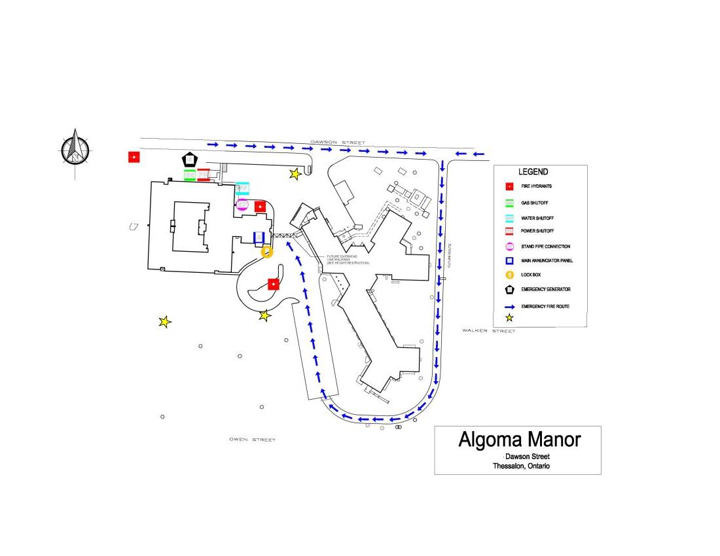

145
OUTSIDE SAFE ZONE

OVERHEAD LINK

INSIDE SAFETY ZONE second level

200 GALLON GAS TANK

200 GALLON DIESEL TANK

APPENDIX B
Maintenance & Inspection Responsibilities
General
Doors in fire separations shall be checked as frequently as necessary to ensure that they remain closed. | Maintenance/All staff
Exit signs shall be clearly visible and maintained in a clean and legible condition. | Maintenance
Internally illuminated exit signs shall be kept clearly always illuminated when the building is occupied. | Maintenance
GENERAL FIRE PROTECTION SYSTEMS/ EQUIPMENT

Weekly/Daily | Responsibility
When subject to accumulation of combustible deposits, hoods, filters, and ducts shall be checked weekly and cleaned when such deposits create an undue fire hazard. | Dietary, Laundry, Maintenance

Monthly | Responsibility
 | All Staff
Doors in fire separations shall be inspected monthly for proper operation.  Disconnect switches for mechanical air-conditioning and ventilating systems shall be inspected annually to establish that the system can be shut down. | Contractor

PORTABLE FIRE EXTINGUISHERS

General | Responsibility
Each portable extinguisher shall have a tag securely attached to it showing the maintenance or recharge date, the servicing agency and the signature of the person who performed the service. | Maintenance
A permanent record containing the maintenance date, the examiner’s name and a description of any work or hydrostatic testing carried out shall be prepared and maintained for each portable extinguisher. | Contractor
All extinguishers shall be recharged after use or as indicated by an inspection or when performing maintenance. When recharging is performed, the recommendations of the manufacturer shall be followed. | Contractor

Monthly | Responsibility
Portable extinguishers shall be inspected monthly. | Maintenance

Yearly | Responsibility
Extinguishers shall be subject to maintenance not more than one year apart or when specifically indicated by an inspection. | Contractor
Maintenance procedures shall include a thorough examination of the three basic elements of an extinguisher:  - Mechanical Parts  - Extinguisher Agent  - Expelling Means | Contractor
5 Years | Responsibility
Every five years, pressurized water and carbon dioxide fire extinguishers shall be hydrostatically tested. | Contractor
6 Years | Responsibility
Every six years, stored pressure extinguishers that require a 12-year hydrostatic test shall be emptied and subjected to the applicable maintenance procedures. | Contractor

FIRE ALARM/VOICE COMMUNICATIONS SYSTEMS

General | Responsibility
Fire alarm and voice communications system components shall be kept unobstructed. | Maintenance
Fire alarm system power supply disconnect shall be locked on in an approved manner. | Maintenance

Daily | Responsibility
The following daily checks shall be conducted and, if a fault is established, appropriate corrective action shall be taken.  - Check the principle and remote trouble lights for trouble indication.  - Inspection of the AC power-on light shall be done to ensure its normal operation. | Maintenance

Yearly | Responsibility
Yearly tests conducted by a certified alarm contractor as required by The Ontario Fire Code, Section 6.3.2.2(1) of Div. B. Tests shall be in conformance with CAN/ULC S536, “Inspection and Testing of Fire Alarm Systems”. | Contractor
Yearly conduct a fire drill, with the member of the fire department as a participant | Administrator
Voice Communications between floor areas and central alarm control facility shall be tested annually, as required for fire alarm initiating and signaling devices. | Contractor

SMOKE DETECTORS

General | Responsibility
Ensure dwelling unit smoke detector are maintained in operating condition. | Contractor

SPRINKLER SYSTEMS

General | Responsibility
Auxiliary drains shall be inspected as required to prevent freezing. | Contractor

Daily
Except for electricity supervised valves, all valves controlling water supplies to sprinklers and alarm connections shall be checked daily to ensure that they are sealed or locked in the open position. | Maintenance
Water supply pressure and system air or water pressure shall be checked daily to ensure that the system is maintained at the required operating pressure. | Maintenance
6 Months | Responsibility
An alarm test on all sprinkler systems, using the alarm test connection located at the sprinkler valve, shall be performed monthly. | Contractor

Yearly | Responsibility
Water flow devices shall be tested. | Contractor
6 Months | Responsibility
Gate-valve supervisory switches and other sprinkler system supervisory devices shall be tested at six-month intervals. | Contractor

Yearly | Responsibility
Exposed sprinkler piping hangers shall be checked yearly to ensure that they are kept in good repair. | Contractor
Sprinkler heads shall be checked at least once per year to ensure that they are free from damage, corrosion, grease, dust, paint, or whitewash. They shall be replaced where necessary because of such conditions. | Contractor
On wet sprinkler systems, water-flow alarm test using the most hydraulically remote test connection, shall be performed annually. | Contractor
Sprinkler system water pressure shall be tested annually or after any sprinkler system control valve has been operated, with main drain valve fully open, to ensure that there are no obstructions or deterioration of the main water supply. | Contractor
Plugs or caps on Fire Department connections shall be removed annually and the threads inspected of wear, rust, or obstruction. Re-secure plugs or caps, wrench tight. If plugs or caps missing, examine the Fire Department connection for obstructions, back flush if necessary and replace plugs or caps. | Contractor

WATER SUPPLIES FOR FIREFIGHTING
(PRIVATE HYDRANTS)

General | Responsibility
Hydrants shall be always readily available and unobstructed for use. | Maintenance

Yearly | Responsibility
Hydrants shall be inspected annually after each use. | Town
Ensure hydrants are equipped with port caps secured wrench tight. The port caps shall be removed annually and inspected for wear, rust or obstructions. | Town
The hydrant barrel shall be inspected annually to ensure that no water has accumulated. | Town
The drain valve shall be inspected for operation if water is found in the hydrant barrel when main valve is closed. | Town
Hydrant water flow shall be inspected annually, and a record shall be kept. | Town

COMMERCIAL COOKING EQUIPMENT

General | Responsibility
Commercial cooking equipment exhausts and fire protection systems shall be installed and maintained in conformance with NFPA 96, “Ventilation Control and Fire Protection of Commercial Cooking Operations”. | Contractor
Ensure wet chemical or alkali based dry commercial cooking equipment and are readily available for use in an emergency. | Contractor

Weekly | Responsibility
Hoods, grease removal devices, fans, ducts, and other equipment shall be checked weekly and cleaned at frequent intervals, prior to surfaces becoming heavily contaminated with grease or oily sludge. | Dietary/maintenance

6 Months | Responsibility
Inspection and servicing of the fire extinguishing system shall be made at least every six months by properly trained and qualified persons in conformance with Ontario Fire Code, Section 6.8.1.1. | Contractor

EMERGENCY LIGHTING SYSTEM

Weekly | Responsibility
Generators shall be inspected weekly and maintained as per manufacturer’s specifications. | Maintenance

Monthly
Emergency lighting equipment shall be tested monthly to ensure that the emergency lighting will function upon failure of the primary power supply | Maintenance
Yearly

Emergency lighting equipment shall be tested annually to ensure that the units will provide emergency lighting for duration equal to the design criteria under simulated power failure conditions.
Maintenance
ELEVATORS

General | Responsibility
Ensure keys required to recall elevators and to permit independent operations are in their approved location. | Maintenance
Monthly | Responsibility
Every three months the elevator door opening devices, operated by means of photo-electric cells, shall be tested to ensure that the devices become inoperative after the door has been held open for more than 20 seconds with the photo-electric cell covered. | Contractor
The key operated switch, located outside an elevator shaft, shall be tested to ensure that the actuation of the switch will recall the car to the desired floor | Contractor
Key operated switches in each elevator car shall be tested to ensure that the actuation of the switch will:  - Allow operation of the elevator without interference from floor call buttons.  - Render door re-opening devices inoperable.  - Control the opening of power operated doors only by the continuous pressure on the “door open” button to ensure that if the button is released while door is opening, the doors will automatically close. | Contractor

EMERGENCY POWER SYSTEMS

General | Responsibility
Emergency power systems shall be inspected, tested, and maintained in conformance with CSA C282, “Emergency Electrical Power Supply for Buildings”. | Maintenance
To ensure continued reliable operation, the emergency power supply equipment shall be operated and maintained in accordance with manufacturer’s instructions. | Maintenance
At least one copy of the instruction manual shall be maintained.  Check fuel supply for enough fuel.  Maintenance | Maintenance

Monthly | Responsibility
The emergency electrical power shall be completely tested monthly as follows:  - Simulate a failure of the normal power supply.  - Arrange so that:  - An engine generator set operates under at least 30% of the rated load for 60 minutes.  - All automatic transfer switches are operated under load.  - Include an inspection of the correct function of all auxiliary equipment such as radiator shutter control, coolant pumps, fuel transfer pumps, oil coolers and engine room ventilation controls.  - Verify all instrument readings associated with the prime mover and generator are normal.  - Log and report as further prescribed in the manual of instruction for operation and maintenance. | Maintenance

Annually | Responsibility
Test generator, control panel and transfer switch in conformance with CSA C282, “Emergency Electrical Power Supply for Buildings”. | Contractor

APPENDIX C
Algoma Manor Floor Plans

G
Gas Shut Off Valve
G

Administration Offices

Link

Algoma Manor Floor Plan- Level Two

BOARD ROOM

Algoma Manor Floor Plan- Level One

COURTYARD
BOILER ROOM
GENERAL STORAGE
RESIDENT
STORAGE
ARCHIVE
MAINT
SHOP
MALE FEMALE
LOCKER LOCKER

RECIEVING
LUNCH ROOM
MED SUPPLY
NO NARCOTICS
WATER \FIRE SYSTEM

CABLE/IT
ELECTRIC ROOM

GARBAGE
LAUNDRY
DRYERS
WASHERS

HSKP
DISHWASHER
KITCHEN

FRIDGE FREEZER
CHAPELLLL
Algoma Manor Floor Plan- Level One

APPENDIX D
Alternative Measures
For Interruptions To
Occupant Fire Safety

Contingency Plans
Alternative Measure in Case of System Shutdowns (fire & sprinkler) FIRE WATCH
The fire system may be disabled all or in part, due to a malfunction, power outage, damage, power interruption or serviceability limitations. Should a failure occur or should service personnel be required to leave the site, a FIRE WATCH must be implemented by building Staff throughout the entire building or affected area.
The sprinkler and standpipe systems may be disabled all or in part, due to malfunction, damage, freezing, water service interruption or serviceability limitations. Should a failure occur or should service personnel be required to leave the site, a FIRE WATCH must be implemented by the building Staff (the magnitude of the Fire Watch must be contingent on the nature and extent of the failure).
In the event a FIRE WATCH process is initiated – all affected areas MUST be patrolled by Staff every hour and a log of each patrolled area MUST be kept. Staff completing the FIRE WATCH must walk floor to floor and check each stairwell, corridor, service room, boiler room, and garbage room.
The RN in Charge or designate will arrange and assign Staff to patrol the building/units. Additional Staffing may be required to complete a FIRE WATCH PROCESS.
If the systems are not restored within 24 hours, the Administrator will notify the appropriate contacts.

.

APPENDIX E
Fire Safety Plan Review Record
Fire Safety Plan Review Record

Name | Signature | Date

