Holy Name of Mary Parish

“Let them grow together until harvest.” (Matthew 13:30)

JULY 26, 2026 | SEVENTEENTH SUNDAY IN ORDINARY TIME
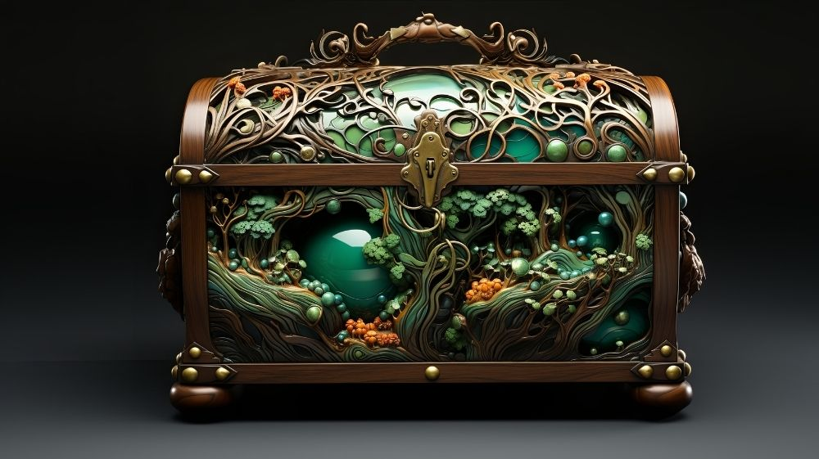
Welcome to Holy Name of Mary Parish! We are a Catholic community dedicated to growth in faith, prayer, and service to others.
NEW MASS TIMES
Weekday Mass Schedule: Monday 12:00pm Holy Name of Mary Montrose
Tuesday 8:30am St. Augustine Church Silver Lake
Wednesday 8:30am, St. Augustine Church Silver Lake
Thursday 12:00pm Holy Name of Mary Montrose
Friday 12:00pm St. Francis Xavier Church Friendsville
Saturday 8:30am St. Augustine Church Silver Lake

Weekend Mass Schedule: Saturday 4:00pm Holy Name of Mary Montrose
Saturday 6:30pm St. Francis Xavier Friendsville
Sunday 7:30am St. Francis Xavier Friendsville
Sunday 10:30am St. Augustine Silver Lake
Sunday 12:30pm Holy Name of Mary Montrose

Divine Food for the Journey: Receiving the Eucharist in the State of Grace
The Catechism of the Catholic Church (paragraph 2837) beautifully affirms to us that “the Eucharist is our daily bread. The power belonging to this divine food makes it a bond of union. Its effect is then understood as unity, so that, gathered into his Body and made members of him, we may become what we receive.... This also is our daily bread: the readings you hear each day in church and the hymns you hear and sing. All these are necessities for our pilgrimage. The Father in heaven urges us, as children of heaven, to ask for the bread of heaven. [Christ] himself is the bread who, sown in the Virgin, raised up in the flesh, kneaded in the Passion, baked in the oven of the tomb, reserved in churches, brought to altars, furnishes the faithful each day with food from heaven.”

Every Sunday, we gather around the altar to receive the greatest gift imaginable: the True Presence of Jesus Christ in the Holy Eucharist. It is our spiritual nourishment, the "source and summit" of our Christian life. But just as we wouldn't serve a feast on a compromised plate, our souls need a proper environment to fully welcome the Lord. This is what the Church means by receiving Holy Communion in a "state of grace."

What is the State of Grace?
To be in a state of grace simply means living in a conscious, loving relationship with God, free from the burden of unconfessed grave (mortal) sin. When our lives are aligned with God's commands, His grace flows freely through us. Saint Paul gave the early Church a very direct reminder about this interior preparation: "Whoever, therefore, eats the bread or drinks the cup of the Lord in an unworthy manner will be answerable for the body and blood of the Lord. Examine yourselves, and only then eat of the bread and drink of the cup."— 1Corinthians 11:27-28 (NRSVCE)

Grace and the Living of Our Lives
Living in a state of grace involves all areas of our lives, including our relationships. In the Catholic tradition, marriage is not merely a legal contract, but a holy Sacrament—a visible sign of Christ’s love for the Church. Because of this, the Church asks Catholics to marry according to canonical form (in a recognized Catholic marriage ceremony). When a couple cohabits or enters a marriage outside of canonical form without the Church's blessing, they are living in a state that objectively contradicts the covenantal nature of Christian marriage. Because receiving the Eucharist is the ultimate sign of full communion with Christ and His Church, doing so while living outside of a canonical marriage creates a spiritual disconnect. Ensuring our marriages are canonically valid is a beautiful, essential part of safeguarding our state of grace.

An Invitation, Not a Barrier
Examining our conscience or looking at our marital status isn't meant to make us feel excluded or unworthy—after all, none of us is perfectly worthy on our own merits. Instead, it is an invitation to experience the fullness of God's healing and order. If you are carrying serious personal sin, the Sacrament of Reconciliation restores baptismal grace and repairs our relationship with Christ. If you are married outside of the Church, our priests are always eager to help you navigate the process of amendment or convalidation (having your marriage blessed and recognized by the Church) so you can return to the sacraments with a joyful heart.

Preparing for Mass
Before arriving at church, take just a few minutes to quiet your mind and look inward:
- Reflect: Ask the Holy Spirit to reveal any areas where you have turned away from God's design in your thoughts, words, or relationships.
- Restore: Seek out Confession or speak to a priest about your marital status if you need guidance on coming back into full sacramental alignment.
- Receive: If you are not prepared to receive Communion on a particular Sunday, you are still an essential part of our parish family! You are warmly invited to come forward for a blessing (crossing your arms over your chest) or to make an Act of Spiritual Communion from your pew, trusting that God sees your desire for Him. Let us always approach the altar with joyful, clean hearts, ready to be transformed by the One who loves us completely.
Edited by Dr. Charmaine Carter

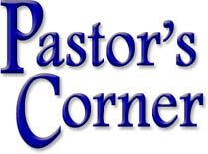

Go and Make Disciples

And Jesus came and said to them, “All authority in heaven and on earth has been given to me. Go therefore and make disciples of all nations…. Matthew 28:18-19

This passage, among the closing words of the Gospel of Matthew, is often called the Great Commission: Jesus gives His disciples, and us the mission of the Church. Before there can ever be a single sacrament celebrated, a church, school or hospital built, before there can be any outreach to the poor and needy, there must be disciples, believers in Christ. Immediately after the waters of baptism are dried from our heads, we are anointed with the sacred chrism to share in Christ’s ministry as priest, prophet and king. As such, we are called to spread the Good News of the salvation of our God.
But what does that mean in practical terms? How can we do this in everyday life? I recently came across a good article by Ava Cilento in Zeale on evangelization etiquette worth sharing.

“We all know that one cradle Catholic friend who only goes to Mass on Christmas and Easter, the Saint Augustines and their Monica mothers, and even the loved ones who have never known Jesus or are completely overwhelmed by religion in general. Their souls, their dignity, and their happiness is on the line, which is why evangelization matters.

In order to evangelize effectively, we must first recognize that God is the one that changes lives, not us. It’s great to be on fire for our faith, but it’s easy to hold on to our pride. This surrender is important because we can’t control someone else. We must remember that Jesus respects everyone’s free will, and He is the one who calls each of us to Himself.

Nobody likes to be preached at or talked down to. To avoid miscommunication, we must listen. This is especially helpful when speaking with someone who’s experienced church hurt. We must remember, Jesus was constantly, emotionally vulnerable. Throughout Scripture, Jesus shows that He cares deeply for others’ personal circumstances and desires. He wants to heal the places where shame, confusion, and destruction sit. We need Jesus to work through us. We are merely His vessels. This is the key to evangelization.”

May the Good Lord through our Blessed Mother richly keep and bless you all, now and always and forever.

Ad Majorem Dei Gloriam…To the Greater Glory of God
Father Kevin

OCIA: Is the Holy Spirit inviting you to more?

INTERESTED IN THE CATHOLIC CHURCH AND FAITH? ALREADY A CATHOLIC ADULT BUT NOT YET CONFIRMED?

Would you like to learn more about the Catholic Church, become Catholic, or if you have already been baptized, would you like to receive the Sacrament of Confirmation? Contact us at the parish office, 570-278-1504!

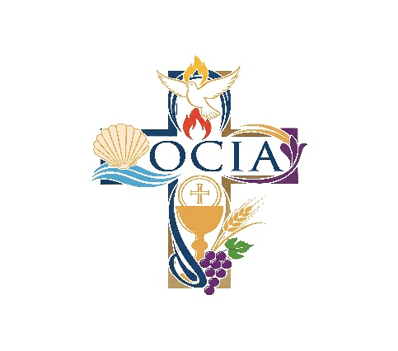
DID YOU KNOW:
Our parish is beginning a Community Rosary on Mondays at 5:15pm in the Chapel! Drop by on your way home from work or dip out before dinner to spend some time with Jesus and pray for your intentions for the week! All are welcome! We will gladly teach you how to pray the Rosary if you need help. Please email Kristin if interested: krisallenmurray@aol.com. Or call the parish office at: 570-278-1504!

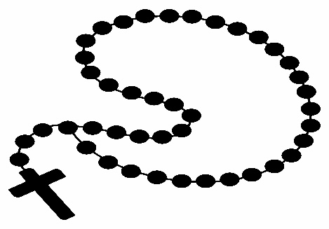

The Kingdom of heaven is like a treasure buried in a field, which a person finds and hides again, and out of joy goes and sells all that he has and buys that field. Matthew 13:44

The 17th Sunday in Ordinary Time Year A focuses on wisdom, God’s plan, and the great value of His kingdom. The readings show how people should seek what truly matters and trust in God’s guidance.

- Seeking Wisdom: Solomon asks God for wisdom instead of riches or power. This shows that true success comes from knowing right from wrong and making good choices.
- God’s Plan for Us: God works in the lives of those who love Him. He calls people, makes them right with Him, and helps them become more like His Son.
- True Treasure: Jesus compares the kingdom of heaven to hidden treasure and a valuable pearl. These stories teach that God’s kingdom is worth more than anything else.
- Sacrifice for What Matters: The people in Jesus’ parables give up everything to gain the treasure or pearl. This reminds believers to let go of what is less important to follow God.
- Judgment and Separation: Jesus tells a story about a fishing net catching all kinds of fish. He warns that in the end, good and bad will be separated.
- Wisdom in Teaching: Jesus says that wise teachers use both old and new lessons. This means faith should be built on past truth while still growing in new understanding.

The 17th Sunday in Ordinary Time Year A teaches that God’s wisdom and kingdom are more valuable than anything else. Those who seek them will find true purpose and lasting joy

Want to help?
PLEASE PRINT NEATLY!
Name:_______________________________________________________________________
Email:________________________________________________________________________
Phone:_______________________________________________________________________

I would like more information about serving in the following ministry:
□ Adult Choir (ages 18 and up)
□ Altar Servers
□ Altar & Rosary Society
□ Bible Study Group
□ Children’s Choir (ages 6-12)
□ Extraordinary Ministers of Holy Communion
□ Grounds Upkeep
□ Handyman
□ Lectors
□ Parish Council
□ Prayer Chain Member
□ Rectory Volunteer (help with answering phones, etc.)
□ Religious Education Program
□ Snow Removal (Sidewalk/Parking lot)
□ Teen Choir and Band (ages 13-18)
□ Ushers & Greeters

Thank you from Holy Name of Mary Church!

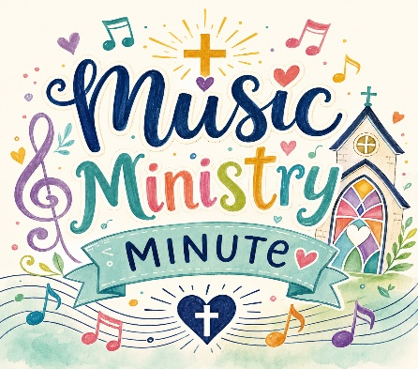

This week’s Responsorial Psalm is long, but its message is clear. God’s word matters. It mattered long ago, and it still matters now. In a world with many voices and opinions, this psalm reminds us to listen to God first. It helps us slow down and remember what is true and good.

Many people today feel lost or confused. The psalmist felt that way too. He prayed for help and asked God to guide him. That makes this psalm a good prayer for us now. We can use the same words to ask God for strength, hope, and direction.

Here’s a modern-day version of the Psalm that you might want to use to pray this week!

Teach Me Your Way, Lord
God, help me listen to your voice
when life is loud and busy.
There are so many choices every day.
Show me what is right and true.

Sometimes I feel lost or unsure.
Friends, school, and the world pull me in many ways.
I want to follow you,
but I need your help to stay strong.

Your word is a light when I feel stuck.
It reminds me that I am never alone.
Even when I mess up,
you are there to guide me back.

Teach me to be kind and honest.
Help me make good choices.
Let your words shape the way I live,
at home, at school, and with my friends.

Thank you for always walking with me.
Give me the courage to keep going.
Help me love your word
and carry it in my heart every day.

