Seventeenth Sunday in Ordinary Time Sunday, July 26th, 2026

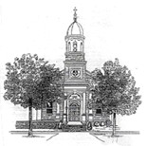 | Holy Name of Mary Parish
CONTACT US:
278 South Main Street,
Montrose, PA 18801
Phone: 570-278-1504
Fax: 570-278-4751
Website: holynameofmary.com
Email: hnmrectory@gmail.com
Facebook: Coming soon!

PARISH STAFF
Pastor…………………………………………….Father Kevin Miller
Welcome home!
At Holy Name of Mary Parish, we are a family of faith gathered around the Eucharist and the Sacraments. We welcome everyone with open hearts as we grow together in knowing, loving, and serving God. Guided by Christ's love, we strive to care for one another, lend a helping hand, and be a light in our community.

NEW MASS TIMES
Weekday Mass : Monday 12:00pm Holy Name of Mary Montrose
Tuesday 8:30am St. Augustine Church Silver Lake
Wednesday 8:30am St. Augustine Church Silver Lake
Thursday 12:00pm Holy Name of Mary Montrose
Friday 12:00pm St. Francis Xavier Church Friendsville
Saturday 8:30am St. Augustine Church Silver Lake

Weekend Mass: Saturday 4:00pm Holy Name of Mary Montrose
Saturday 6:30pm St. Francis Xavier Friendsville
Sunday 7:30am St. Francis Xavier Friendsville
Sunday 10:30am St. Augustine Silver Lake
Sunday 12:30pm Holy Name of Mary Montrose
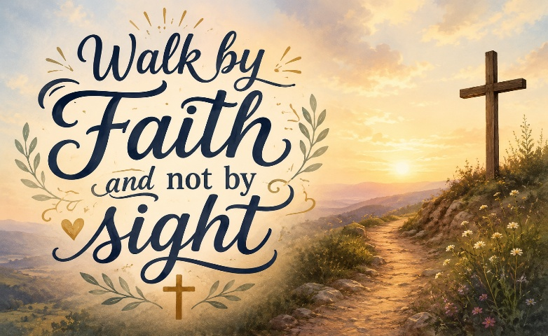
MASS INTENTIONS & REMEMBRANCE

Consider offering a prayer of intercession through the Eucharist with a Mass intention for loved ones who have gone before us by contacting the parish office at 570-278-1504 or by email at: hnmrectory@gmail.com.
MASSES FOR THE WEEK AT HOLY NAME OF MARY CHURCH
Saturday  Sunday | July 25  July 26 | 4:00 PM  12:30 PM | For Emma McKeown – Frank & Rita DeRiancho  For Kathleen Pascoe – Fran & George Calafut
Monday | July 27 | 12:00 PM | For Eleanor Kurosky – Cheryl Kurosky
Tuesday  Wednesday  Thursday  Friday | July 28 July 29  July 30  July 31 | No Mass  No Mass  12:00 PM  No Mass | For All Souls in Purgatory
Saturday  Sunday | Aug 1  Aug 2 | 4:00 PM  12:30 PM | Kathleen Conklin – Rita & Frank DeRiancho  Kathleen Pascoe – Rita & Frank DeRiancho

the sacrament of  ANOINTING OF THE SICK  Please call the parish office if one of your family members is in the hospital or nursing home and would like to receive the Sacrament of the Anointing of the Sick. | 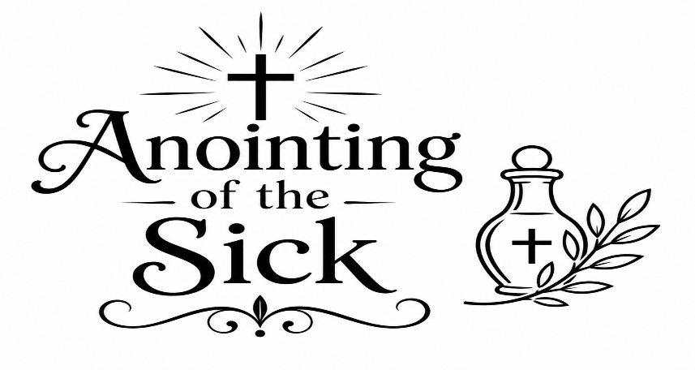

 | If you would like to have a prayer intention listed in the bulletin, please contact the parish office. We are here for you.  Members of the Holy Name of Mary Prayer Chain are also available to pray for you or your loved ones. Please call Maureen Van Nostrand at: 570-498-0760.

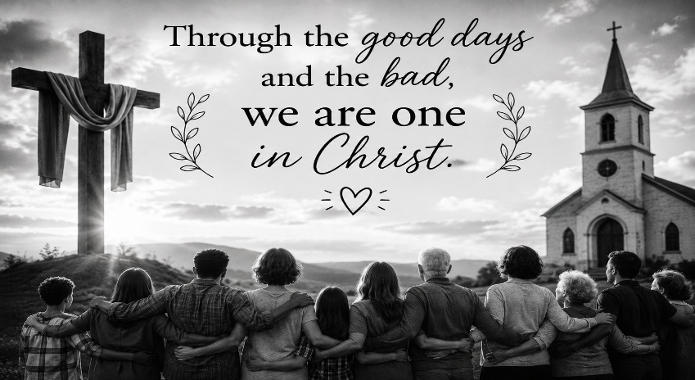

In This Family, We Mourn and We Rejoice Together:
(Please let us know if you would like anyone listed here)

WELCOME THE NEWLY BAPTIZED INTO OUR FAITH COMMUNITY
(Baptism on 9.12.2026) Aiden Garcia Diaz

PLEASE PRAY FOR THESE RECENTLY MARRIED COUPLES
Caitlin & Christopher Jordan
Rachel & Taylan Unal

CONGRATULATE THOSE CELBRATING A SIGNIFICANT ANNIVERSARY
Roberta & Ron Hess

HAPPY BIRTHDAY
Scout Murray

PLEASE PRAY FOR ALL THOSE WHO ARE SICK
Betsy Arnold & family, Anne Belles, Jerry Blodgett, Ralph Blodgett, Brad Booker, Ellen Booker, Brad Bozzo, Katie Calvin, JoAnne Catlin, Becky Cole, Aiden Conklin, James Conklin, Odessa Cornell, Carmen Cruz, Wilma Daniels, Mary Ann DeWitt, Philip Donahue, Larry Ferris, Mary Ferris, Harvey Fletcher, Geraldine Flynn, Phyllis Fritz, Brandy Golden, William Hector, Gerard Heiser, Jane Heiser, Billie Jackson, Kevin Jenner, Susan Jennings, Timothy Jones, Bill Kozerski, Josh Landis, Shawn McGraw, Walter Miller, Alexis Mock, Christian Mondi, Luis Muloski, Denelle Myers, Gerry Nashacky, Russel Nowalk, Mike Rayias, Kimberly Richey, Luke Richey, Bob Roccia, Debbie Rossi, Rob Rossi, Jack Rozanski, Sandra Seeger, Dorothy Sergent, Jaqueline Shedden, Pauline Sheehan, Kathleen Sitkowski, Delores Slatter, Fran Tometchko, Florence Trowbridge, Rosemarie Whalen, Gerry Washack.

REMEMBER THOSE WHO HAVE RECENTLY PASSED
Doris Carnese
Matthew Fischer
Teresa Schumann
Nicole Stankavage
Joanne Luecke

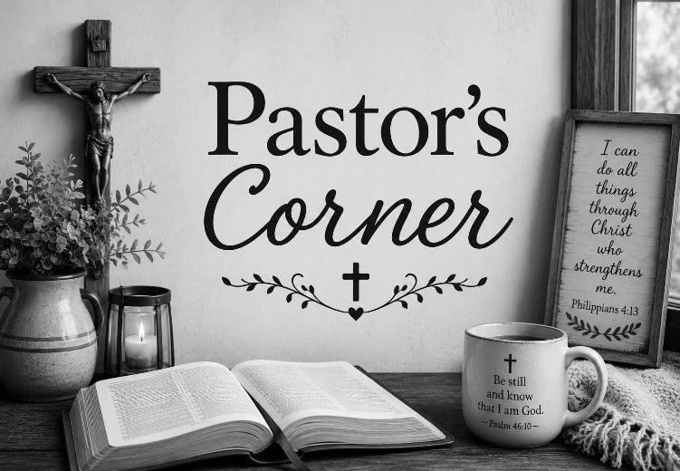
“Go and Make Disciples”

And Jesus came and said to them, “All authority in heaven and on earth has been given to me. Go therefore and make disciples of all nations…. Matthew 28:18-19

This passage, among the closing words of the Gospel of Matthew, is often called the Great Commission: Jesus gives His disciples, and us the mission of the Church. Before there can ever be a single sacrament celebrated, a church, school or hospital built, before there can be any outreach to the poor and needy, there must be disciples, believers in Christ. Immediately after the waters of baptism are dried from our heads, we are anointed with the sacred chrism to share in Christ’s ministry as priest, prophet and king. As such, we are called to spread the Good News of the salvation of our God.

But what does that mean in practical terms? How can we do this in everyday life? I recently came across a good article by Ava Cilento in Zeale on evangelization etiquette worth sharing.
“We all know that one cradle Catholic friend who only goes to Mass on Christmas and Easter, the Saint Augustines and their Monica mothers, and even the loved ones who have never known Jesus or are completely overwhelmed by religion in general. Their souls, their dignity, and their happiness is on the line, which is why evangelization matters.

In order to evangelize effectively, we must first recognize that God is the one that changes lives, not us. It’s great to be on fire for our faith, but it’s easy to hold on to our pride. This surrender is important because we can’t control someone else. We must remember that Jesus respects everyone’s free will, and He is the one who calls each of us to Himself.

Nobody likes to be preached at or talked down to. To avoid miscommunication, we must listen. This is especially helpful when speaking with someone who’s experienced church hurt. We must remember, Jesus was constantly, emotionally vulnerable. Throughout Scripture, Jesus shows that He cares deeply for others’ personal circumstances and desires. He wants to heal the places where shame, confusion, and destruction sit. We need Jesus to work through us. We are merely His vessels. This is the key to evangelization.”

May the Good Lord through our Blessed Mother richly keep and bless you all, now and always and forever.

Ad Majorem Dei Gloriam…To the Greater Glory of God
Father Kevin
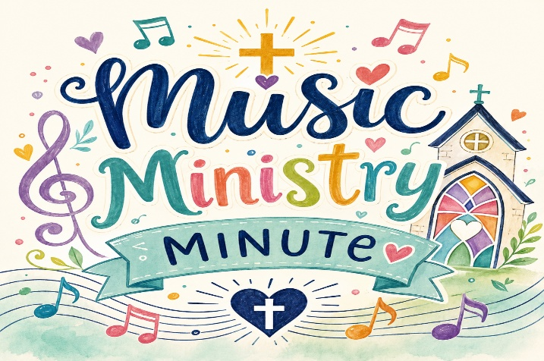
Today’s Responsorial Psalm:
“Lord, I love your commands.”

Did you know that Psalm 119 is the longest psalm in the Bible? It’s a beautiful love song to God’s Word and should remind us that when we stay close to our Father and listen to His voice, we discover the path that leads to life.

We all know that life can be hard! There are joys, struggles, fears and tears, great and small things that happen every day. Today’s Psalm asks us to gently treasure our Father’s Word. Why? Because it will always guide us, strengthen us, and lead us closer to Him. He delights in you! As a small child yells out to a parent, “Do it again!” when they are having fun, our Father asks us to visit Him daily. Do not forget that he watches our lives with love and tenderness. When we cry, He cries. When we laugh, he asks, “Do it again!”

Here’s a more modern translation of Psalm 119 – pray it every day and see if you can hear God’s voice!

A Prayer for Guidance
Lord, help me hear Your voice
when life is busy and full of distractions.
Show me what is good and true,
and give me the courage to follow You.

When I feel unsure or make mistakes,
remind me that You are always with me.
Let Your Word be the light that guides my steps
and fills my heart with peace.

Teach me to be kind,
honest,
and loving in all I do—
at home,
at school,
and with my friends.

Thank You for Your love
and for always leading me closer to You.
May I carry Your Word in my heart every day.
Amen.

Want to help?
PLEASE PRINT NEATLY!
Name:_______________________________________________________________________
Email:________________________________________________________________________
Phone:_______________________________________________________________________

I would like more information about serving in the following ministry:
□ Adult Choir (ages 18 and up)
□ Altar Servers
□ Altar & Rosary Society
□ Bible Study Group
□ Children’s Choir (ages 6-12)
□ Extraordinary Ministers of Holy Communion
□ Grounds Upkeep
□ Handyman
□ Lectors
□ Parish Council
□ Prayer Chain Member
□ Rectory Volunteer (help with answering phones, etc.)
□ Religious Education Program
□ Snow Removal (Sidewalk/Parking lot)
□ Teen Choir and Band (ages 13-18)
□ Ushers & Greeters

Thank you from Holy Name of Mary Church!
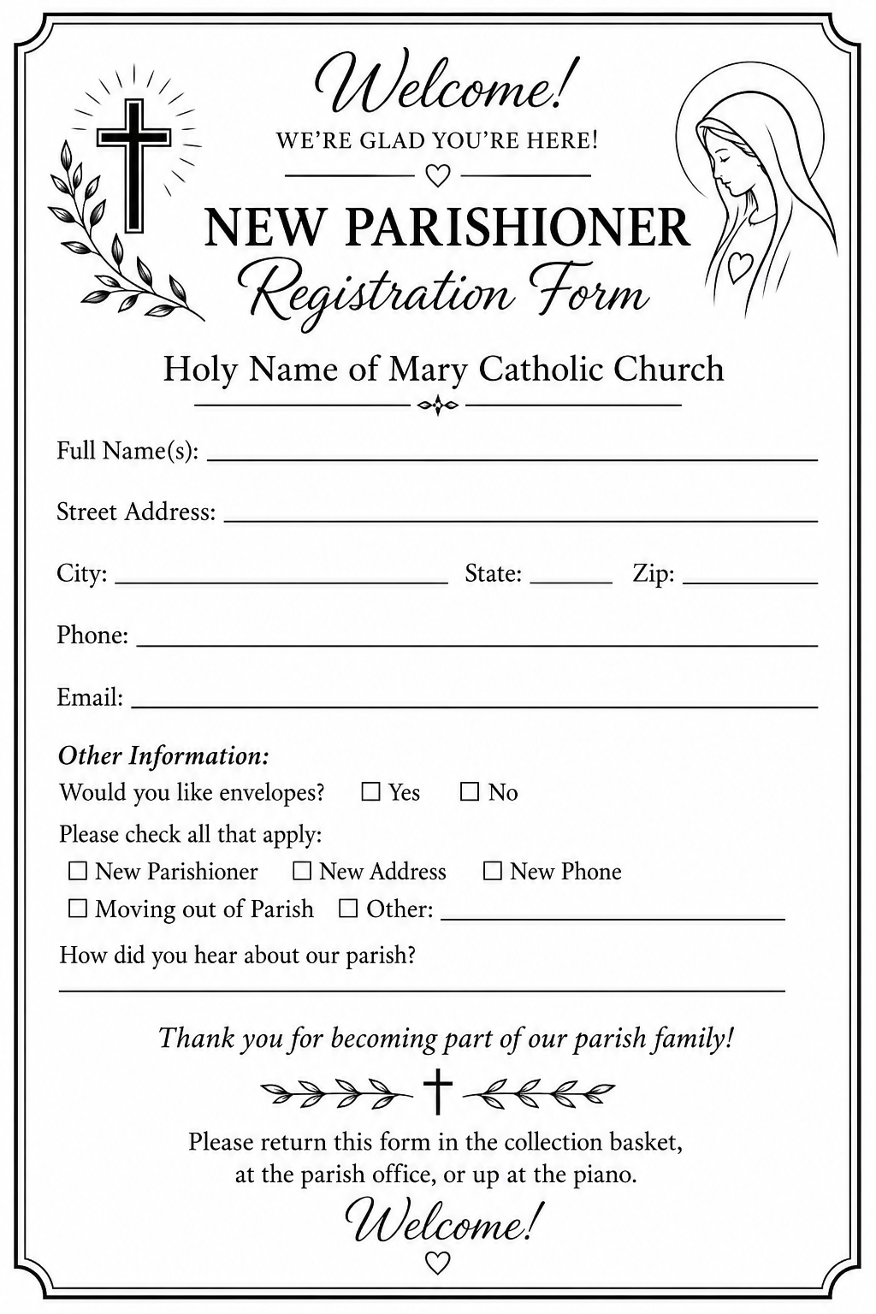
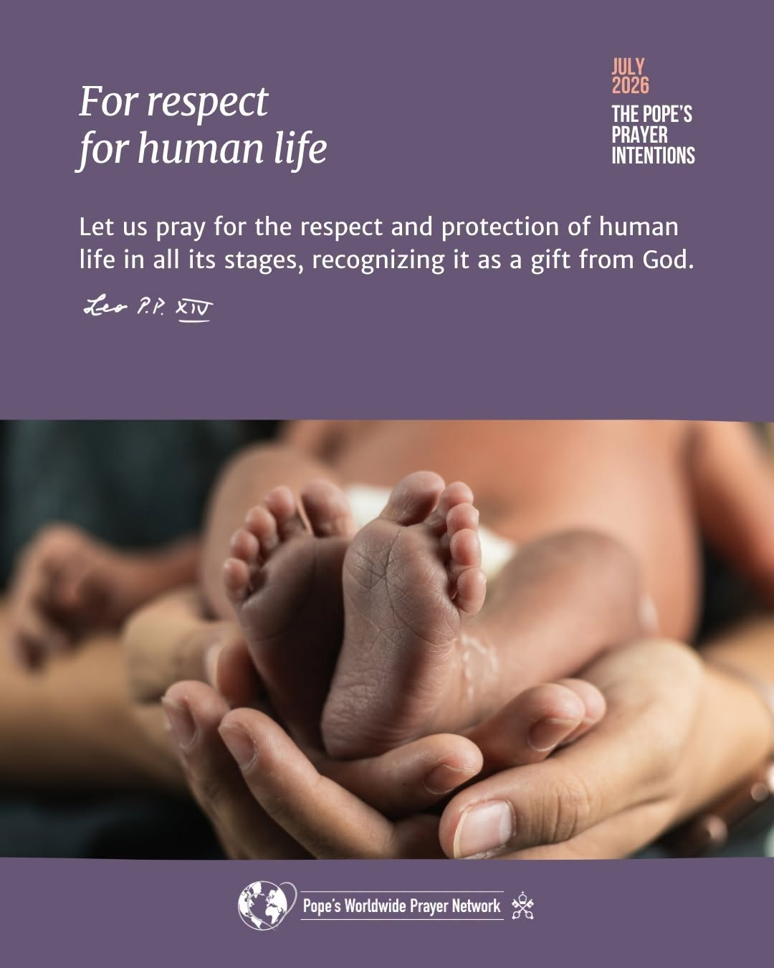
Treasure Hunt Game for Families!
Materials
- Chocolate coins or small treats
- Safe indoor or outdoor hunt area
- Optional: paper and pen for clues
Set Up
- Choose a safe area
- Hide the coins before children arrive
- Use easy hiding spots for younger children
- Use harder spots or written clues for older children
- Clearly explain where children may search
How to Play
- Gather children and explain the hunt
- Hand out clues, if using them
- Let children search for the treasure
- Stop when all coins are found or time is up.
- Celebrate everyone’s efforts.
Ideas & Variations
- Bible Hunt: Attach Bible verses to coins
- Friendly Competition: Offer a small prize for finding the most coins.

Help Our Sanctuary Bloom!  One of the simplest ways to honor God is by helping make His house a place of beauty. We invite you to consider donating flowers for our altar and sanctuary to enhance our Masses.  Flowers may be given in memory of a loved one, in in thanksgiving, or for any prayer intention close to your heart. Whether it's to celebrate a birthday, anniversary, a special blessing, or simply as an act of love for the Lord, your gift will help create a welcoming and prayerful atmosphere for our parish family.  If you would like to sponsor flowers, please contact the parish office. We would be happy to help you choose a date and include your dedication. Thank you for sharing your generosity and helping to keep Holy Name of Mary beautiful for all who come to worship! | 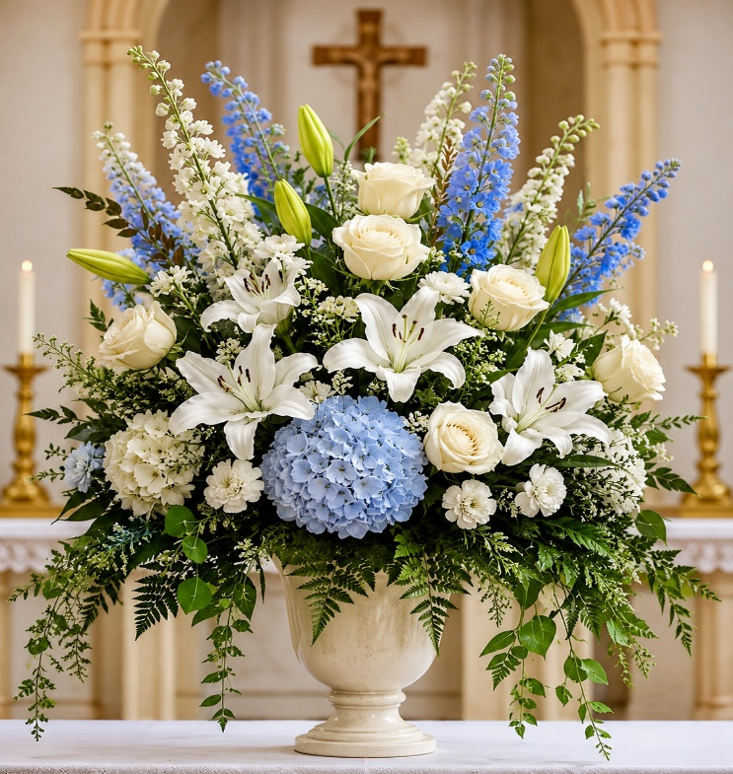

PLEASE NOTE, Fr. Philip’s new Parish:
Rev. Philip Rayappan
Holy Child Catholic Church
237 S Main St, Mansfield, PA 16933
Phone: (570) 662-3568

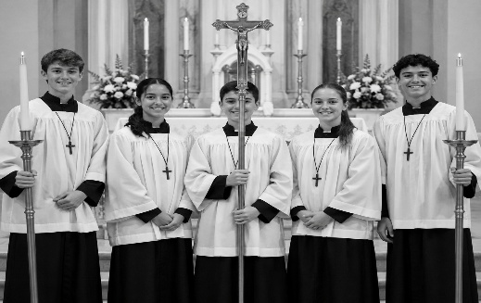
ALTAR SERVER SCHEDULE
Sunday, July 26 – 12:30 PM Albert Paolucci
Sunday, Aug 2 – 12:30 PM Stanely Grochal
Sunday, Aug 9 – 12:30 PM Bernadetta Paolucci
Become an Altar Server! Call the Parish Office!

RELIGIOUS EDUCATION NEWS
. If you are new to the parish and would like to register your child for the 2026-2027 Religious Education year, forms are available at the rectory. Also you can find a registration form on the Holy Name of Mary Church website on the pull down menu under Religious Education.,
Have a great summer!
Thank you to those parents who support their children in their Faith Formation. If you have any questions or concerns, please call Fran Calafut at (570) 396-5879.

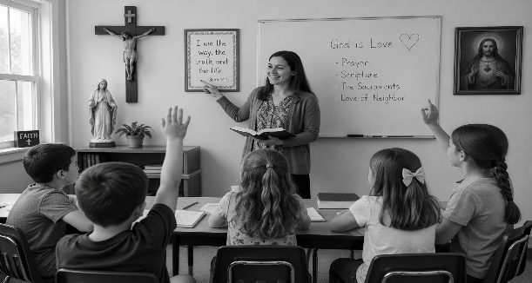
The Angelus Prayer (English)
V. The Angel of the Lord declared unto Mary.
R. And she conceived of the Holy Spirit.
Hail Mary, full of grace……
V. Behold the handmaid of the Lord.
R. Be it done unto me according to thy word.
Hail Mary, full of grace……
V. And the Word was made flesh.
R. And dwelt among us.
Hail Mary, full of grace……
V. Pray for us, O holy Mother of God.
R. That we may be made worthy of the promises of Christ.
Let us pray: Pour forth, we beseech Thee, O Lord, Thy grace into our hearts, that we to whom the Incarnation of Christ Thy Son was made known by the message of an angel, may by His Passion and Cross be brought to the glory of His Resurrection. Through the same Christ Our Lord. Amen.

Let us pray for those who proudly serve or served in the military: Floyd Beamer, Thomas Butler, Daniel Daly, Christopher Jordan, James Kane, John Murray, Mark Nowalk, Michael Pelicci, David Place, Nate Seymour, Julie Snyder, Travis Walter.



