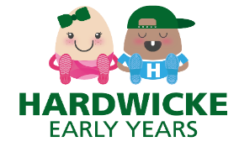
October Newsletter

Dear Parents/Carers,
Firstly, we would like to say how pleased we are with how well the children have all settled. We are seeing some lovely friendships forming and all the children are happily exploring the activities available to them.
A polite reminder that we are a settling that promotes healthy eating and drinking we would like to ask that you send you child in with only Water in their bottles. Can we also remind you not to send your child in with any nut-based products in their lunch boxes due to allergies. Please can we also remind you to cut up grapes, blueberries, sausages etc as these can be a choking hazard.
Dates for your diaries
We break up for half term on Thursday 23rd October, and we return on Tuesday 4th November.
AGM – Our AGM will be held on Tuesday 21st October, 7:30pm at The Barn Owl Pub in Kingsway. Please come along and support your setting. You will be able to meet the committee and share ideas for raising funds for the setting.
We will also be starting to design Christmas cards that you will also be able to order. (More information to follow).
General Information
Our topic for October is Autumn. We have been investigating the world around us and exploring changing colours. We will be counting conkers, leaf printing and tasting harvest foods. If you are out on walks and find any natural objects that you would like to bring in for the children to look at/ collage with, that would be great. We have also started planting flowers and some vegetables. This will help the children learn what plants need to grow healthy and how we can look after them. Once our vegetables have grown, we will be trying them at snack times.
The colder days are upon us therefore can we please ask that the children have some extra layers and coats for outside play, clearly labelled with their names in thank you.
Immunisations- We would also like to remind you that our policies state that children should remain at home for 24 hours after having an immunisation’s, including the flu nasal spray. This is so you can keep an eye on your child for any reactions and to make sure that they are well enough to come into the setting after the 24 hours.
We are also trying to think outside of the box for fundraising ideas, so you have any ideas please speak to a member of staff.

Thank you for all your continued support,
Nicki, Georgina, Sarah, Colleen, Hannah and Claire.

