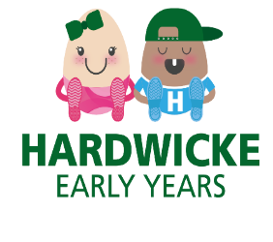
February Newsletter

Dear Parent/Carers,
We are looking forward to taking part in the Big School Bird Watch starting on 2nd February. The children will be having fun making their bird feeders and we are looking forward to hearing about how they made their binoculars! We will also be going on bird watch walks around the school grounds, looking for birds in the trees.

Chinese New Year.

We will be celebrating Chinese New Year; we will turn the home corner into a Chinese restaurant and the children have the opportunity to use our Chinese plates and bowls. The children will also be able to dress up in traditional Chinese clothes. At snack time the children will enjoy trying some noodles and prawn crackers along with their fruit.

Fundraising.

We are looking for fundraising ideas, so if there is something you would like us to consider, please email Nicki on hardwickeplaygroup@eygloucestershire.co.uk

We would like to thank you for your continued support, if you have any questions or suggestions, we value your opinions so please feel free to come and speak to a member of staff.

Many Thanks
Nicki, Georgina, Sarah, Colleen, Hannah and Claire

Dates for your Diaries
Bird watch week – 2nd February 2026.
Our last day before half term is Friday 13th February 2026.
Half term 16th -20th February 2026.
Monday 23rd February 2026 – Inset day.
Tuesday 24th February 2026 – First day back after half term

