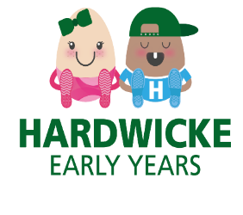

February Newsletter

Dear Parent/Carers,

We are looking forward to taking part in the Big School Bird Watch starting on 10th February. The children will be having fun making their bird feeders and we are looking forward to hearing about how they made their binoculars! We will also be going on bird watch walks around the school grounds, looking for birds in the trees.

Just for information, that the alley way by the school is currently closed off. If you need to collect a child from school after collecting a child from us, you will need to walk around the houses to get to the other school entrance gate.

Chinese New Year.

We have been celebrating Chinese New Year; we have turned the home corner into a Chinese restaurant and the children have enjoyed using our Chinese plates and bowls. The children have also enjoyed dressing up in traditional Chinese clothes. At snack time the children have enjoyed trying some noodles and prawn crackers along with their fruit. We are so proud of the children for trying something new.

Fundraising.

We are looking for fundraising ideas, so if there is something you would like us to consider, please speak to Nicki or email Nicki on [hardwickeplaygroup@eygloucestershire.co.uk](mailto:hardwickeplaygroup@eygloucestershire.co.uk)

We would like to thank you for your continued support, if you have any questions or suggestions, we value your opinions so please feel free to come and speak to a member of staff.

Many Thanks

Nicki, Georgina, Sarah, Colleen, Hannah and Natalie

*Dates for your Diaries*

Bird watch week – 10th February 2025.

Our last day before half term is Friday 14th February 2025.

Half term 17th -21st February 2025.

Monday 24th February 2025 – First day back after half term.