Text | Imagery | Production Notes
In the posterior section of the brain’s parietal lobes (under the rear portion of the top of the skull) are two patches of cortex called “the orientation association areas.” |  | Talking Head
The patch in the left hemisphere appears to contribute to the mental sensation of having a limited and physically defined body—it helps you keep track of your edges. The corresponding area in the right hemisphere maintains a map of the space around you. | 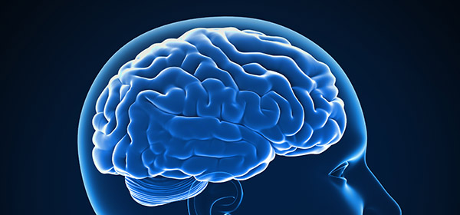 | Track through brain imagery, high-light this area of the brain
These two areas receive input from your senses to help them maintain an ongoing representation of your self and its location in space. |  | Human body in a room, surrounded by things
If this area is damaged in a stroke, then that person has trouble sensing where they end and the floor, the couch, the objects around them begin. |  | Old person foot tapping to look for the floor
The neuroscientist Andrew Newberg studied the brains of people undergoing mystical experiences-- moments when the self is turned off and a person feels merged with the entirety of the universe…with God. | 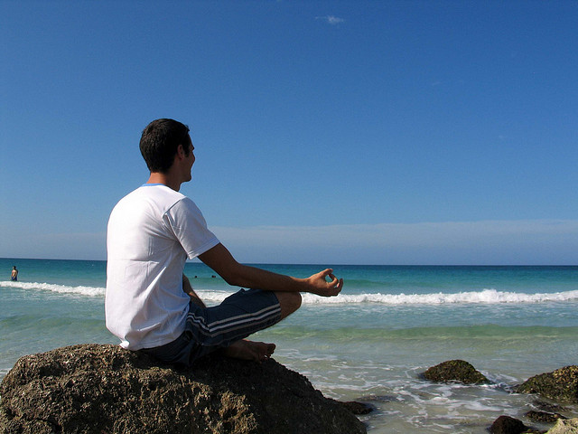 | Zoom into person meditating. When shot reaches the person, flash of light and track through images of out to space
At the very moment when they would report entering this state, these two areas of the brain appear to turn off. | 
They experience a loss of self, combined with a paradoxical expansion of the self out into space, yet with no fixed location in the normal world of three dimensions. The person feels merged with something vast, something larger than the self. Something… mystical. |  | Talking head
There appear to be some ways to override the orientation association areas and essentially turn that part of the brain off on purpose. In fact, many religious practices and rituals seem to be designed to set up “resonance patterns” in the brain to make it more likely. | 
Meditation, chanting, repetitive movements, drumming—especially when done in community—can lead to transcendent experiences, alternative states of consciousness, merging with the entirely of the universe…with god. | 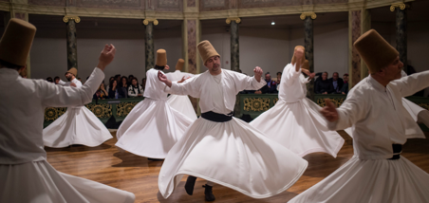
Three activities come to mind that are good for the body, good for the mind, and good for the soul, which advanced practitioners seem to encourage their students to imaginatively sense yourself beyond the body’s hard edges—beyond the limits set by the orientation association areas of the brain: dancing, yoga, and grounding. |  | Talking head
Dance teachers implore their students to imagine their feet pushing down, extending through the floor. |  | Dancer feet, line through the floor
Good technique is not just raising your arms, lines stopping at your fingertips | 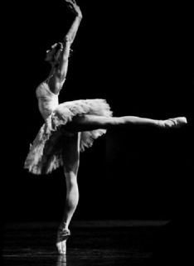 | Dancer lines, maybe lighting makes it look like the dancer is lit up, but darkness at fingertips
…but emanating energy outward in full extension, the beauty of the line defined by its extension beyond the self, into the ether. | 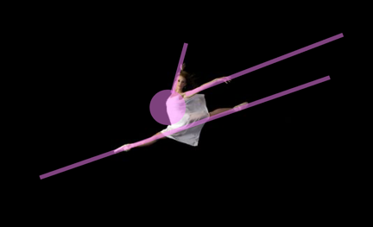 | Dancer in motion, light emanating from heart center, out of fingertips and toes
In yoga, each asana more than a position but a multidimensional expression of lines beyond the physical definitions. We’re encouraged to imagine the lines we are creating, deep into the earth, up out of the head, outward in each direction. | 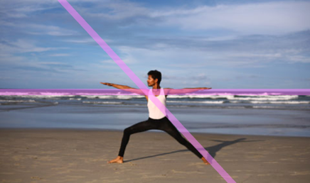 | Asanas like Warrior II, Half Moon, lines/light across the body, entending to show the X/shape that is created
Tree pose is deeply grounded through your roots, your branches outstretched into the sky. Reaching and stretching beyond dimension. | 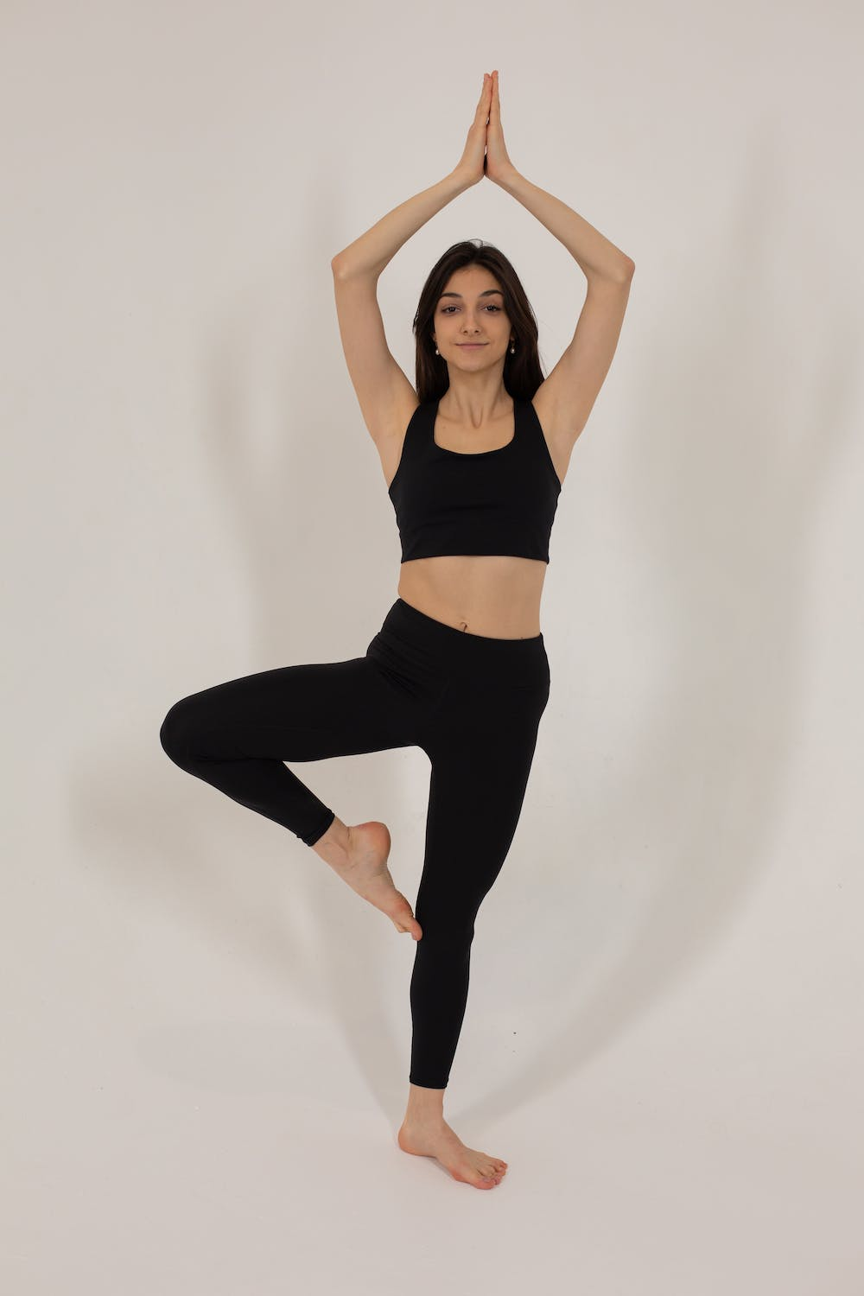 | Tree pose in motion, light blooms beyond hands out the top
Grounding—taking your shoes off and touching the earth—is good for the body, good for the mind. | 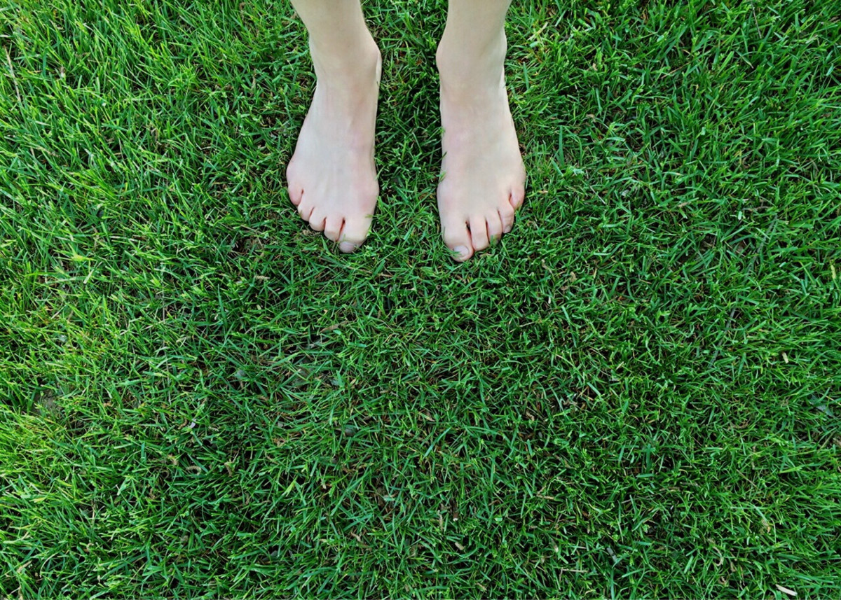 | Bare feet in grass
This type of grounding is sometimes referred to as “earthing” because the term “grounding” has been used as a broader mental health technique of drawing one’s attention out of the monkey brain and into sensate experience. Also great, and wonderful that it can be done anytime, anywhere, I want to focus on earthing—kind-of a sub-category of Grounding (all earthing is grounding, not all grounding is earthing)-- because of a key difference in how I’ve heard it taught. |  | Talking head
First, I recognize you may not be familiar with grounding or how it has physical and psychological benefits. This area of science is fairly new and still under-researched, so I’ll share a glimpse into the latest in what we understand about it, but consider this a starting point.
The human body is conductive, like metal or a ground rod. When it touches the earth, the body exchanges electrons and equalizes with the earth. These electrons are thought to be used by the body | 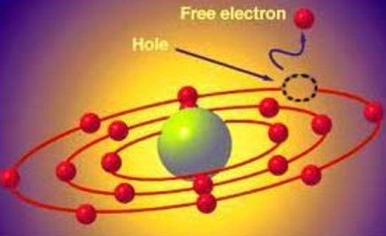 | Zoom in or overlay of atoms exchanging elections
to help improve function and reduce inflammation, leading to all kinds of health benefits, including reducing chronic pain, chronic fatigue, anxiety, depression, sleep disorders, and reducing blood pressure in individuals with hypertension, a precursor to cardiovascular disease (America’s #1 leading cause of death). |  | Talking head, text overlay
In short—take off your shoes. Touch the grass. Feel the dirt. It’s good for you. | 
Like dancing or yoga, you can just *do the thing* and you’re going to get benefits from it. But also like dancing and yoga, advanced practitioners seem to teach their students that to do it well, to do it…beautifully… engage your mind in extending sensory experience beyond the physical borders of your skin. |  | Back to dancer and/or yoga in motion
Ground yourself deep into the earth. Send pent up energy, negative emotions, and cleansing breaths down into the earth. You are not a contained self, but in energetic exchange with the trees, the earth, and the world of which you are a part. Through that feel peace. Through that, feel god. |  | Person breathing, pushing hands downward with exhalation
In dance, in yoga, through grounding… we imagine ourselves beyond our edges but an outpouring of the self into space. Experiencing yourself as vast, filling the space around you, removing the limitation of the physically defined body, sensing something bigger than yourself, and reaching out to the mystical.
Sometimes, we turn the orientation association areas of the brain off. And sometimes we simply quiet their demands as we extend ourselves beyond their limits.

