Text | Image | Production Notes
When I was a kid I loved Magic Eye posters. Have you seen these? |  | Talking head
They are pictures that look like a bunch of dots and waves and colors and spaces, but nothing discernable, or recognizable as a picture. Looking across the image, the tiny repeating multiplicity takes on a oneness—a single, tangible page. One beautiful, undulating composition. But if you refocus your eyes, an image will suddenly appear before you. A whale swimming under |  | Magic Eye book/posters
A sailboat
Words: I love you
When I was in third grade I had a magic eye book. I remember sitting on the bus and turning through the pages just as fast as I could see each image. |  | Kid on bus with the book
A tree, A heartm birds |  | Show turning pages, delay before image "pops out"
It was a challenge to keep my eyes in focus so that I could see beyond the oneness, and find the concrete, discernable, nameable image before me. And when I was really good, I would forget the oneness was even there, and the images became all I could see. |  | Show turning each page and the images popped out already
A dolphin is different from a tree. A sailboat is not birds. But each of these images emerge in front of me out of the one-ness. It’s simply a matter of focus. Magic, that Magic Eye.
All matter is made up of atoms. You’ll remember from middle school science that atoms have a nucleus and are surrounded by electrons. There’s space between the nucleus and electrons. There’s space between atoms. And when they collide, they don’t actually collide, but we experience the sound and sense produced by the movement of energy. When I hit my hand on the table, the atoms of my hand do not touch the atoms of the table. The feeling and sound result from the vibration of energy between them.  In the Yoga Sutras it says, “Scientifically, we can say that when manifested objects are reduced to their unmanifested condition, they go back to the atomic vibration.” P.42  My eyes aren’t able to see this happening. My level of focus and vision only allow me to see my hand and the table. But I know that if I could zoom in and watch at the atomic level, that’s what I would see—the dots, the space between, the energy, the undulation of hydrogen, oxygen, and carbon. If I zoom in close enough, I might not be able to tell the difference between my hand and the table. Pan across the table, find you sitting at the table, and it all starts to blur into a single expanse—a beautiful organized arrangement of dots and waves, colors and spaces, held together by a singular likeness, a shared composition of atoms and energy. | 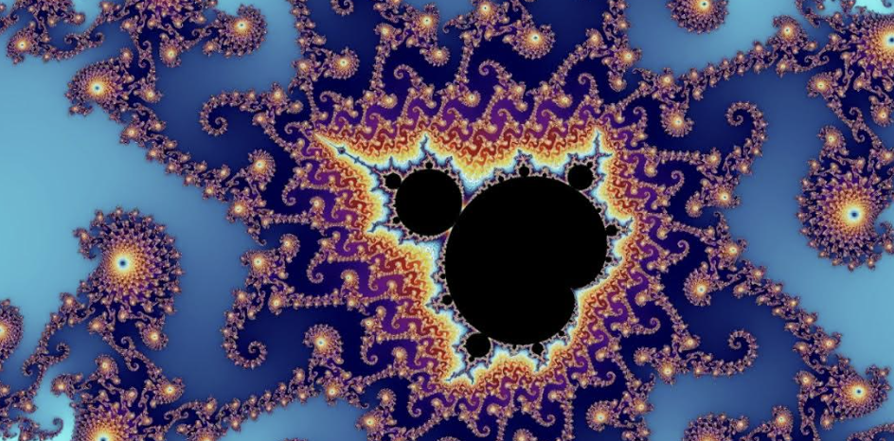 | Maybe zoom in on the girl, switch to atomic level, like a sea of atoms. Zoom back out to show girl and everything around her with same colors as the atoms dotted across whole screen--an animated image like a moving magic eye. A hand of atoms hits a table of atoms. It would be cool if one of the fades between real-life and retro poster were across a Mandelbrot set.
Through the shared intelligence and energy between, We have collectively created meaning, difference, separateness, and individual out of the collective. We agree together that one configuration means table, and We make meaning from its usage. It is a surface on which we set other groupings of atoms. It is a place to find sustenance. It is where I find you and a sense of family and belonging. Like a dolphin jumping off the page, I find my self, my identity, my meaning at the table, because I have the ability to refocus and see that I have jumped off the page. We have made it so. |  | She sets the book on the table
Looking at my Magic Eye, it’s easy to bounce back and forth. I simply choose to refocus.
Retro color poster, Image, poster, image. |  | poster, popped image
But in life, it’s difficult to un-focus on our selves to remember the poster. We forget the oneness is there. It is a meditative practice to fade into the poster. But when we connect with it? Magic. |  | Would love this to be a person sitting still amongst a crowd bustling all around them. Then the whole thing fades into retro color poster
I was pregnant once. Magic. We lured that precious individual out of the collective. The atoms of a sperm met up with the atoms of my egg and together they danced in a swirl of energy, reconfiguring atoms and cells step by step, split by split, seemingly drawing something out of nothing. Like the spinning energy that threads and collects and grows in a dance of sugar and heat to make the sweetest cotton candy. |  | Cells spinning, dividng, dancing… turns poster
I had the amazing honor of being her vessel--providing energy, sustenance, safety and love—as she emerged within and eventually from me. That precious, nameable individual before me. The sweetest cotton candy. |  | turns popped image of mom and baby…fades to real mom and baby
Slowly, over time, she learns to focus. She learns to separate self, identity, and meaning from the oneness. At first she cannot see beyond herself. Her eyes take focus at the distance of face-to-face. She sees me and finds she. She learns who she is, and how to climb on, hide under, and sit at the table. And soon, she’ll forget the oneness is there. The images become all she can see. And they allow her to see. To feel. To dance and twirl and experience the world around her. To be herself. To touch others. To find meaning. Magic. |  | Blurred edges look at Mom's face. Montage kid growing, climbing on (9mo), playing under (3yrs), sitting at (kid) table. Holding hands across the table.
It is my job to help her learn who she is. To provide energy, sustenance, safety and love. And to help her remember and know the oneness. It is my job to teach her how to focus. That she is because We are. To show her that the multiplicity emerges from oneness—one beautiful, undulating composition—so she can feel greater appreciation and beauty in the world around her. It is because We made it so. |  | Mom and daughter in nature or meditating, fade into retro color poster
A landscape. A dolphin jumping out of water. A sailboat. Family. Belonging. Sense of self. The words: I love you.  Meaning.  Magic I. |  | Finish with a family as popped image, into real family.

