OCTOBER 2025

CONNECTIONS

Called and gifted to reflect Christ as we love, serve, and teach.

Monthly by
St. John Lutheran Church
336 W. Market Street
P.O. Box 311
Canal Fulton, OH 44614
Church Phone: 330-854-2159

E-Mail: stjohnlutherancanalfulton@gmail.com
Website: www.loveserveteach.org

Adult Sunday School
9:15 P.M.

Sunday Worship: 10:45 A.M.
SALT Box Ministries
408 West Market Street
Canal Fulton OH
E-Mail: saltboxcanalfulton@gmail.com
Free Meal & Pantry Distributions

Second & Last Sunday of Each Month
4:00 - 5:30 P.M.

FROM THE DESK OF PASTOR LISA ARLEDGE:
"Your kingdom come, Your will be done, on earth as it is in heaven" Matthew 6:10
“Your will be done” is the way we admit that human ways get in the way of God’s ways. How do we know? Well, simply look at the history of the world to see how human beings have been doing so far. Humans have hurt each other and killed each other. This part of the prayer is so ultimately huge that the line once spoken, should change everything, but it doesn’t seem to be working. Why aren’t things any better?
When we pray “Your kingdom come,” we are praying that God’s ways come into our bodies and replace our hateful parts with love. We also pray for God’s kingdom to come into our families, our churches, and even our Pentagon, the United Nations, and our whole world. Jesus says to pray this so we can bring God’s ways on to our planet. Bring God on to make our world more like God – more like love, more like compassion, more like getting through to the other side of every argument.
When we pray “Your kingdom come,” we are asking God to enter all the alarming things that happen to us. “Your kingdom come” is asking God to disrupt our systems of control, our patterns of behavior, and our stinking thinking that really need to stop.
“Your kingdom come” means our unhealthy coping mechanisms are out -- and God’s healthy coping mechanisms are in. What are God’s coping mechanisms? That’s what we are here to learn together. Every Sunday worship and Sunday school, and bible study and prayer time teach us another way that is God’s way. Together we are learning to pray the Lord’s prayer, not just repeat it. Why? Because our world needs God’s kingdom to come and God’s ways to start with you and me and this church now.
Let us pray: We ask for the Holy Spirit to get involved with us to help us understand that God’s ways can replace our dysfunctional ways. Jesus asks us to pray for God’s kingdom to come. And Lord, we ask that the God’s-way-not-my-way door that has been locked for whatever reason be opened to us today. Amen.
With love from your Pastor Lisa
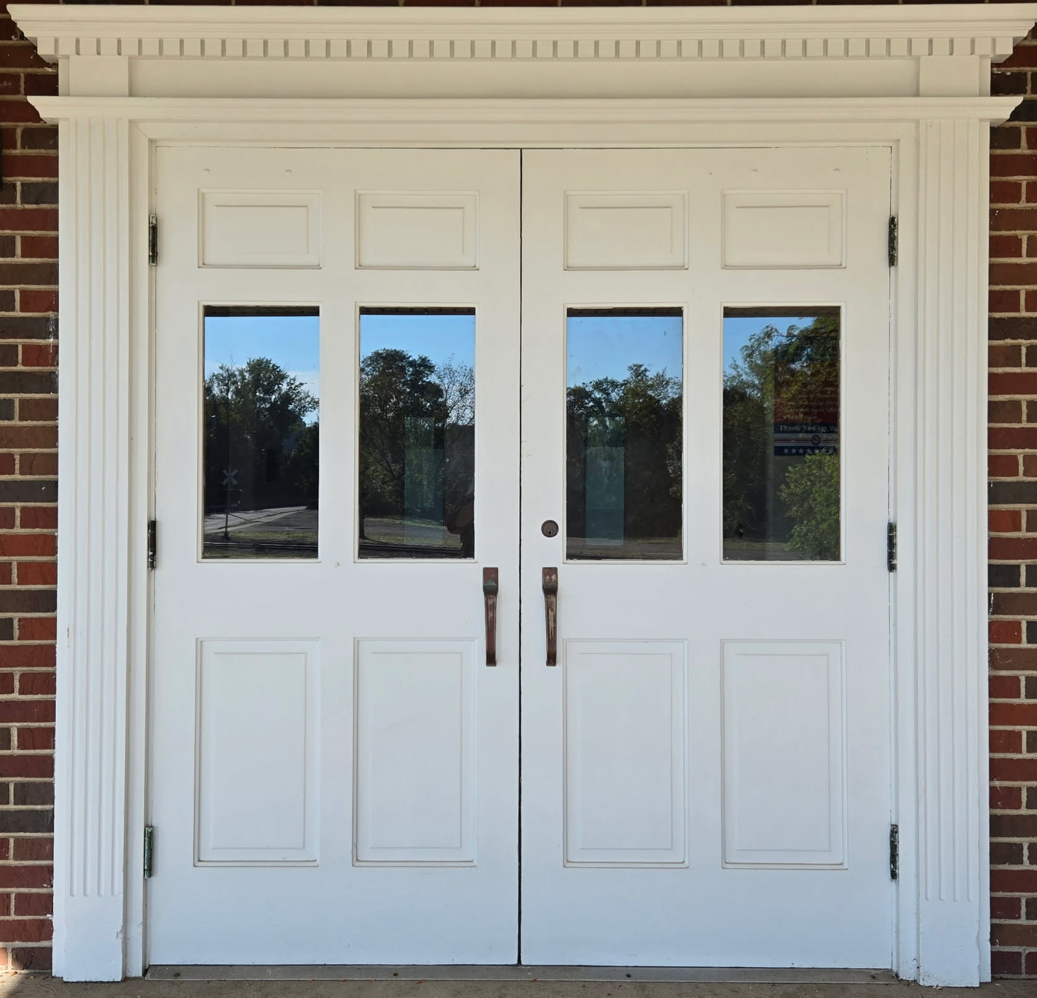
OUR WEBSITE
Our St. John Lutheran Church website is found at loveserveteach.org or by searching for St. John Lutheran Church in your Google or Chrome search engine and selecting Website.
Pastor Lisa writes a weekly blog called Love Writes. The blog is found as you scroll down to Reflections from Pastor Lisa. To see some recent exciting pictures from the life of our congregation, open the website and go to More in the upper menu and select Newsletter/Activities. By selecting Learn More, Get Involved, and Join us, you can access even more pictures and information.

Prayer with Pastor - Mondays 9:30 a.m.
We have a safe space to let our requests be known to each other and lifted to God! Join us in Pastor Lisa’s office every Monday at 9:30 am.

Philippians 4:6: Do not be anxious about anything, but in every situation, by prayer and petition, with thanksgiving, present your requests to God.

Pray For Youth - Wednesdays 9:30 a.m.
We gather to specifically pray for the youth of our community and our church. Join us in Pastor Lisa’s office every Wednesday at 9:30 am.

OCTOBER 2025 READINGS

Sunday, October 5, 2025
Seventeenth Sunday after Pentecost
Habakkuk 1:1-4; 2:1-4
Psalm 37:1-9
2 Timothy 1:1-14
Luke 17:5-10

A little faith goes a long way is Jesus’ point in the gospel. A mustard seed’s-worth of faith has miraculous potential. The patience, tenacity, and endurance required for the life of faith are the blessings received in holy baptism, holy communion, and the word read and proclaimed in this assembly. Anticipate them. Receive them with thanksgiving.

Sunday, October 12, 2025
Eighteenth Sunday after Pentecost
2 Kings 5:1-3, 7-15c
Psalm 111
2 Timothy 2:8-15
Luke 17:11-19

It’s a miracle! Multiple miracles! The waters of holy baptism have healed us. The body and blood of Jesus in holy communion have made us clean. We have died with Christ and been raised with him. For all this we have returned to offer thanks. From this place we are sent on our way rejoicing to share the good news.

Sunday, October 19, 2025
Nineteenth Sunday after Pentecost
Genesis 32:22-31
Psalm 121
2 Timothy 3:14—4:5
Luke 18:1-8

Pray always. Do not lose heart. This is Christ’s encouragement in the gospel today. Wrestle with the word. Remember your baptism again and again. Come regularly to Christ’s table. Persistence in our every encounter with the divine will be blessed.

Sunday, October 26, 2025
Reformation Sunday
Twentieth Sunday after Pentecost
Jeremiah 31:31-34
Psalm 46
Romans 3:19-28
John 8:31-36

Rooted in the past and growing into the future, the church must always be reformed in order to live out the love of Christ in an ever-changing world. We celebrate the good news of God’s grace, that Jesus Christ sets us free every day to do this life-transforming work. Trusting in the freedom given to us in baptism, we pray for the church, that Christians will unite more fully in worship and mission.

Next Council meeting will be held on TUESDAY, OCTOBER 14TH, 2025 at 1:00 p.m.

Council meetings are open to all members of the congregation. If you have something to bring before the council, please contact the council president or pastor so that we reserve time on the agenda for the topic.

Council & Board Reports

Reports are posted on the church bulletin board if you would like to view them.

October 18th – Dinner Out, Dessert In & Game Night
Please join us as we gather for a meal at Dravenschott’s in Orrville at 5:00 p.m. Then we will return to the church for dessert & games.
(Please SIGN UP by October 12, 2025 if are interested in attending.)
December 3, 10 and 17th – Advent Services
The advent Wednesday evening meal and service will be at St. Michael’s. St. Michael’s will be providing the soup, bread, and dessert.

St. John
Mission Statement – Called & gifted to reflect Christ as we love, serve, & teach

IGNITE – 1st Wednesday of every month
Super fun games, music, crafts and a delicious meal! Preschool to High School.

Hope Circle - 3rd Wednesday of every month at 1:00 p.m.
This is a bible study that utilizes the Gather Magazine. Everyone is welcome.

Come & See Bible Study – Mondays at 10:30
A bible study of the Gospel of John lead by Pastor Lisa. This is an ongoing study, and everyone is welcome to join in at any time.

Thanksgiving Community Service
This is a service that is combined with the Methodist church in Canal Fulton. There will be more information to follow with date, time and hopefully, a choir that consists of members from all 3 churches. This is a great opportunity for those of us that love to sing!
Hope Circle will meet October 15, 2025 at
1:00 p.m. in the fellowship hall.

NOVEMBER 2025 NEWSLETTER INFO DUE IN OFFICE BY FRIDAY, OCTOBER 17, 2025.

Board of Education
The next Board of Education meeting will be on October 5, 2025 after worship in fellowship hall. Anyone wishing to see what is happening in our Sunday School, please feel free to attend.

IGNITE
IGNITE will meet on Wednesday, October 1, 2025 at 5:30 p.m. Please keep the Ignite Ministry in your prayers.
We could use help moving tables and chairs to make space for the activities. If able to help, please be at the Church by 4:45pm. Please feel free to enjoy our meal with the Kiddos at 6pm. We will need help then at 7:30pm to put back the tables and chairs back in place.
Board of Finance
Financial Report – AUGUYST JULY 2025
Income 14,797.74
Expenses 8,999.48

S.A.L.T. Box
Income 1,450.00
Expenses 872.99

Board of Ministry

Did You Borrow Something?
If you have any dish towels, wash cloths, dishes/plates, bowls, pots, pans or utensils from the downstairs kitchen at home, it would be greatly appreciated if you could please return them.

If you borrow something from the kitchen or church, please let Mary Dodson in the office know before you take it home. If she is not there, you can drop a note in the office door pocket with the information as to what you have borrowed and when you plan to return it. Thank you!

Board of Outreach


SALT Box Ministries

2025 SALT Box Meals:
10/12, 10/26, 11/9, 11/23, 12/14, 12/28

2026 SALT Box Meals:
1/11, 1/25, 2/8, 2/22, 3/8, 3/29, 4/5, 4/26, 5/17, 5/31, 6/14, 6/28, 7/12, 7/26, 8/9, 8/30, 9/13, 9/27, 10/11, 10/25, 11/8, 11/29, 12/13, 12/27

The Saltbox needs VOLUNTEERS to unload orders from the food bank every Friday (unless otherwise noted) at 8:00 a.m. Please consider this as part of our mission to serve.

We Need your Help!
We are still collecting bars of soap and kitchen trash bags to be given to those in need.

We would appreciate any and all donations that are given. We have committed to supply 900 bags (not boxes) and 90 bars of soap per month. Please place these in the box in the hall. Thank you and God Bless.
We still need volunteers for several months October, November and December 2025) to deliver meals to shut ins. The sign-up sheet is on the bulletin board. Please consider this a way to serve Gods will.

It’s receipt saving time for receipts from Acme starting August 1, 2025 through February 15, 2026. We will be placing a box in the saltbox and will be available during all meals please do your part to get us your receipts Here are some dates to remember:

IMPORTANT DATES:
Collect Receipts: August 1, 2025 – February 15, 2026
Submit Total Collections to Acme: Feb 15 – Feb 28, 2026
You will receive your Community Cash Back check: March 1 – 31, 2026 a box
We are counting on you!
Board of Worship and Music

Altar Flowers – The cost is $20 per vase.
There is a flower chart located on the bulletin board in the narthex if you would like to sign up and make a
flower dedication.

Communion Assistants
Serving communion to fellow Christians is so spiritually fulfilling. If you would like to volunteer to be a Communion Assistant, please contact Sue Chu at 330-8
54-9837 or sachu@chuaa.com.

Altar Guild
If you can assist with Altar Guild duties, which include preparing communion, setting up the altar, filling the oil candles and so on, please contact Lil Wise.

Assistant Ministers

A big “Thank you” to all those who participate as Assistant Ministers in our worship service – Cantors, Lectors, Prayer Leaders, Communion Assistants, Ushers, Altar Guild, and Sound/Video.

If you are interested in serving as a Lector, please contact Judy Ruehling at 330-854-3603.

It would be greatly appreciated if you would consider serving as any of these Assistant Ministers. Training is available until you are comfortable with the duties. Contact Sue Chu.

SERVING ON SUNDAYS-OCTOBER 2025

CANTOR
10/5 Kathy White
10/12 Larry White
10/19 Sue Chu
10/26 Sue Chu

LECTOR
10/5 Sue Chu
10/12 Theresa Kennedy
10/19 Sue Beaudin
10/26 Deb Shelestak

PRAYER LEADER
10/5 Pastor Lisa
10/12 Janet Kurtz
10/19 Kathy White
10/26 Bob Hudson

USHERS
10/5 Judy Ruehling/Diana Stevens
10/12 Theresa Kennedy/Emily Warstler
10/19 Larry & Brenda White
10/26 Todd & Suzanne Trachok

ACOLYTES
10/5
10/12 Hunter Warstler
10/19
10/26 Kristian Harman

OFFERING COUNTERS – OCTOBER 2025
10/5 Bob & Terri Hudson
10/12 Diana Stevens//Lil Wise
10/19 Wes Beaudin/Lil Wise
10/26 Wes Beaudin

ALTAR GUILD – OCTOBER 2025
Joyce Henry/Lil Wise

VIDEO/SOUND – OCTOBER 2025
Dan Chu/Christy Hill

HAPPY BIRTHDAY – OCTOBER 2025
10/1 – Brad Kurtz
10/3 – Eric Carlson/Emily Warstler
10/14 - Charles Habart
10/19 – Lee Messner
10/20 – Grace Hill
10/25 – Lil Wise
10/29 – Terri Hudson

HAPPY ANNIVERSARY – OCTOBER 2025
10/11 – Bill & Theresa Kennedy
10/16 – Tom & Cheryl Hardgrove

COUNCIL MEMBERS
Pastor: Pastor Lisa Arledge
Cell: 330-715-4477 lisa.arledge@gmail.com

President: Diana Stevens
330-309-1800 (Cell)
diana.stevens@hotmail.com

Vice-President: Bob Hudson
330-854-6368 (H)
330-904-4763 (C)
hudsons38@hotmail.com

Secretary: Lil Wise
330-854-2768 (H)
330-268-4434 (C)
Lilwise37@hotmail.com

Treasurer: Joyce Henry
330-882-5159 (H)
william_henry_32210@yahoo.com

Education: Kathy White
330-705-8078
Kathyw1668@aol.com

Finance: Vicki Shank
330-882-1013 (H)
330-571-2304 (C)
milogc@sssnet.com

Music & Worship
Deb Shelestak
330-687-9984
debshelestak@gmail.com

Outreach: Brenda White
330-575-6416 (C)
Lwhite812@sbcglobal.net

Co-Chair: Terri Hudson
330-904-5409
Hudsons38@hotmail.com

Property: Wes Beaudin
330-324-7083
ano1granpa@aol.com

Text or Call Kathy White at 330-705-8078 or email Pastor Lisa at lisa.arledge@gmail.com


1st Wednesday of the Month!
October 1, 2025
5:30 pm to 7:30 pm

St. John Lutheran Church 336 Market St. W.
Canal Fulton

Ages: Pre-School through 5th Grade
6th Grade through High School

Super Fun Games, Music, Crafts,
and Delicious Meal

Parents, please drop off children in lower-level parking lot, join us for dinner, or enjoy an evening out. We will provide a safe, kind, and meaningful time for your children.

Illuminate
Grow in faith
Never be afraid
Invite friends
Trust Jesus
Energize for God



“Come and See Bible Study is a great way to start my week!”

“Come and See” are the words of Jesus in the Gospel of John, which serve as the invitation to our Bible Study at St. John Lutheran Church in the conference room on Mondays at 10:30 am

This Bible study is invigorating!
You can roll in anytime!





Dear St. Michael’s Family,
We are excited to share the launch of a new group at St. Michael’s created especially for teens:

Michael’s Messengers!
This group will be a Sunday morning space where teens can connect, ask questions, and explore how faith shapes everyday life. The name reflects both our congregation’s identity and the call for young people to be God’s messengers in the world. Our hope is that this group will grow into a community where teens find encouragement, build lasting friendships, and gain confidence in living out their faith.

Our motto is: “Gather. Grow. Go.”
● Gather with friends in a welcoming, encouraging space.
● Grow in faith by diving into God’s Word together.
● Go into school, home, and community ready to live and share God’s love.

When & Where: Our first meeting will be on October 12, 2025 at 10am following regular Sunday worship. We will continue to meet on the second Sundays of each month. If there is a change in schedule we will keep you posted through St. Michael’s Facebook page and email chain.
If you’re a teen looking for a place to belong, learn, and be challenged in your faith—or if you know a teen who is searching—this group is for you. Bring your questions, your energy, and even a friend.
We pray that Michael’s Messengers will become a place where the teens of St. Michael’s, and our community, can grow in Christ and be equipped to live as His messengers.

ST. JOHN LUTHERAN CHURCH – OCTOBER 2025
Sun | Mon | Tue | Wed | Thu | Fri | Sat
 |  |  | 1  4:00 P.M.. – TUTORING CLASSROOM  5:30 P.M.  IGNITE | 2  6:00 P.M.  AA – Hall | 3 | 4
5  9:15 A.M. – SUNDAY SCHOOL  10:45 A.M. –  WORSHIP  12:00 P.M. BOARD OF EDUCATION | 6  9:30 A.M.  PRAYER WITH PASTOR  10:30A.M.  BIBLE STUDY  1:00 P.M. COUNCIL MEETING  6:00 P.M.  AA – Hall | 7  6:00 P.M.  AA – Hall | 8  4:00 P.M.. – TUTORING CLASSROOM  6:00 P.M.  AA – Hall | 9  6:00 P.M.  AA – Hall | 10 | 11
12  9:15 A.M. – SUNDAY SCHOOL  10:45 A.M. –  WORSHIP | 13  9:30 A.M.  PRAYER WITH PASTOR  10:30A.M.  BIBLE STUDY  6:00 P.M.  AA – Hall | 14  1:00 P.M. – COUNCIL MEETING.  6:00 P.M.  AA – Hall | 15  4:00 P.M.. – TUTORING CLASSROOM  6:00 P.M.  AA – Hall | 16  6:00 P.M.  AA – Hall | 17  NOVEMBER NEWSLETTER INFO DUE IN OFFICE | 18  5:00 p.m. – Meet at St. Michaels – Dravenstotts for Dinner
19  9:15 A.M. – SUNDAY SCHOOL  10:45 A.M. –  WORSHIP | 20  9:30 A.M.  PRAYER WITH PASTOR  10:30A.M.  BIBLE STUDY  6:00 P.M.  AA – Hall | 21  6:00 P.M.  AA – Hall | 22  4:00 P.M.. – TUTORING CLASSROOM  6:00 P.M.  AA – Hall | 23  6:00 P.M.  AA – Hall | 24 | 25
26  9:15 A.M. – SUNDAY SCHOOL  10:45 A.M. –  WORSHIP | 27  9:30 A.M.  PRAYER WITH PASTOR  10:30A.M.  BIBLE STUDY  6:00 P.M.  AA – Hall | 28  6:00 P.M.  AA – Hall | 29  4:00 P.M.. – TUTORING CLASSROOM  6:00 P.M.  AA – Hall | 30  6:00 P.M.  AA – Hall | 31

SALT BOX CALENDAR – OCTOBER 2025
Sun | Mon | Tue | Wed | Thu | Fri | Sat
 |  |  | 1  5 – 8:30 P.M.  MARTIAL ARTS  UPSTAIRS  6:00 P.M. – AA - DOWNSTAIRS | 2  9:00 A.M. -12:00 P.M.  VOLUNTEER  THURSDAY & SHOPPING  4:00 P.M. PRAYER  MTG  5:45 P.M. – MARTIAL ARTS | 3  8:00 A.M. VOLUNTEERS NEEDED TO HELP UNLOAD | 4  8:45 A.M. -12:30 P.M.  -YOGA  UPSTAIRS  9:00 A.M. – 12:00 P.M.  S.A.L.T. BOX SHOPPING
5  1:00 P.M.– 3:00 P.M.  MARTIAL ARTS – OPEN GYM | 6  5 – 8:30 P.M.  MARTIAL ARTS  UPSTAIRS | 7 | 8  5 – 8:30 P.M.  MARTIAL ARTS  UPSTAIRS | 9  9:00 A.M. -12:00 P.M.  VOLUNTEER  THURSDAY & SHOPPING  4:00 P.M. PRAYER  MTG  5:45 P.M. – MARTIAL ARTS | 10  8:00 A.M. VOLUNTEERS NEEDED TO HELP UNLOAD | 11  8:45 A.M. -12:30 P.M.  -YOGA  UPSTAIRS  9:00 A.M. – 12:00 P.M.  S.A.L.T. BOX SHOPPING
12  1:00 P.M.– 3:00 P.M.  MARTIAL ARTS – OPEN GYM  4:00 P.M. – 5:30 P.M.  SALT BOX MEAL | 13  5 – 8:30 P.M.  MARTIAL ARTS  UPSTAIRS | 14 | 15  5 – 8:30 P.M.  MARTIAL ARTS  UPSTAIRS | 16  9:00 A.M. -12:00 P.M.  VOLUNTEER  THURSDAY & SHOPPING  4:00 P.M. PRAYER  MTG  5:45 P.M. – MARTIAL ARTS | 17  8:00 A.M. VOLUNTEERS NEEDED TO HELP UNLOAD | 18  8:45 A.M. -12:30 P.M.  -YOGA  UPSTAIRS  9:00 A.M. – 12:00 P.M.  S.A.L.T. BOX SHOPPING
19  1:00 P.M.– 3:00 P.M.  MARTIAL ARTS – OPEN GYM  ````````` | 20  5 – 8:30 P.M.  MARTIAL ARTS  UPSTAIRS | 21 | 22  5 – 8:30 P.M.  MARTIAL ARTS  UPSTAIRS | 23  9:00 A.M. -12:00 P.M.  VOLUNTEER  THURSDAY & SHOPPING  4:00 P.M. PRAYER  MTG  5:45 P.M. – MARTIAL ARTS | 24  8:00 A.M. VOLUNTEERS NEEDED TO HELP UNLOAD | 25  8:45 A.M. -12:30 P.M.  -YOGA  UPSTAIRS  9:00 A.M. – 12:00 P.M.  S.A.L.T. BOX SHOPPING
26  1:00 P.M.– 3:00 P.M.  MARTIAL ARTS – OPEN GYM  4:00 P.M. – 5:30 P.M.  SALT BOX MEAL | 27  5 – 8:30 P.M.  MARTIAL ARTS  UPSTAIRS | 28 | 29  5 – 8:30 P.M.  MARTIAL ARTS  UPSTAIRS | 30  9:00 A.M. -12:00 P.M.  VOLUNTEER  THURSDAY & SHOPPING  4:00 P.M. PRAYER  MTG  5:45 P.M. – MARTIAL ARTS | 31  8:00 A.M. VOLUNTEERS NEEDED TO HELP UNLOAD

CONNECTIONS
ST. JOHN LUTHERAN CHURCH
336 WEST MARKET ST.
P.O. BOX 311
CANAL FULTON OH 44614

OCTOBER 2025

Mission Statement
Called and gifted to reflect Christ as we love, serve, and teach.

SUNDAY ACTIVITIES
Sunday School: 9:15 a.m.
Worship: 10:45 a.m.

S.A.L.T. BOX MINISTRIES
408 West Market Street Canal Fulton OH
E-Mail: saltboxcanalfulton@gmail.com

Free Meal @ S.A.L.T. BOX
Second & Last Sunday of Each Month!
4:00 P.M. – 5:30 P.M.

