SEPTEMBER 2026

CONNECTIONS

Called and gifted to reflect Christ as we love, serve, and teach.

Monthly by
St. John Lutheran Church
336 W. Market Street
P.O. Box 311
Canal Fulton, OH 44614
Church Phone: 330-854-2159

E-Mail: stjohnlutherancanalfulton@gmail.com
Website: www.loveserveteach.org

Adult Sunday School
9:15 P.M.

Sunday Worship: 10:45 A.M.
SALT Box Ministries
408 West Market Street
Canal Fulton OH
E-Mail: saltboxcanalfulton@gmail.com
Free Meal & Pantry Distributions

Second & Last Sunday of Each Month
4:00 - 5:30 P.M.

With Love from Pastor Lisa

Pray More than You Say!
In the Gospel of John Jesus states five times for us to ask in his name and we will receive:
- John 14:13 “And I will do whatever you ask in my name, so that the Father may be glorified in the Son.”
- John 14:14 “You may ask me for anything in my name and I will do it.”
- John 15:16 “So that whatever you ask the Father I my name, he will give you.”
- John 16:23 “Truly, truly, I say to you, whatever you ask of the Father in my name, he will give it to you.”
- John 15:7 “If you remain in me and my words remain in you, ask whatever you wish, and it will be done for you.”
And let’s include the teaching on the Sermon on the Mount which links asking, seeking and knocking to receiving:
- Matthew 7:7-8 “Ask, and it will be given to you; seek, and you will find; knock, and it will be opened to you. For everyone who asks receives, and the one who seeks finds; and to the one who knocks it will be opened.”
- Matthew 7:11 “If you then, who are evil, know how to give good gifts to your children, how much more will your Father who is in heaven give good things to those who ask him.”
Similar words are found in Luke 11:9-10. So, let’s . . .
PRAY MORE THAN WE SAY THEN GET ON WITH OUR DAY!
In Grace and Gratitude from Pastor Lisa!

Answers to last month’s questions about when Jesus quotes the Psalms:

- Psalm 35:19, 69:4 – “They hated me without cause” – during the Last Supper discourse (John 15:25).
- Psalm 41:9 “He who ate my bread has lifted his heel against me” – during the Last Supper, Jesus washes his disciples’ feet and tells them he knows who will betray him (John 13:18).
- Psalm 82:6 “You are gods” – Jesus is at the temple in Jerusalem during the Festival of Dedication. He adds: “I and the Father are one.” (John 10:34).
- Psalm 110:1“The Lord says to my Lord, sit at my right hand until I make your enemies your footstool.” – in Jerusalem during holy week. Jesus used this verse to challenge the religious experts’ understanding of the Messiah.
- Psalm 118:22-23 “The stone that the builders rejected has become the chief cornerstone. This is the Lord’s doing; it is marvelous in our eyes” – during Holy Week right after the telling of the parable about the rejected stone (Matthew 21:42, Mark 12:10-11, Luke 20:17).
- Psalm 22:1 – “My God, my God, why have you forsaken me?” – while hanging on the cross (Matthew 27:46, Mark 15:34).
- Psalm 31:5 – “into your hands I commend my spirit” – final words on the cross (Luke 23:46).
- Psalm 35:5 – (Jesus does not actually quote 35:5 – just wanted to see if you were paying attention).

OUR WEBSITE
Our St. John Lutheran Church website is found at loveserveteach.org or by searching for St. John Lutheran Church in your Google or Chrome search engine and selecting Website.
Pastor Lisa writes a weekly blog called Love Writes. The blog is found as you scroll down to Reflections from Pastor Lisa. To see some recent exciting pictures from the life of our congregation, open the website and go to
More in the upper menu and select Newsletter/Activities. By selecting Learn More, Get Involved, and Join us, you can access even more pictures and information.

Prayer with Pastor - Mondays 9:30 a.m.
We have a safe space to let our requests be known to each other and lifted to God! Join us in Pastor Lisa’s office every Monday at 9:30 am.

Philippians 4:6: Do not be anxious about anything, but in every situation, by prayer and petition, with thanksgiving, present your requests to God.

Pray For Youth - Wednesdays 9:30 a.m.
We gather to specifically pray for the youth of our community and our church. Join us in Pastor Lisa’s office every Wednesday at 9:30 am.

SEPTEMBER 2026 READINGS
Sunday, September 6, 2026
Fifteenth Sunday after Pentecost
Ezekiel 33:7-11
Psalm 119:33-40
Romans 13:8-14
Live honorably as in the day
Matthew 18:15-20

Conflict is a part of relationships and life in community. Jesus’ words in today's gospel are often used in situations having to do with church discipline. The prophet Ezekiel tells of warning the wicked to turn from their ways, and Paul reminds us that love is the fulfilling of the law. We gather in the name of Christ, assured that he is present among us with gifts of peace and reconciliation.

Sunday, September 13, 2026
Sixteenth Sunday after Pentecost
Genesis 50:15-21
Psalm 103:[1-7] 8-13
Romans 14:1-12
Matthew 18:21-35

In today’s second reading Paul questions why we judge one another, since we all stand before the judgment of God. Yet we do sin against one another, and Jesus’ challenge that we forgive seventy-seven times reveals God’s boundless mercy. When we hear the words of forgiveness in worship and sign ourselves with the cross, we are renewed in baptism to be signs of reconciliation in the world.

Sunday, September 20, 2026
Seventeeth Sunday after Pentecost
Jonah 3:10—4:11
Psalm 145:1-8
Philippians 1:21-30
Matthew 20:1-16

Matthew narrates one of Jesus’ controversial parables in which Jesus says that the reign of God is like that of a landowner who pays his workers the same wage no matter what time of day they began to work. When God changes God’s mind about punishing Nineveh for their evil ways, Jonah is angry. Yet God is gracious and merciful, abounding in steadfast love. In baptism we receive the grace of God that is freely given to all. As Martin Luther wrote, in the presence of God’s mercy we are all beggars.

Sunday, September 27, 2026
Eighteenth Sunday after Pentecost
Ezekiel 18:1-4, 25-32
Psalm 25:1-9
Philippians 2:1-13
Matthew 21:23-32

Jesus’ parable about two sons who don’t do what they say reveals surprises in the reign of God. In the reading from Ezekiel the people claim the ways of the Lord are unfair, while God offers repentance and new life. Paul urges us to look to Christ as a model of humility, putting the interests of others above our own. Nourished by the broken bread and shared cup, we offer our lives for the sake of our needy world.

Next Council meeting will be held on Monday, SEPTEMBER 14, 2026 at 1:00 p.m.

Council meetings are open to all members of the congregation. If you have something to bring before the council, please contact the council president or pastor so that we reserve time on the agenda for the topic.

Council & Board Reports

Reports are posted on the church bulletin board if you would like to view them.

Hope Circle - 3rd Wednesday of every month at 1:00 p.m. - This is a bible study that utilizes the Gather Magazine. Everyone is welcome.

Hope Circle will meet on Wednesday, SEPTEMBER 16, 2026 - 11:30 A.M. in the fellowship hall. We will have a luncheon.

COME & SEE BIBLE STUDY

Mondays at 10:30 a.m.
A bible study of the Gospel of John lead by Pastor Lisa. This is an ongoing study, and everyone is welcome to join in at any time.

OCTOBER 2026 NEWSLETTER INFO DUE IN THE OFFICE BY FRIDAY SEPTEMBER 18, 2026.

Board of Education
Board of Education will meet September 6, 2026 after Worship in the Library.
Anyone wishing to attend join us to see how the Education Board is serving, is encouraged to do so.
YOUTH SERVICE/RALLY DAY
September 13, 2026

Help celebrate the St. John Youth and return to Christian Education Classes. The youth will lead our morning Worship. Please plan on supporting Kiddos of all ages.

We will have a Church family picnic after Worship in the Fellowship Hall.

Bring a side dish or dessert to share. Meat, buns and drinks will be provided.

We will resume Sunday School on Sunday, September 20th at 9:15 am. A light breakfast will be available for the Kiddos.

Pray for our Shepherds as they minister to the Sunday School classes.

ADULT SUNDAY SCHOOL will continue to meet at 9:15 a.m. led by Janet Kurtz. Please continue to pray for our Sunday School and the Shepherds of St. John.
IGNITE
IGNITE Community Ministry Wednesday,
SEPTEMBER 2, 2026 at 5:30 - 7:30 p.m.
Dinner provided for all children and their parents each month.

We will need volunteers at 4:30 p.m. to assist in the set-up for the evening. Tear down is 7:30 p.m.

Please consider serving His Ministry. There are opportunities for service in meal preparation and support for the program. Join us for dinner at 6:00 p.m.
Prayer Chain – Anyone wishing to join the prayer chain, please send your email to Kathy White - kathyw1668@aol.com or call her at 330-705-8078.

Trunk Or Treat - We will be participating in the "Trunk or Treat" downtown on October 10, 2026 from 4:00 p.m. – 7:00 p.m.

We are asking for donations of individually wrapped candy for the event.

Board of Finance

Financial Report – JULY 2026
Income 8,870.00
Expenses 15,989.80

S.A.L.T. Box
Income 830.00
Expenses 1,176.29


SALT Box Ministries
2026 SALT Box Meals:
9/13, 9/27, 10/11, 10/25, 11/8, 11/29, 12/13, 12/27

S.A.L.T. Box - The S.A.L.T. Box needs SOUP for the grocery bags we hand out at the meals on the 2nd and last Sundays of each month. This is your way of being a part of this wonderful ministry. You can also drop them off on Thursdays from 9:00 a.m. – 12:00 p.m. at the S.A.L.T. Box OR at the church in the designated box under the coat rack. Please consider donating to our mission. Thank you and God Bless!
We Need your Help!
We are still collecting bars of soap and kitchen trash
bags to be given to those in need. We would appreciate any and all donations that are given.

We have committed to supply 900 bags (not boxes) and 90 bars of soap per month. Please place these in the box in the hall. Thank you and God Bless.

Drivers still Needed for 2026:
Still need drivers for September through December to deliver meals to our shut-ins for 2026 for the Saltbox Meals. This is twice a month, the 2nd and last Sunday of the month. It normally takes about an hour of your time and all deliveries are local. The sign-up sheet is on the bulletin board. Please consider this a way of giving back to the Saltbox Mission and those in need and do not have a way to get the meals and groceries.

Any questions, please give Brenda White a call at 330-575-6416

Board of Worship and Music

Altar Flowers – The cost is $20 per vase.
There is a flower chart located on the bulletin board in the narthex if you would like to sign up and make a flower dedication.

Board of Worship & Music will meet on Wednesday, SEPTEMBER 23, 2026 at 10:00 a.m. in the library.

Worship & Planning will meet on Wednesday,
SEPTEMBER 23, 2026 at 11:00 a.m.

Altar Guild
If you can assist with Altar Guild duties, which include preparing communion, setting up the altar, filling the oil candles and so on, please contact Lil Wise.

Assistant Ministers

A big “Thank you” to all those who participate as Assistant Ministers in our worship service – Cantors, Lectors, Prayer Leaders, Communion Assistants, Ushers, Altar Guild, and Sound/Video.

If you are interested in serving as a Lector, please contact Judy Ruehling at

330-854-3603.

It would be greatly appreciated if you would consider serving as any of these Assistant Ministers. Training is available until you are comfortable with the duties. Contact Sue Chu.

SERVING ON SUNDAYS-SEPTEMBER 2026

CANTORS – SEPTEMBER 2026
9/6 Kathy White
9/13 Larry White
9/20 Sue Chu
9/27 Sue Chu

COMMUNION ASSISTANT
9/13 Kasey Elton

USHER
9/13 Kenzie Elton

USHERS/COMMUNION ASSISTANT
9/6 Judy Ruehling/Diana Stevens
9/20
9/27 Todd & Suzanne Trachok

ACOLYTE
9/13 Kristian Harman

CRUCIFER
9/13 Hunter Warstler
ACOLYTES
9/20 Kristian Harman
9/27 Virgil Russell

PRAYER LEADER-SEPTEMBER 2026
9/6 Pastor Lisa
9/13 Isaac LaFay
9/20 Kathy White
9/27 Bob Hudson

LECTORS-SEPTEMBER 2026
9/6 Elisa Hershey
9/13 Kristian Harman
9/20 Sue Beaudin
9/27 Deb Shelestak

OFFERING COUNTERS – SEPTEMBER 2026
9/6 Wes Beaudin/Diana Stevens
9/13 Bob Hudson/Lil Wise
9/20 Wes Beaudin/Lil Wise
9/27 Bob Hudson/Diana Stevens

ALTAR GUILD – SEPTEMBER 2026
Sue Chu/Dan Chu/Christy Hill

VIDEO/SOUND – SEPTEMBER 2026
9/6 Dan Chu/Christy Hill
9/13 Dan Chu/Christy Hill
9/20 Dan Chu/Christy Hill
9/27 Dan Chu/Christy Hill

HAPPY BIRTHDAY – SEPTEMBER 2026
9/5 Joyce Henry
9/7 Katie Stroney
9/8 Chuck Oakes, Brenda White
9/14 Jax Beddow, Mark Kaufman

HAPPY ANNIVERSARY – SEPTEMBER 2026
9/7 Brad & Janet Kurtz
9/20 Dan & Amanda Howard

COUNCIL 2026

Pastor: Pastor Lisa Arledge
Cell: 330-715-4477
llisa.arledge@gmail.com

President: Diana Stevens
330-309-1800 (Cell)
diana.stevens@hotmail.com

Vice-President: Bob Hudson
330-904-4763 (C)
rphjda@gmail.com

Secretary: Lil Wise
330-854-2768 (H)
Lilwise37@hotmail.com

Treasurer: Joyce Henry
330-882-5159 (H)
william_henry_32210@yahoo.com

Education: Kathy White
330-705-8078
Kathyw1668@aol.com

Finance: Vicki Shank
330-882-1013 (H)
330-571-2304 (C)
milogc@sssnet.com

Ministry:
Suzanne Trachok
330-206-7055
strachok@sssnet.com

Music & Worship
Deb Shelestak
330-687-9984
debshelestak@gmail.com

Outreach: Terri Hudson
330-904-5409
hudsons38@hotmail.com

Property: Wes Beaudin
330-324-7083
ano1granpa@aol.com

SALT BOX:
Brenda White
330-575-6416 (C)
Lwhite812@sbcglobal.net

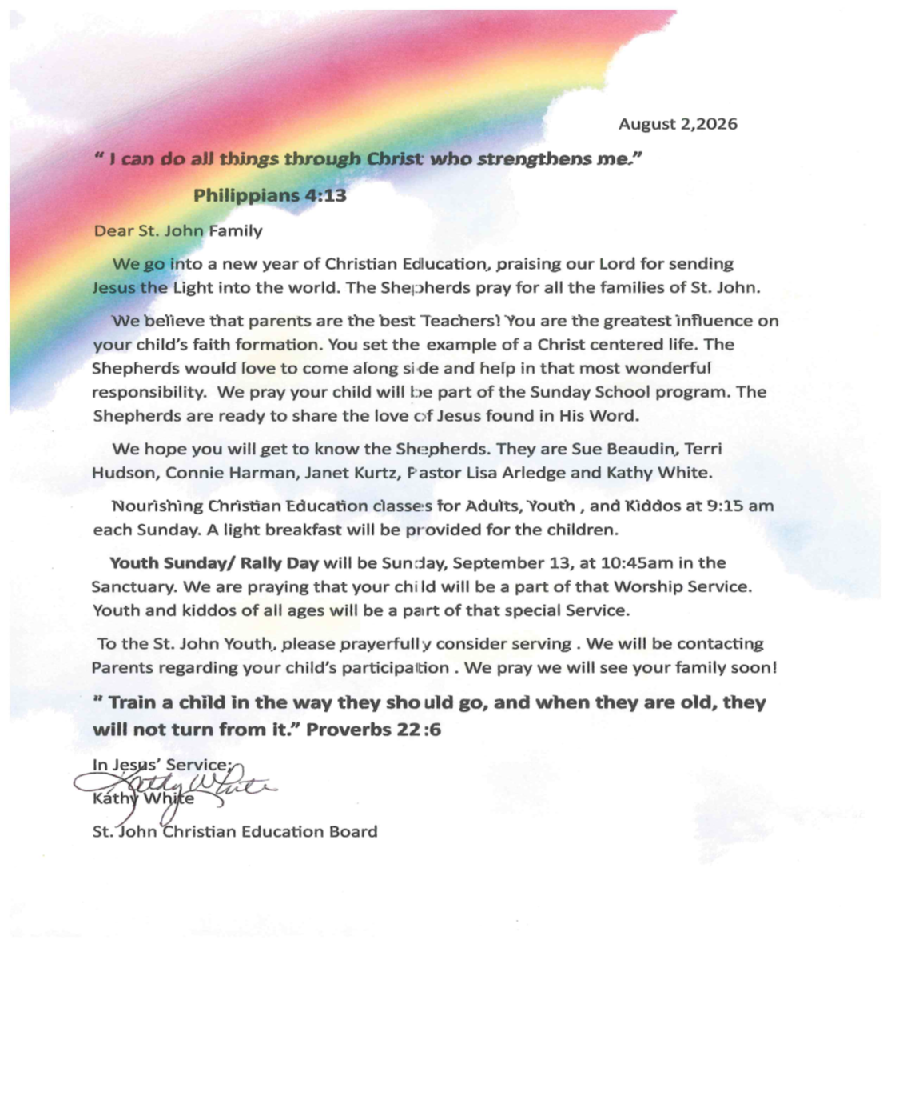

Text or Call Kathy White at 330-705-8078 or email Pastor Lisa at lisa.arledge@gmail.com


1st Wednesday of the Month!
SEPTEMBER 2, 2026
5:30 pm to 7:30 pm

St. John Lutheran Church 336 Market St. W.
Canal Fulton

Ages: Pre-School through 5th Grade
6th Grade through High School

Super Fun Games, Music, Crafts,
and Delicious Meal

Parents, please drop off children in lower-level parking lot, join us for dinner, or enjoy an evening out. We will provide a safe, kind, and meaningful time for your children.

Illuminate
Grow in faith
Never be afraid
Invite friends
Trust Jesus
Energize for God



“Come and See Bible Study is a great way to start my week!”

“Come and See” are the words of Jesus in the Gospel of John, which serve as the invitation to our Bible Study at St. John Lutheran Church in the conference room on Mondays at 10:30 am

This Bible study is invigorating!
You can roll in anytime!



ROAD TRIP FOR WOMEN – OCTOBER 16, 2026 – CONTACT KATHY WHITE –
330-705-8078 OR PASTOR LISA - lisa.arledge@gmail.com IF INTERESTED!
ST. JOHN LUTHERAN CHURCH – SEPTEMBER 2026
Sun | Mon | Tue | Wed | Thu | Fri | Sat
 |  | 1  6:00 P.M.  AA – Hall | 2  5:30 P.M. - IGNITE | 3  12:00 P.M. CHOIR PRACTICE  2:00 P.M. – H.O.A. HALL  AUTUMN MEADOWS  COOKRO  6:00 P.M.  AA – Hall | 4 | 5
6  9:15 A.M. – SUNDAY SCHOOL  10:45 A.M. –  OUTDOOR  WORSHIP  12:00 P.M. BOARD OF EDUCATION | 7  9:30 A.M. – PRAYER W/PASTOR  10:30 A.M.  BIBLE STUDY  6:00 P.M. | 8  6:00 P.M.  AA – Hall | 9  6:00 P.M.  AA – Hall | 10  12:00 P.M. CHOIR PRACTICE  6:00 P.M.  AA – Hall | 11  5:00 P.M. - HALL | 12  HALL USE – ALL DAY MD
13  RALLY DAY/PICNIC  9:15 A.M. – SUNDAY SCHOOL  10:45 A.M. –  WORSHIP | 14  9:30 A.M. – PRAYER W/PASTOR  10:30 A.M.  BIBLE STUDY  6:00 P.M. | 15  6:00 P.M.  AA – Hall | 16  1:00 P.M. HOPE CIRCLE – HALL  6:00 P.M.  AA – Hall | 17  12:00 P.M. CHOIR PRACTICE  6:00 P.M.  AA – Hall | 18  OCTOBER  NEWSLETTER INFO DUE IN OFFICE  5:00 P.M. - HALL | 19  HALL USE ALL DAY KW
20  9:15 A.M. – SUNDAY SCHOOL  10:45 A.M. –  WORSHIP | 21  9:30 A.M. – PRAYER W/PASTOR  10:30 A.M.  BIBLE STUDY  6:00 P.M. | 22  6:00 P.M.  AA – Hall | 23  10:00 A.M. BD OF WORSHIP & MUSIC  11:00 P.M.  WORSHIP PLANNING  6:00 P.M.  AA – Hall | 24  12:00 P.M. CHOIR PRACTICE  6:00 P.M.  AA – Hall | 25 | 26
27  9:15 A.M. – SUNDAY SCHOOL  10:45 A.M. –  WORSHIP | 28  9:30 A.M. – PRAYER W/PASTOR  10:30 A.M.  BIBLE STUDY  6:00 P.M. | 29  6:00 P.M.  AA – Hall | 30  6:00 P.M.  AA – Hall
S.A.L.T. BOX CALENDAR – SEPTEMBER 2026
Sun | Mon | Tue | Wed | Thu | Fri | Sat
 |  | 1 | 2  5 – 8:30 P.M.  MARTIAL ARTS  UPSTAIRS  6:00 P.M. AA DOWNSTAIRS | 3  9:00 A.M. -12:00 P.M.  VOLUNTEER  THURSDAY & SHOPPING  4:00 P.M. PRAYER  MTG  5:45 P.M. – MARTIAL ARTS | 4  8:00 A.M. VOLUNTEERS NEEDED TO HELP UNLOAD | 5  8:45 A.M. -12:30 P.M.-YOGA - UPSTAIRS  9:00 A.M. – 12:00 P.M.  S.A.L.T. BOX SHOPPING
6  1:00 P.M.– 3:00 P.M.  MARTIAL ARTS – OPEN GYM | 7  5 – 8:30 P.M.  MARTIAL ARTS  UPSTAIRS | 8 | 9  5 – 8:30 P.M.  MARTIAL ARTS  UPSTAIRS | 10  9:00 A.M. -12:00 P.M.  VOLUNTEER  THURSDAY & SHOPPING  4:00 P.M. PRAYER  MTG  5:45 P.M. – MARTIAL ARTS | 11  8:00 A.M. VOLUNTEERS NEEDED TO HELP UNLOAD | 12  8:45 A.M. -12:30 P.M.-YOGA - UPSTAIRS  9:00 A.M. – 12:00 P.M.  S.A.L.T. BOX SHOPPING
13  1:00 P.M.– 3:00 P.M.  MARTIAL ARTS – OPEN GYM  4:00 P.M. – 5:30 P.M.  SALT BOX MEAL | 14  5 – 8:30 P.M.  MARTIAL ARTS  UPSTAIRS | 15 | 16  5 – 8:30 P.M.  MARTIAL ARTS  UPSTAIRS | 17  9:00 A.M. -12:00 P.M.  VOLUNTEER  THURSDAY & SHOPPING  4:00 P.M. PRAYER  MTG  5:45 P.M. – MARTIAL ARTS | 18  8:00 A.M. VOLUNTEERS NEEDED TO HELP UNLOAD | 19  8:45 A.M. -12:30 P.M.-YOGA - UPSTAIRS  9:00 A.M. – 12:00 P.M.  S.A.L.T. BOX SHOPPING
20  1:00 P.M.– 3:00 P.M.  MARTIAL ARTS – OPEN GYM | 21  5 – 8:30 P.M.  MARTIAL ARTS  UPSTAIRS | 22 | 23  5 – 8:30 P.M.  MARTIAL ARTS  UPSTAIRS | 24  9:00 A.M. -12:00 P.M.  VOLUNTEER  THURSDAY & SHOPPING  4:00 P.M. PRAYER  MTG  5:45 P.M. – MARTIAL ARTS | 25  8:00 A.M. VOLUNTEERS NEEDED TO HELP UNLOAD | 26  8:45 A.M. -12:30 P.M.-YOGA - UPSTAIRS  9:00 A.M. – 12:00 P.M.  S.A.L.T. BOX SHOPPING
27  1:00 P.M.– 3:00 P.M.  MARTIAL ARTS – OPEN GYM  4:00 P.M. – 5:30 P.M.  SALT BOX MEAL | 28  5 – 8:30 P.M.  MARTIAL ARTS  UPSTAIRS | 29 | 30  5 – 8:30 P.M.  MARTIAL ARTS  UPSTAIRS
More Calendars from WinCalendar: October, November, December

ST. JOHN LUTHERAN CHURCH
336 WEST MARKET ST.
P.O. BOX 311
CANAL FULTON OH 44614

SEPTEMBER 2026

Mission Statement
Called and gifted to reflect Christ as we love, serve, and teach.

SUNDAY ACTIVITIES
Sunday School: 9:15 a.m.
Worship: 10:45 a.m.

S.A.L.T. BOX MINISTRIES
408 West Market Street Canal Fulton OH
E-Mail: saltboxcanalfulton@gmail.com

Free Meal @ S.A.L.T. BOX
Second & Last Sunday of Each Month!
4:00 P.M. – 5:30 P.M.

