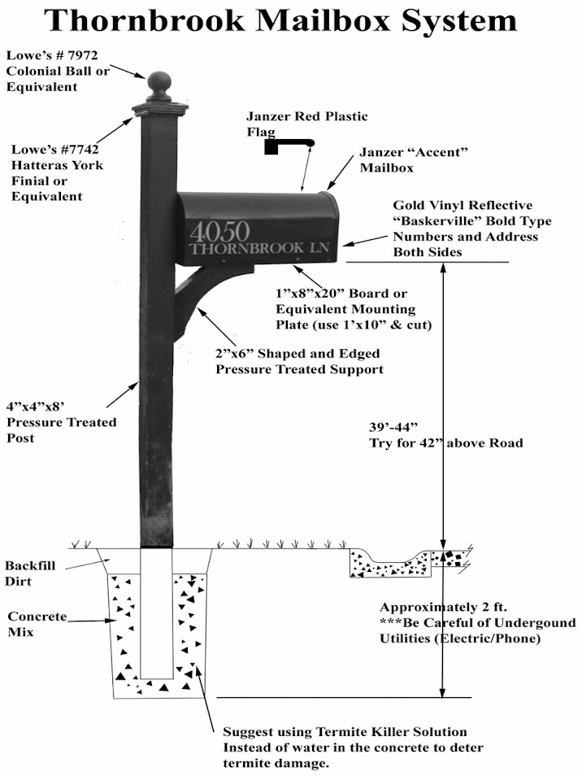

**Home Depot ProWood 4 in. x 4 in. Pressure-Treated Unfinished Pine Ball $3.98**

**Ace Hardware Waddell 4 inch by 4 inch Prefinished brown pine post cap Item#5000583 $4.59**

**Custom made by Curb Appeal/Denise $25.00**

**\*ALL PARTS SHOULD BE GLOSSY BLACK\***

# **Ace Hardware Gibraltar Mailboxes Elite Classic Galvanized Steel Post Mount Black Mailbox 29.99**

Item #5266192| Mfr #E1600BAM

## **Home Depot Gilbraltar Mailbox steel red flag replacement kit. Model # RF000R06 $7.47**



Dear Thornbrook Residents,

If the Thornbrook Architectural Control Committee finds your mailbox is in need of repair/replacement, you have several options for bringing your mailbox into compliance with the Thornbrook HOA Covenants. Your options are as followed:

1. Repair or replace it yourself by following the HOA Covenants guidelines provided on the following page.
2. You can hire either of these venders to complete the repairs or replacement at your cost. These venders know the guidelines of the covenants. Guy: 678-887-7345 or Denise: 404-630-4525

Thornbrook HOA is in no way affiliated with either of the venders mentioned above and is not responsible for their workmanship. Both vendors have much experience working with the mailboxes in our subdivision.

If you do not follow the specific guidelines, you will be asked to re-do your mailbox until it is compliant with the HOA Covenant guidelines. Mailbox parts can be equivalent to those listed as options. You have 60 days from receiving the Thornbrook ACC notification to have the work completed on your mailbox.

If you have any questions or concerns, please email [theboard@thornbrookhoa.com](mailto:theboard@thornbrookhoa.com)

Thank you!

**Options for buying parts for mailboxes (prices may change or vary)**

**Home Depot 4 in. x 4 in. Pressure-Treated Unfinished Pine Ball Top Finial**

**Model #**102615 **Store SKU #**429323 $3.98

**Gibraltar Mailboxes Elite Large Classic Galvanized Steel Post Mount Black Mailbox** Item #5266192| Mfr #E1600BAM $29.99

**Gibraltar Mailboxes Steel Red 2-1/2 in. W X 7-1/2 in. L Flag Replacement Kit**

Item #53783| Mfr #RFL-1 $4.79

**Home Depot**

**4 in. x 4 in. x 8 ft. #2 Ground Contact Pressure-Treated Southern Yellow Pine Timber** $10.48

**Waddell pine exterior post top finial round** Model#110 $7.27

## **Gilbraltar Mailbox steel red flag replacement kit.** Model # RF000R06 $7.47

**Amazon**

**Letter/Numbers Gold - Baskerville Mailbox Numbers - 2" Tall - Vinyl Sticker - Name Home House Office Address - BASK - Die Cut Decal-Minglewood Trading Store** $6.99

**Brace for Under Mailbox**

**Denise/Curb Appeal Mailboxes** Call 404-630-4525**-**These braces are custom made by her. $25.00

Regularly wax your mailbox with car wax in order to prevent it from fading