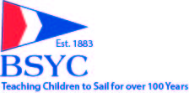

Junior Yacht Club Sailing Program
‘Fundraiser for the Fleet’

Friday, October 19th, 2018 – 7pm-10pm
The Victorian Room
BSYC
36 West main St., Bay Shore
Ticket Price - $40 per person

Open Bar, Passed Hors d' Oeuvres
Door Prize Raffle and Gift Baskets Galore
Help our Kids Win on the Great South Bay!
RSVP by October 10th - All tickets must be purchased prior to the event
Please click on the link below to purchase tickets

