**MSAT Task Instructions**

Thank you for helping with our research study to improve medication choice for depression!

As part of the study, you have been asked to complete the Moral Sentiment and Action Tendencies (MSAT) task. The task presents a series of short statements describing your social behaviour towards your best friend, or short statements describing social behaviour of your best friend towards you.

Please imagine the described behaviour and how it would make you feel. You will be asked how much you would blame yourself for the described behaviour, and how much you would blame your best friend. Then, you will be asked to select the feeling that you feel most strongly, followed by the action you would most strongly feel like doing.

**Accessing the task online:**

We recommend you use your computer or laptop to complete the task. However, the task works on tablet as well.

You should see the following set-up screen:

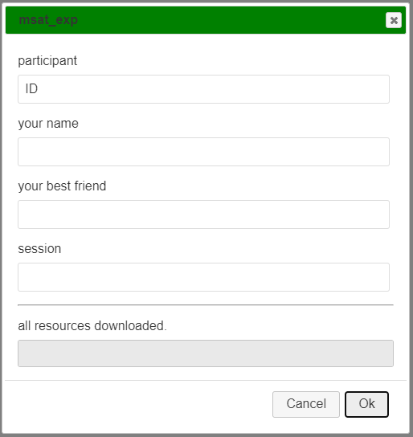

* Under “participant”, please type in **your participant ID** that has been assigned to you by the researcher.
* Under “your name”, please type in **your name** (what you like to be called by your best friend
* Under “your best friend”, please type in the **name of your best friend** (what you call her/him)
* Under “session”, please type in **baseline** (first time) or **follow-up** (second time)

Once you click on “**OK**”, the task will start in full-screen mode and take you to the instructions screen. Please click “**continue**” to continue.

Please try to complete the task in a quiet environment if possible. There are 54 statements in total, which should take you around 20 minutes to complete.

*If for any reason you want to end the task prematurely during the session, please press “escape” twice. However, please note that you will not be able to resume the task from the point where you left and would need to restart the task from the beginning.*

**End of the task**

At the end of the task, you will see a screen informing you that the task has finished. This will be followed by a screen with a warning message in yellow: please **do not close your browser until you receive a green message** thanking you for your patience.

This allows the server to store your data.

