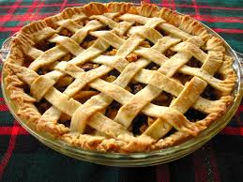 TENINO FARMERS MARKET

BLUE RIBBON PIE CONTEST!

Saturday, July 23rd 2022 during OREGON TRAIL DAYS
The Annual Blue Ribbon Pie Contest and Pie Buy-the-Slice Fundraiser is sponsored by O Bee Credit Union. Submit pie(s) between 9:30am-11:30am at the Tenino Farmers Market Booth on Olympia Street. Pie categories are BERRY, FRUIT (other than berry), NUT, and JUNIOR BAKER (under 16 years old). First place awarded in each category, plus a Grand Champion.

Submit your pie entry between 9:30 and 11:30 along with your RECIPE/Ingredients List. Entries are judged on appearance, flavor and texture.
Application below, and available on the day of the contest at the Tenino Farmers Market Booth.
The Tenino Farmers Market takes place every Saturday from 10AM to 3PM from May through September on Olympia Street downtown Tenino.
www.teninofarmersmarket.org
ENTRY FORM
TENINO FARMERS MARKET
BLUE RIBBON PIE CONTEST
SATURDAY July 23, 2022

PIE CATEGORY (circle one): Berry Fruit Nut Junior Baker (Under 16)
NAME:
PHONE:
ADDRESS:
EMAIL:
TFM is not responsible for the return of pie plates, PLEASE mark your plates with your name and number. Judging begins at 1:00. Include your recipe/ingredients list.

