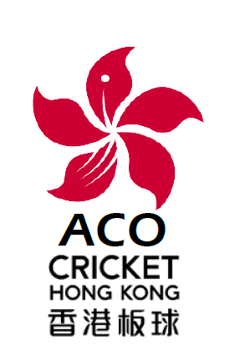
CRICKET HONG KONG ASSOCIATION OF CRICKET OFFICIALS
Membership Application
2019 - 2020
UMPIRES & SCORERS
(HK CHINA)

Membership Application Form
2019 - 2020

Family Name:
Given Name(s):
HKID Card No: |  |  |  | Permanent HKID? Yes/No:
Date of Birth: |  |  |  | Country of Birth:
Nationality:
Postal Address:
E-mail Address:
Office Tel: |  |  |  | Home Tel:
Fax No: |  |  |  | Mobile Tel:
Existing Umpire/Scorer Qualifications & Experience (continue overleaf if necessary):

Note: The Executive Committee has absolute discretion whether to accept or reject this membership application and to determine the class of membership. Membership expires on 31st August 2020.
Membership Class requested:  (Tick √ one) |  | Qualified or  Intermediate |  |  | Associate |  | Junior (U18) | Senior  Citizen
 |  | HK$ 300 ( ) |  |  | HK$ 150 ( ) |  | No fee ( )
*Cheque No: |  | Bank:
Please do not write below this line
Payment received/deposited on:
Membership class: |  |  | Effective date:

Proposer: ……… Seconder: …

Signed: …………………………….. Signed: ……………………………..
Date: Date:

Form Submission & Payment of Fees Due
Please send a completed application form & Bank deposit or transfer confirmation to
the Secretary – hongkong.aco@gmail.com
Payments should be made to the Association Bank account:
HSBC 808-370092-001

