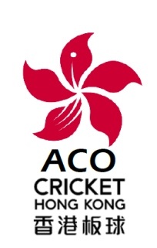
CRICKET HONG KONG
ASSOCIATION OF CRICKET OFFICIALS

Membership Application
2020-21
Family Name:
Given Name(s):
Preferred Name
HKID Card No: |  |  |  | Permanent? (Y/N):
Date of Birth: |  |  |  | Country of Birth:
Nationality:
Postal Address:
E-mail Address:
Phone #: |  |  |  | Other:
Personal Bank Details: for Umpiring Fees and other Payments
Account Name:
Bank: |  |  |  | Account #:
Umpire/Scorer Qualifications & Experience (continue overleaf if necessary):

1. The Executive Committee has absolute discretion whether to accept or reject this membership application and to determine the class of membership.
2. Membership expires on 31st August 2021.
Membership Class & Fees (based on advice)
Qualified | Intermediate |  | Associate |  | Junior (U18) |  |  | Senior(65 plus)
HK$ 300 |  |  | HK$ 150 |  | No fee

Proposer: ………............................... Seconder: …..........................................

Signed: …………………………….. Signed: ……………………………..
Date: Date:
Form Submission & Payment of Fees
Please the completed application form & confirmation of payment to the Secretary secretary@chkofficials.com
Please make payments to Bank Account
HSBC 808-370092-001 “The Association of Cricket Umpires & Scorers (HK China)”
Payment:
Membership class: | Effective date:

