Bathgate Solar Coop Project
July 2025
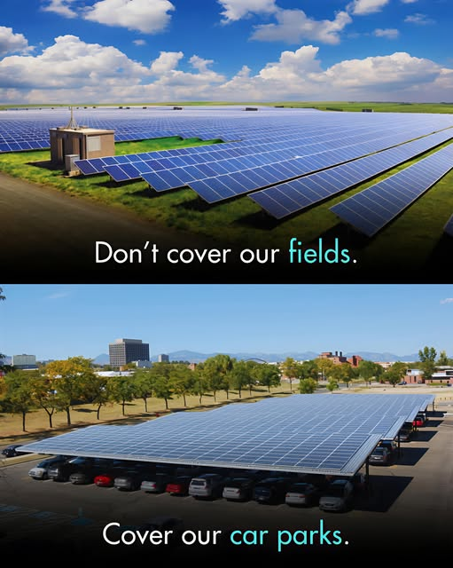

Bathgate Solar Coop Project
The project we want to develop is the installation of solar panels in all of Bathgate Car Parks to generate power for the benefit of the town. This type of scheme is already in operation in different areas of Europe.
- The power would be sold to the grid and used to power recharging units for electric vehicles and for any community projects requiring energy.
- The financial benefit coming from the project would be spent on projects to improve the quality of life for Bathgate residents
There are eight public car parks in Bathgate and a large private car park at the town centre retail park and the biggest car park in town is at the Railway Station. The car parks at the two superstores in Bathgate Tesco and Morrisons are also very big.
Our aim would be to persuade the private owners in the town to join in the scheme after the public car parks were up and running and proved their viability. The local council we are sure would be cooperative as they support climate change initiatives .
The Council owned Car Parks
The table detailing council car parks in Bathgate, the areas are approximate.
Car Park Locations | Spaces |  | Area Sqm
Acredale | 165 |  | 3,984
Mansefield | 45 |  | 859
Mill Road | 64 |  | 1,149
Gardners Lane | 151 |  | 3,409
King Street | 22 |  | 1,364
Gideon Street | 48 |  | 1,273
MarjorieBanks | 30 |  | 616
Hopetoun Street | 30 |  | 538

The solar panels would be installed on steel framework above the car parking bays similar to the shelter provision built into car parks in Mediterranean countries.
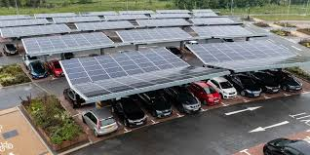
Solar panel technology is improving every year so we would aim to have the latest on the market when the project gets the go ahead to build.
The Community Development Trust would manage the project through the various stages up to launch but envisage establishing a separate organisation to manage and maintain the solar farm for the benefit of the community. The organisation could be a Cooperative model with all residents of the community automatically being members. Members would guide the use of benefit generated into projects that would improve the quality of life of Bathgate residents. Other structures can be considered but the principle of community control and community benefit is paramount
Phase One
We will seek funding to employ a project development employee to develop the feasibility study of the project and develop a business plan
Phase Two
Seek funding for extra staff to conduct a community consultation on the project and develop and lodge a planning application.
Phase Three
Seek funding for a procurement team to develop a specification and tender documents and take the project to tender and evaluation.
Phase Four
Establish the controlling body that will manage the facilities
Seek funding to pay contractors to build the solar farms and begin operations

Bathgate Community Development Trust Ltd
contact@bathgatecdt.org www.bathgatecdt.org July 2025

