Meadow Park Survey Report
May 2021

416 Responses to Survey

Organised by
Bathgate Community Development Trust Ltd

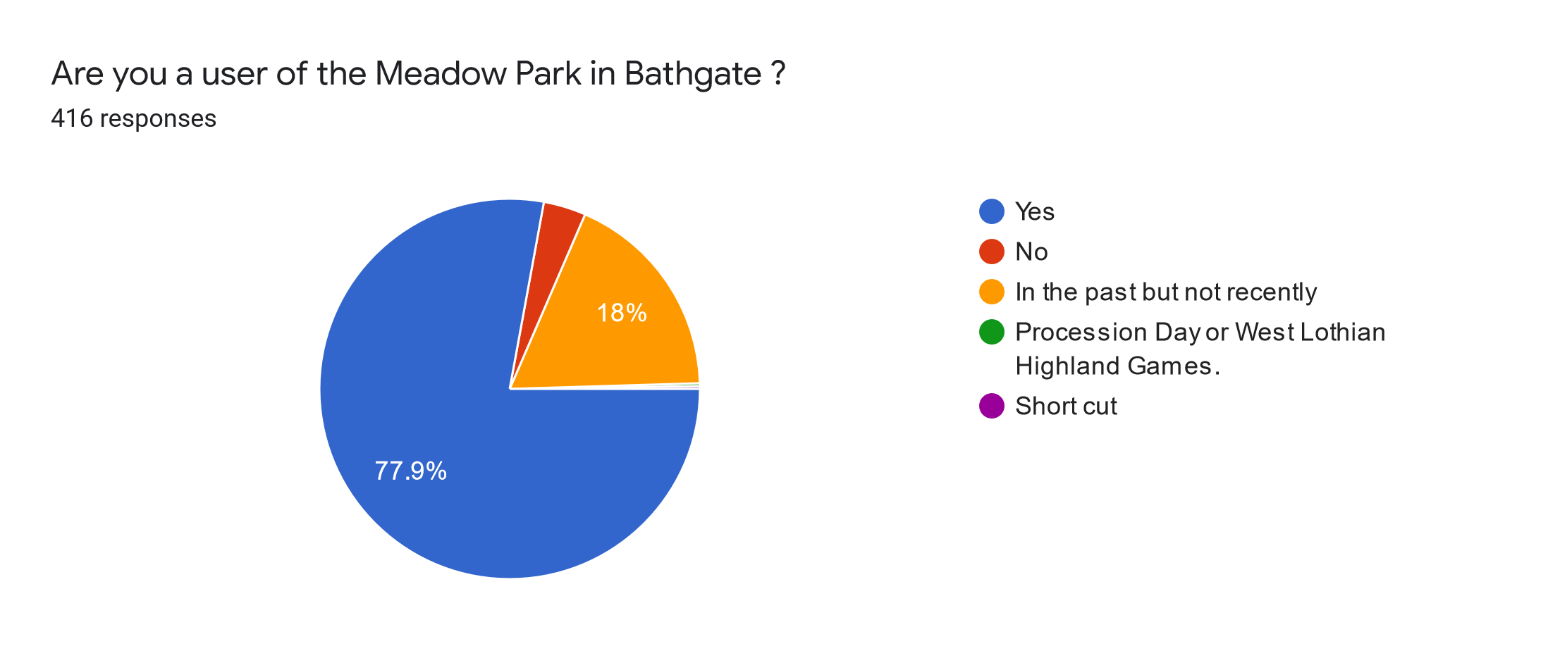
Just about everybody who responded uses or has used the park in total about 96%. Only 3.6% had never used the park.
Interestingly about 18% had not used it recently.

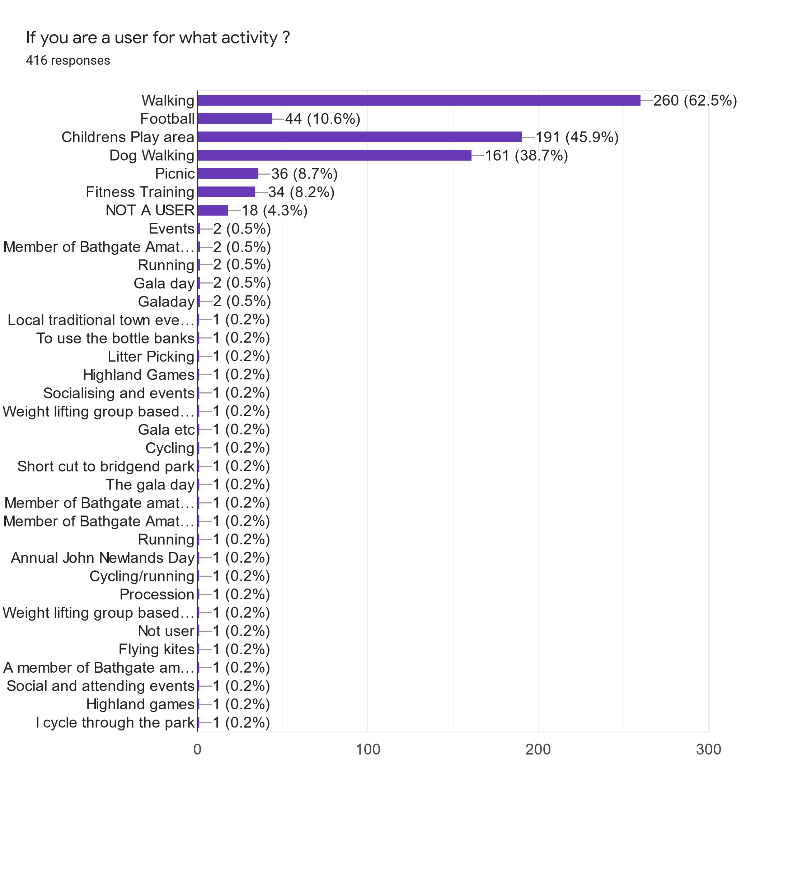
So the biggest park uses are :- Walkers Children’s Play Area and Dog Walkers

Walkers (62.5 %) Children’s Play Area (45.9 %) Dog Walking (38.7 %) Football (10.6%) Picnic (8.7%) Fitness Training (8.2%) with Non Users (4.3%) Other mentions in the survey for the events like the Procession/Gala Day and the weightlifters that use the changing rooms.
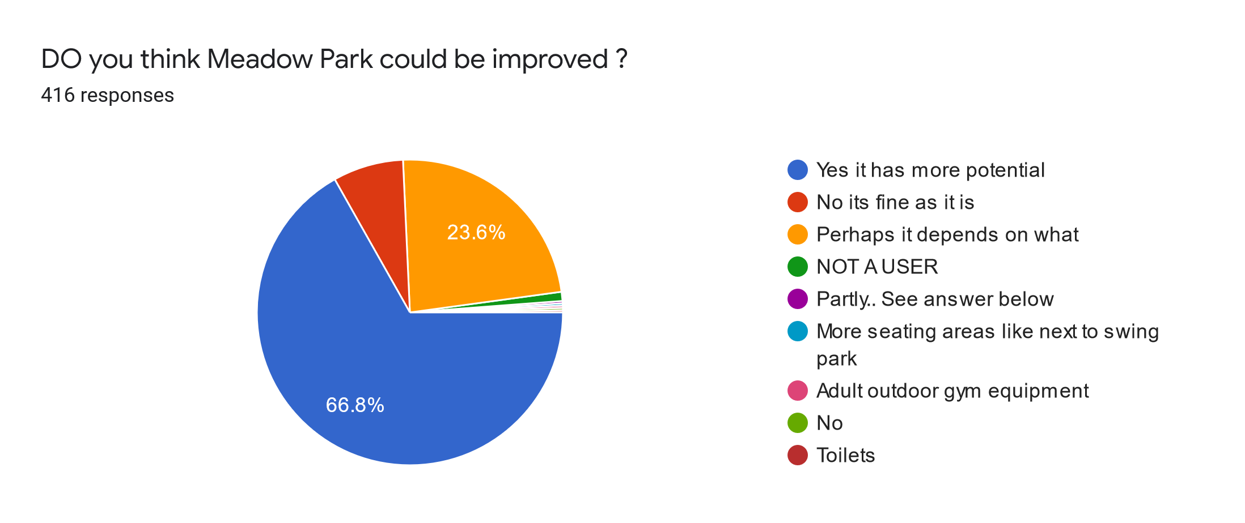
Big percentage (66.8%) think it could be improved with many (23.6%) waiting to be convinced depending on what proposals might come forward. A small minority (7.5%) think its ok as it is.

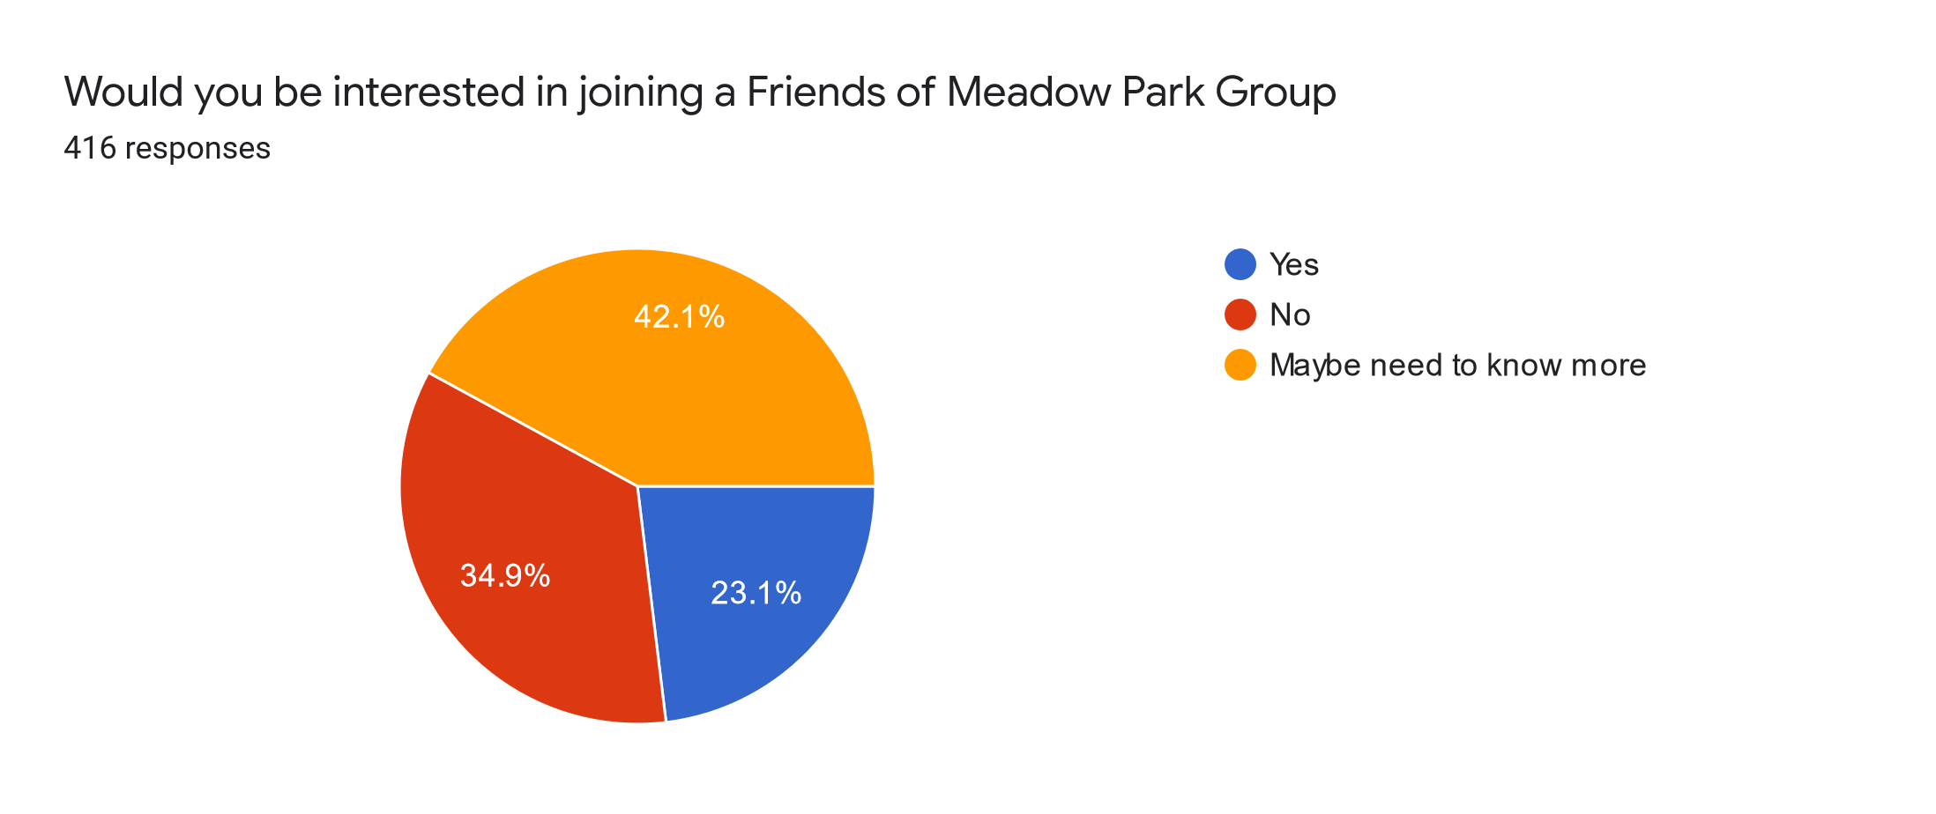

There is potential for a Friends of the Park Group being created with (23.1%) interested and a larger group (42.1 %) willing to be convinced depending on the detail. Almost (35%) do not want to be involved.

Have you got a suggestion(s) on how the park could be developed
More benches and litter bins
Be nice to have a coffee shop or trailer to encourage more people to use it
Picnic areas, planting of more trees. Possibly raised beds for colour and wildlife friendly plants. Orchard?
needs a community wellness hub
Develop on current accessibility - accessible play equipment.
If suggest a better path could be made on the periphery. It tends to be very wet and boggy. I’d suggest there is a potential for an improved play park. it’s very small. and again, drainage needs improving. Could the path include outdoor gym equipment?
Try and get a Bathgate park run there?
Clean up the burn and keep it neat and tidy
A few picnic fences, drive in movies
A fenced, floodlit 3G football facility to complement the existing pavilion facility in addition to a dedicated dog walking area.
Fenced off 3G football pitch with upgraded changing facility’s
Benches, picnic tables, proper path round the whole park with lighting, more trees, more litter bins
Football pitch and facilities for Bathgate Thistle Community Football Club which has over 400 kids and volunteers. Shame they can’t use the creamery which has a much smaller kids’ section so a facility for the community club would be amazing
Possibly a fenced in area, where people can let their dogs off their leads, allowing other dog walkers (with dogs on a leash) and children to walk freely
More/bigger play park. Shelter/ meeting area for older kids they will get together anyway so embrace it.
Better facilities for sports
Upgrade of path round, more litter bins, nature corner
Fitness playground
The burn area needs dredged, more trees /plants /flowers
7 aside goals more relevant to younger kids
A community gym in the pavilion would also be welcome
It could be improved by adding a lot more picnic benches and seating areas. It’s a lovely big space and would be great to see it full of spaces to sit and eat and meet with friends/family.
Better lighting, things for older kids to do
Improve children play area add to for older children.
More planted areas to make walking/picnicking in the park more enjoyable
It is a great park, used well at gala days and on weekends by local football teams.
The playpark has been adequately regenerated and the placing of benches by the riverbank a welcome addition for older walkers. Perhaps the Bank itself could be more attractive. Wildflower and the like.
Perhaps improvement to the 'track' that encircles the grass football park. That red ash is awful, pothole filled and unusable in rain.
Small astro turf area with basketball net etc
More developed area for outdoor exercise classes
Smaller goals set out for younger kids
Wildflowers along burn & bottom corner
Assault course/ exercise equipment
Improved perimeter footpath
I think a smooth track should be put round edge of park could be used for running or skating instead off rough stony ground. To encourage fitness further could implement obstacle course equipment around back edge.
Expand play park and include more items for younger children
Astro turf 4G
More seating areas
Flood lights/training pitch
Link the development of the park to Bathgate Community Development Trust rather than set up another group.
More flowers around the perimeter. Fence to be repainted. Repainting of the bridge which is looking very tired. Removal of the old broken stump of lamppost. New bin next to the bridge
Free public toilets
If fitness classes could stop from here. I find it intimidating.
Resurfacing of the path round the grass and a cycle lane. More picnic benches. Outdoor gym equipment.
Something for kids. A hub of some kind
Drainage, clean up and planting along the water, benches
Clearer/more inviting entrance on the Glasgow Road side (a sign maybe). Some sort of cafe (even something pop up at weekends) and a few benches/seats especially for parents bringing children for playpark/sports.
More variation and colour in the plants around the park (a few planters/flowerbeds or wildflower section).
Allotments, community garden.
More seating areas
More bins especially after junior football when there is a huge amount of empty water bottles
Football nets or goals that remain up. More rubbish bins and dog waste bins (the one at bottom of path vandalised). Possibly more planting/flowers.
Make it more accessible for the youngsters to play football.
Seating areas, picnic area. Could do with more variety in play park for young children (preschool age).
Better disabled access
Perhaps a safety railing along the burn due to people and dogs being injured.
More seating areas, better lighting of play area, fencing all round football area to stop dog fouling which is not a pleasure for teams to have to clear before they can play or anything else to tackle this!!
More sitting areas, better park
No. It's need for gala day
Needs better lighting revamped more family friendly
Picnic tables would be nice and some cctv put up round the skate park and basketball area so there is a way to stop the kids setting a fire every night during the summer wasting the fire brigade’s time.
Basketball net needs a run-up at least - can’t dribble. Picnic benches would be nice. Use for events. Could do a pop-up street food festival
Cycle path, more seats, picnic tables, information board, historic info boards on Bathgate rich history, CCTV
Skateboard/Scooter Park
Bike pump track, MAGA, outdoor fitness facilities, roof-covered/shelter area, more bins, water fountain, toilet, bike rack. Running track, lights.
Better maintenance,
Outdoor gym
Proper children’s play area - like at Eliburn
Have the burn areas cleaner to help the wildlife around the park.
Yes, it could have seats and maybe and toilets and better play areas for children. there’s nothing there.
Could do away with the shrub beds at the car park and landscape the area and get it back to the two full sized football pitches that used to be there. I would like to see a permanent bridge between the showground and the Meadow park. Tithe entrance at the east end needs a bollard put up to stop the cars parking on the area where the old changing rooms there. A decent fence needs to be put up so people can’t fall into the two burns.
Bigger play area more suitable for all ages, cycle track, skate park,
Picnic tables maybe
Better parking and access
More bins in the play park, goalposts to remain in the summer.
More seating areas or picnic tables, public toilets, more dog poo bins, over growth of bushes cut back make a nicer water view, wider pathway with cycle lane
Whole place needs looked after better. Where does all the money go?
More picnic benches and seated area. Morrison’s trollies removed along with bikes and council refuse bin from burn. Burn dredged and embankments cut back like our friends over in western inch. Broken fences at car park end either replaced or removed. Also stop grave diggers dumping spoil at edge of burn. Cars and keep fitters use car park instead of driving onto grass area. Bins emptied more regular.
Think it could have more distinct areas fenced off, such as a doggy area (keep dirt all in one place) and allows non-keen people feel secure in that dogs stay in one part - saw such a park on holiday. Then an area for teens, with pods to allow small groups to have their own space. Saw similar in Thurso- a clear pod with seating. It was clearly a popular idea, as every time we passed, teens were sitting in full view of public, just eating/drinking/talking.
Too much grass, make it more like a park to walk through. Dog poo everywhere on that grass.
Perhaps a fenced area for dogs to run off lead
More seating and tables for people, it's just a nice park to sit in as we don't have any others in area.
Cycle path around the park, and perhaps a small tea shop/cafe
A Muga pitch for football and basketball line the schools have, a treehouse with ropes and climbing features.
Remove graffiti from pavilion, add more bins, repair broken fencing, remove shrubs and replace with flower beds
Less litter and burn cleaned up
Like a music park now and again like the gala days
Trim trails, nature trail, bug habitats, natural art features,
More seating and better lighting
More picnic tables. Maybe some sort of circuit to run around.
Leisure facilities, cafe, events space, dog exercise and play compound, swing park
sports field running tract and exercise centre
New kids park, pitch, training tracks, bike trail etc community centre
Maybe more sport facilities
The play park could be twice the size with more equipment like a train or pirate ship or Fort like structure with a sandy area too as its often overcrowded because it’s so small. More picnic benches around that area as well.
Develop the play park in size and choice of play equipment
More could be made of the burn.
The path going all round the outside. Some of it is ash and gets muddy and you have to walk through the car park to go all the way round. This could easily be a great path for walking/ running all the way round.
Some flowers too would be nice
Dedicated exercise area and machines.
Focus on the play park, make it bigger and add picnic benches.
Picnic area
A selection of Adult exercise equipment as on the Davie Kerr Walk in Armadale on the Barbauchlaw Glen section.
A multi play unit with different play activities spread across different levels in the play park. Play park too small and is very popular. Discourage dog walkers
Not really, I Like it as a park
More events
Plant more trees and make it more like a park for dog walking.
Fitness resources
Never been in it so do not know
Need an actual court area in front of the basketball net, no point having a basketball net and then grass.
Add play areas or an adventure area, have a look at Lochore Meadows Park in Fife. They have an exercise, and zip wire activities as well as a barbecue area. Sadly everything you do will need to be vandal proof.
Installing MUGA multi use games area to all a variety of sports and not just football. https://www.softsurfaces.co.uk/application/muga/
More of those picnic benches
Better lighting for winter
Public clean toilets
Landscaping and picnic tables
Picnic area would be nice
The swing park is really busy and often more kids than activities. There could also be more dog bins
Larger park area for kids to play, larger basketball area, small football area, hills for kids on bikes. Something for every age level for kid’s that would keep them all entertained
Make safer by the water having a fence etc beside, improve the drainage by entry to play park. Have hard ground by basketball hoop for older kids to play. Could the grass field be put to multipurpose use e.g. rugby posts
Seating / benches, extended play park,
Adult training circuit, bbq areas, more landscaping
A better path all the way around would be great. It gets very muddy and waterlogged at points at the moment.
Tidy the canal up
Trim trail. More benches
Drainage requires to be looked at, when it has been wet at all, I stay away. It’s a wellies job.
Improve the ash path round the park to act as running track
No
More nice seating areas for picnics
Whilst in Spain they had a 100-metre caged dog park area with various obstacles in it for training, meadow park would be perfect venue for this
More benches
More for older kids, teenagers, maybe some fitness equipment
Enclosed area for dogs
Better paths around the whole perimeter of park
Events out with the fair; create gardens of interest rather than just a field; and include an area for kids e.g. one of those water elements as at Kelpies in Falkirk - actually loads to learn from their example.
Turn the big football pitch into pitches that can be rented to local football teams for training
Outdoor gym equipment
Flower beds
Local art installations
CCTV
Park wardens
Leave it be!!!! Outsiders who weren’t born in Bathgate, leave it alone, stop trying to change things!!!
The gravel path which runs from Bridgend could be improved. It floods quite badly. The playpark.
More sports stuff
Litter picking! The muddy Ditch that runs down the side (coming from the dirt path - Bridgend Park direction) is full of rubbish/metal/plastic etc. And the woods next to the pavement by the ditch is full of rubbish
Toilets, bike track, basketball nets
More benches, better park facilities
More seating
The top end I. E. Off Glasgow Road, could be tidied up perhaps a nice wee garden and sitting area. Picnic benches just adjacent to the play park. Area by side of burn tidied up to look more attractive. A circuit running area around perimeter.
No money to develop, it’s a park and can be used quite well as it is. The money should be used for essentials.
No
It should not be! In this current financial crisis, money should be given to local independent businesses to help with costs.
Fenced area for dog play, benches, more litter bins
Add a shelter and/or a BBQ area at the south end of the park
Outdoor music venue & picnic area with plenty of bins!
Fenced 3G facility to accommodate the growing Bathgate Thistle community football club
Larger park area
I do not have any suggestions on how the park could be developed, but it could be an idea to rent the park out to more outdoors events - great space for the Highland games and Gala Day events. I think the park acts as a vital green space to the local community; it would be a real shame for this space to change.
No
more dog poo bins
Put a hang out area in for young people.
Stricter penalties for dog mess
Small takeaway cafe
More seating
Picnic tables
More seating areas, keep fit areas like you see on European. Beaches, toilets
Bigger play park, more picnic benches, more dog bins,
More wildlife needs to be encouraged there such as putting up bird and bat boxes on trees. Notices up saying dogs and people are forbidden from interfering with wildlife.
Bird and bat boxes in trees
Gets a bit waterlogged, improved drainage. Also replace the lamp post at top, poor lighting in winter nights
Better drainage and possibly tennis court
More picnic benches
More benches
The ash path on the south west side be replaced as it terrible when wet
Picnic area. Flower beds and trees.
Yes, they could plant some flowers and have picnic benches
Yes, they could plant some flowers and have picnic benches
More picnic tables. The park is lovely, the children’s play area is great, perhaps some exercise machines which we saw in Tarbet would be good if they didn’t get vandalised.
Outdoor /indoor fitness facilities, all weather football pitch, bandstand
Better pathing to walk on. It gets so wet that you cannot walk around it.
Outdoor gym area with dedicated space for people to go down and use. Maybe with specific sponge type grounding. Utilisation of the little building as it seems a waste to sit not being used.
Hardcore track to far side upgraded to tarmac. Running track round outskirts of football pitch. More benches outside playpark area for those with dogs.
Meadow park u in any fir football anymore it can be so much more with a skate park small 4G football pitch/basketball a nice lake anything like that nice paths to walk around on things like that
Maybe some keep fit equipment like I have seen in other parks
Regular litter picking. Dog free areas or dog on leash areas
Focus on the play park, make it bigger and add picnic benches.
Bigger park for the kids
More seating areas, picnic tables, toilets reinstalled
Flood lights new goals, pitches marked out
Improved security, eg the lighting by the bridge/playpark is non existent
no
Focus on the play park, make it bigger and add picnic benches.
Make more use of it for community outdoor events as it's such a beautiful park in such a lovely area and so central for people to commute to
Enclosed rubber / soft ground football pitch that can be used for basketball as well.
Flying fox.
Better street lighting
Remove graffiti from change room building.
Benches are great. Need a few more. Red ash path could be improved
Not at this time
An outdoor events arena. Concert venue.
Proper football (3G) facility that the huge local Bathgate Thistle community football club could use along with the pavilion
Community tennis courts or a MUGA
Toilet block
Other sport/leisure facilities in it
Better drainage
Perhaps a bigger play area, a picnic area.
N/A
N/A
Floodlight 3G football pitch
Clean out the burn.
I would like to see the pavilion used and suggest a community gym.
A pond to encourage wildlife and clean up the burn the pond could be tapped of burn any excess water goes back into burn
More shrubs flowers seats and bins. Large chute and trim trail for older kids.
I would be happy to see any improvements that can bring all ages together.
Improve the perimeter path and perhaps more park benches.
Fitness rig or MUGA for football etc

Do you want to know the results of the survey and/ or join the Friends of the Park fill in your email below:-
There were 192 positive responses to this question so everyone who left an email address will get a copy of this report.
Some said Yes but did not leave an email address. If this, was you, please request a copy of this survey report by emailing bathgatedevtrust@gmail.com

We would like to thank everyone who took part it was a terrific response, and we will use the information and suggestions to take forward a Meadow Park Development Project with the community which would include a Friends of Meadow Park Group. We will also be discussing this with West Lothian Council, Forth Valley Rivers Trust and our local councillors and trying to set out a draft vision for Meadow Park’ future to gain support from the community. Big Thank You everyone

In addition
We also have information on the setting up of a Friends of Meadow Park Group registered with the West Lothian Council so we will be sending that out shortly to the mailing list we hold.
This survey was undertaken by the Bathgate Community Development Trust and all its members will be sent a copy.

If you want to know more about the Bathgate Community Development Trust, we have a web site at www.bathgatedevtrust.com

If you wish to join Bathgate Community Development Trust as a member its free and can be done on this link
https://bathgatedevtrust.com/members

