Alpha Strike 350 Tournament

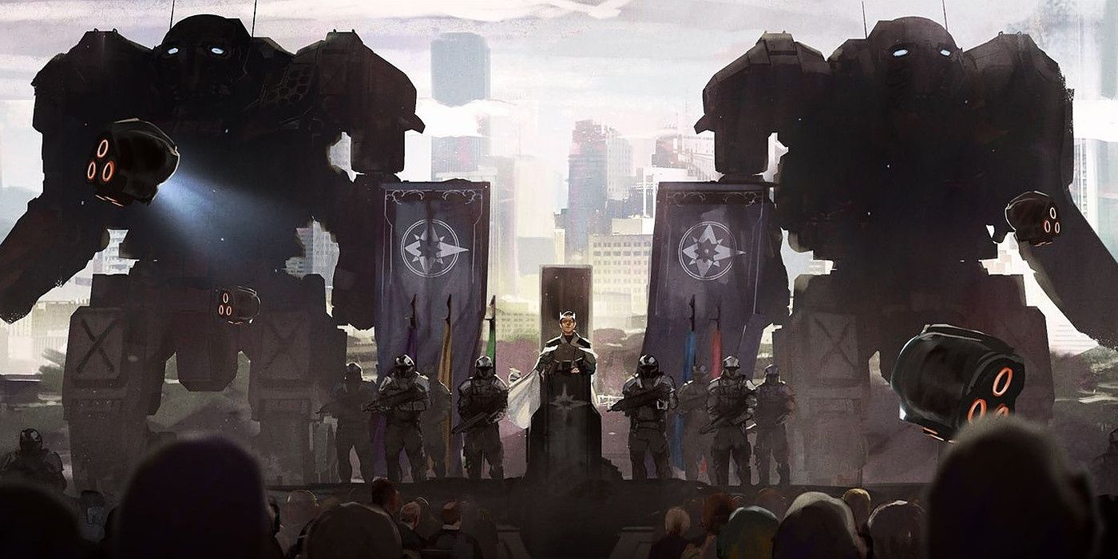

Hosted by Colorado Battletech and The Valhalla Club: Battletech Podcast

Sponsored by The Colorado Battletech Patreon

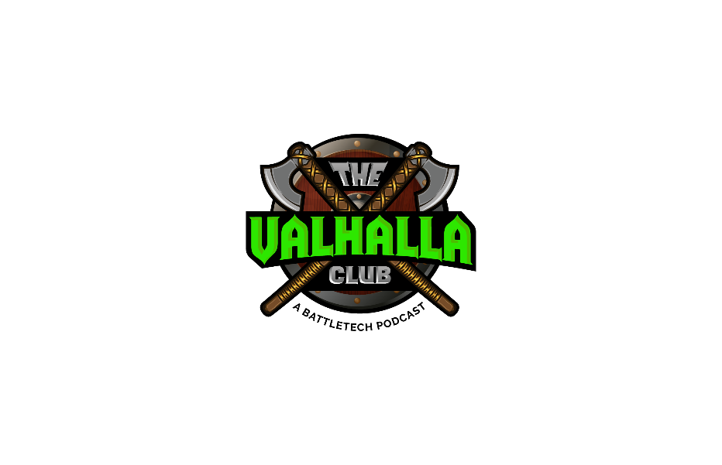

EVENT OVERVIEW

Welcome to our WOLFNET Alpha Strike 350 (AS350) Tournament. This event utilizes the Alpha Strike 350 tournament rules format found at <https://wolfsdragoons.com>. Players are expected to have read the document and bring one 350 point army and email their lists to [thevalhallaclub@outlook.com](mailto:thevalhallaclub@outlook.com) with the subject line “COPO 2 List” for validation 2 weeks prior to the tournament. Please include 2 copies of your full list printed from the Master Unit List website ([www.masterunitlist.info](http://www.masterunitlist.info)), as well as all necessary items listed in the AS350 rules. The tournament will be 4 rounds of swiss to crown the Winner!

## Welcome to the AS350 Tournament the Colorado Premier Open II!

The AS350 Tournament Format uses Alpha Strike: Commanders Edition core rules along with the AS350 Tournament Rules in order to create a fast paced, tactical game set in the Battletech Universe. Each player must design a 350 Point Value Army that is capable of capturing the four objectives found in 8 unique scenarios to win the contest. This format uses hexless 36”x42” maps and 10 pieces of 3D terrain per map. Armies are restricted to the Army Construction rules found in the AS350 document noted above.

**ERA: Star League**

## A big thank you to Colorado Battletech Patreon

## for sponsoring this event!

**Tournament organizer: David Burbridge**

EMAIL: thevalhallaclub@outlook.com

**[Facebook Page](https://www.facebook.com/groups/855610917900228)**

EVENT SCHEDULE

This event will have 4 rounds of swiss play that are 80 minutes in length with a 10 minute set up time before each game. There will be a 15 minute break between rounds as well as an hour break for lunch.

### 

|  |  |  |
| --- | --- | --- |
| Rounds | Start Time | End Time |
| Round 1 | 10:00 am | 11:30 am |
| Round 2 | 11:45 am | 1:30 pm |
| Lunch/Paint Judging | 1:30 pm | 2:00 pm |
| Round 3 | 2:15 pm | 3:45 pm |
| Round 4 | 4:00 pm | 5:30 pm |

FORMAT AND FAQ’s

This event will be in the casual format of the Wolfnet 350 rules but will utilize all of the optional rules allowed in a premier event. Proxying units is completely acceptable but the proxy must be an official Btech mini of the same type of unit, kit bashing is perfectly ok but 3Dprints are not allowed. When preparing your army we really encourage you to paint them, but it is not required to participate. Finally, the Alpha Strike Commanders Edition 6th printing and errata published before 9/1/24 will be in play. Unpublished errata that is not in the official release will not be used (ie forum posts on the Battletech errata forums). Finally, come prepared. In an effort to increase positive play experiences we are going to add a few additional rules to the Wolfnet Official Rules.

Additional Rules for List building:

**Combat Vehicle PV Minimum: All combat vehicles must be a minimum of 5 PV.**

**Banned Vehicles: Skimmers, Flatbed Trucks, J27’s are banned from this tournament.**

**Infantry PV Minimum: All Infantry units must be a minimum of 5 PV.**

**For the full Wolfnet AS350 Rules open the document below or go to** [Wolf's Dragoons | Running with the Pack (wolfsdragoons.com)](https://wolfsdragoons.com/)

