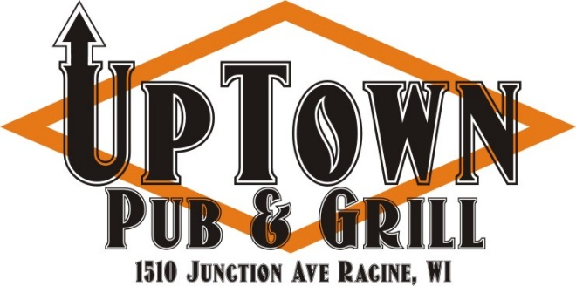


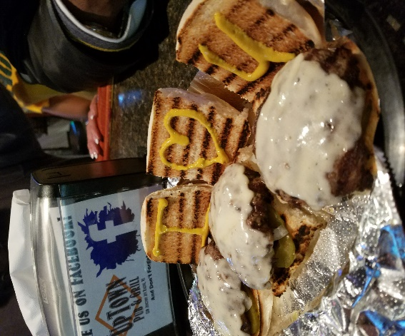
Not so fast fast food, but it sure is good! During high volume times please be patient. Thank You

Appetizers

Cheesy Bacon Bombs $10.00
Imagine warm biscuits stuffed with cheese & wrapped in bacon, finished with a drizzle of sugar & a side of Chipotle Mayo. An Uptown Favorite!
Mozzarella Sticks…$10.00
Again, Hand wrapped and seasoned with Parmesan. BIG!
Firecrackers…$10.00
Jalapeño Peppers stuffed with cream cheese & smoked bacon, breaded in Panko
Basket of French Fries
$5.50

Don’t forget to check the chalkboard
For the chalkboard specials!
COMING SOON!
FRIDAY FISH FRY!
Cod-Walleye-Mahi Mahi-Grouper



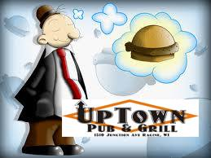
Consuming raw or undercooked meats, poultry, seafood, shellfish, or eggs may increase your risk of foodborne illness.

Wings (Traditional or Boneless)
10..$14 20..$27 40..$52
We take wings to another level. Our wings are fried to perfection and then tossed on the grill to add that little crisp and flavor our mouth will thank you for.
*Buffalo, Sweet Red Chili,
Garlic Parmesan, BBQ & Lemon Pepper
NEW!
Chicken Thighs-n-Fries
3 for $12

Shrimp Jammers……….$11
Cheddar or Jack Stuffed Shrimp served with a small portion of french fries and our garlic butter sauce.
Sliders (3)
Hamburger………..…………….…$8.50
Cheese Burger……….................$9.50
Pulled Pork…………….………....$10

Pulled Pork Sandwich…….…$10
Slow cooked pork shoulder blended with our Uptown BBQ sauce & topped with homemade coleslaw.

Flambeau Prime Rib Steak Sandwich……………………$17
Hand cut choice Angus Prime Rib seasoned and served on Texas Toast with Fries. Smother it with fresh mushrooms & onions for $1.00 each.
Stuffed Burger…………..$12
Stuffed with your choice of cheese. This gooey burger comes out with a molten center of cheese. This thing is HOT, so give it a minute before biting into it so you do not scald your tongue, then dive into it and enjoy!

Build your own Burger……$10
1/3lb burger grilled how you want it…Add as much as you like! See server for details
Ron Seniors Italian Beef…..$11
This tender Guarascio recipe is cooked with secret Italian spices served with an Aus Jus that is out of this world. This tender Guarascio recipe is cooked with secret Italian spices served with an Aus Jus that is out of this world.

Grilled Chicken Wrap……$12
Uptown Buffalo or Bacon Ranch , both are wrapped with lettuce, tomato, onion & cheese and of course…bacon.

Texas Toast BLT Club……$11
This three-layer club is an all-time American favorite with added size and flavor.
Caprese Style grilled cheese $8
This grilled cheese sandwich is inspired by Insalata Caprese, a dish consisting of mozzarella, ripe tomatoes, and basil. “Bon appetito!”
Grilled Cheese……………$8
Texas Toast, smothered in American cheese perfect for a taste of a childhood memory.

