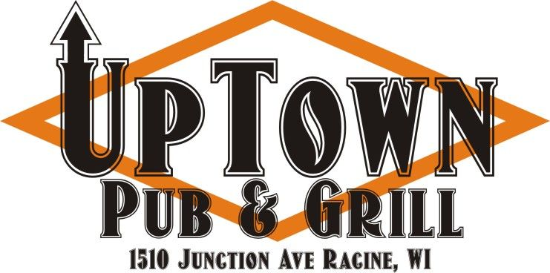  Custom Made Burgers and  Grilled Cheese  (Circle One)  Stuffed Burger Regular Burger Sliders  Chicken Breast Grilled Cheese  Med Rare Medium Well Done  STEP 1 - Ketchup - Mustard - Mayo - Pickle - Lettuce - Raw Onion STEP 2 (Add .50 cents) - Fried Onion - Tomato - Giardiniera - Jalapeno - Fried Pickles - Fried Mushrooms STEP 3 (Add $1.00) - Bacon - Fried Egg - Mozzarella Cheese - American Cheese - PepperJack Cheese - Bleu Cheese - Cheddar Cheese - Swiss Cheese - Sweet Red Chili - BBQ Sauce - Chipotle Mayo - Ranch - Uptown Buffalo - Marinara NAME _______________________  *ALL STUFFED BURGERS INCLUDE ONE CHOICE OF CHEESE  *GRILLED CHEESE INCLUDES FOUR SLICES OF CHEESE | Custom Made Burgers and  Grilled Cheese  (Circle One)  Stuffed Burger Regular Burger Sliders  Chicken Breast Grilled Cheese  Med Rare Medium Well Done  STEP 1 - Ketchup - Mustard - Mayo - Pickle - Lettuce - Raw Onion STEP 2 (Add .50 cents) - Fried Onion - Tomato - Giardiniera - Jalapeno - Fried Pickles - Fried Mushrooms STEP 3 (Add $1.00) - Bacon - Fried Egg - Mozzarella Cheese - American Cheese - PepperJack Cheese - Bleu Cheese - Cheddar Cheese - Swiss Cheese - Sweet Red Chili - BBQ Sauce - Chipotle Mayo - Ranch - Uptown Buffalo - Marinara NAME _______________________  *ALL STUFFED BURGERS INCLUDE ONE CHOICE OF CHEESE  *GRILLED CHEESE INCLUDES FOUR SLICES OF CHEESE

