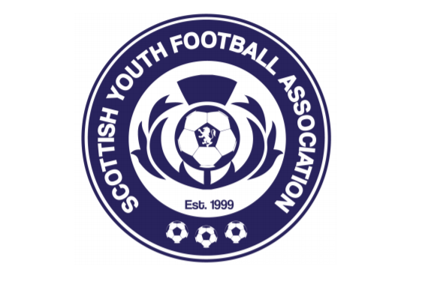

SCOTTISH YOUTH FA
SYFA C01: Official Written Complaint Form

Personal information of complainer:
Name:

Position: Member League / Member Club / Player / Official / Parent/Guardian of a player

Club: SYFA Club ID:

Contact information:

Complaint made against:
Delete as appropriate:

SYFA Member Club | Club Official | Club not in membership of the SYFA
SYFA Registered Player | Player’s Parent/Guardian | SYFA Member League
League Official | SYFA | SYFA Board Member or Staff
Name of individual(s) complaint refers to:

Summary of events leading to concern or dissatisfaction:
Please include details that may be relevant to an investigation such as dates, locations, and witnesses.
Do you believe there has been a breach of any specific Disciplinary Rule(s)? Please provide any relevant rule numbers below.

Please outline the steps you have taken to resolve this issue:

What would you consider to be a satisfactory outcome?

Evidence provided in support of the complaint):
 | Description of document attached as evidence (e.g. letter, e-mail, statement) | Name of witness providing evidence | Their position or role (e.g. parent, official, coach)
1.
2.
3.
4.
5.

Any other relevant considerations:

Confidentiality

In submitting this form an allegation is made. This allegation will progress on a strictly confidential basis. Any “Confidential Information” disclosed to you and by you for the purposes of any investigation must remain confidential and must not be disclosed for any purpose other than in connection with this investigation.

Confidential information is:
- Information relating to any SYFA investigation which is not publicly available
- Information which should reasonably be regarded as possessing a quality of confidence or as having sensitive value in relation to the business of the SYFA

This document will be circulated to the party to whom the complaint relates.
Any information that you do not wish to share should be sent in a separate envelope marked “Private and Confidential” together with this form to: Scottish Youth FA, Hampden Park, Glasgow, G42 9BF

Declaration

To the best of my knowledge, the information I have provided in this form is correct. I agree to act in accordance with Confidentiality terms above. I consent to SYFA processing and storing my personal information as necessary in handling this complaint.

Signed:

Print Name:

Date:

