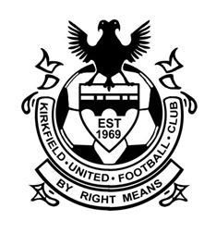

**SCOTTISH FA QUALITY MARK**

**CODE OF CONDUCT- PLAYERS**

We all at Kirkfield United Football Club have a responsibility to promote high standards of behavior in the game. As a player, you have a big part to play by playing by the clubs motto of ‘By Right Means’. Fair Play and respect for all others in the game is essential. We are asking every player to follow a Code of Conduct to honor our game.

When playing football, I will:

* Always work hard to learn and improve and play to the best of my ability.
* Play for my own enjoyment and to improve my own skills.
* Play fairly with sportsmanship and respect to Honor Our Game.
* Respect my team-mates, opposition, officials and self. Treat all players as I would like to be treated – fairly.
* Control my temper – verbal abuse of officials and abusing other players doesn’t help you enjoy or win any games.
* Play by the rules – the rules of the club and laws of the game.
* Value my opposition by playing hard and fair.
* Shake hands with the other team and referee at the end of the game.
* Lead by example both on and off the pitch.
* Cooperate with my coach, the referee and team-mates.
* I will not use ugly remarks based on gender, race, religion or ability – you will let down your coach, team-mates and family if you do – and many such comments are now illegal.
* Talk to someone I trust or the club welfare officer if I’m unhappy about anything at my club.

I understand that if I do not follow the Code of conduct, actions may be taken by my club, league or National Association.

Player: _____________________________________ Date: _________________

Coach: _____________________________________ Date: _________________