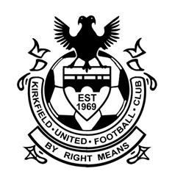

**SCOTTISH FA QUALITY MARK**

**CODE OF CONDUCT- PARENTS & SPECTATORS**

We all at Kirkfield United FC have a responsibility to promote high standards of behavior in the game. Parents have a great influence on children’s enjoyment and success in football. Children play football because they first and foremost love the game – it’s FUN. We ask all our players to play by the clubs motto of ‘By Right Means’ and ask you support in the same way. Remember children’s football is a time for them to develop and learn. We want them to win but not at all costs. Play your part by supporting your child and observe the Code of Conduct at all times.

I will:

* Remember that children play for FUN.
* Applaud effort and good play.
* Always respect the match officials’ decisions.
* Remain outside the field of play or within the Designated Spectators’ Areas.
* Let the coach do their job and not confuse the players by telling them what to do.
* Encourage your child, and others, or be quiet. Praise for effort and performance, not results.
* Encourage the players to respect the opposition, referee and officials.
* Avoid criticising a player for making a mistake – mistakes are part of learning.
* Never engage in, or tolerate, offensive, insulting, or abusive language or behavior.
* Parents must develop an appropriate supportive relationship with both the coach and their child based on mutual trust and respect.
* Support the coach’s decisions and discuss any concerns directly with the coach.

I understand that if I do not follow the Code of conduct, action may be taken by the club, league or National Association.

Parent: ________________________________________ Date:_______________

Coach: ________________________________________ Date:________________