

Cooking with your dog

Training while making homemade treats for your dog



March 19, 2022

REn’s Pups, LLC

1025 Anderson Rd., Hendersonville, TN 37075

**Pumpkin Dog Biscuits**

By [Jim McCourt](https://www.facebook.com/jim.mccourt?eid=ARDiADms23Ld_lkcO2S0bCt43h2G-fZBFV7STs0JRQKY0Y-pfKch4bxrmHElhrBodShpkGTn10ThSAi5) on [Saturday, August 15, 2015 at 8:53 PM](https://www.facebook.com/notes/dog-treat-recipes/pumpkin-dog-biscuits/919205434818152/)

2 eggs  
1/2 cup canned pumpkin  
2 tablespoons dry milk  
1/4 teaspoon sea salt  
2 1/2 cups whole wheat flour (use RICE flour for GLUTEN FREE)  
1 teaspoon dried parsley (optional)

Preheat oven to 350.

In large bowl, whisk together eggs and pumpkin to smooth. Stir in dry milk, sea salt, and dried parsley (if using, optional). Add brown rice flour gradually, combining with spatula or hands to form a stiff, dry dough. Turn out onto lightly floured surface (can use the brown rice flour) and if dough is still rough, briefly knead and press to combine.

Roll dough between 1/4 – 1/2″ – depending on your dog’s chew preferences, – and use biscuit or other shape cutter to punch shapes, gathering and re-rolling scraps as you go. Place shapes on cookie sheet, no greasing or paper necessary. If desired, press fork pattern on biscuits before baking, a quick up-and-down movement with fork, lightly pressing down halfway through dough. Bake 20 minutes. Remove from oven and carefully turn biscuits over, then bake additional 20 minutes. Allow to cool completely on rack before feeding to dog.

Makes up to 75 small (1″) biscuits or 50 medium biscuits

**3-Ingredient Peanut Butter Pumpkin Homemade Dog Treats**

By [Jim McCourt](https://www.facebook.com/jim.mccourt?eid=ARA34PW-m8xMIxli2SSar80P85bV2NnqfvobR0HnGiabLWN_NJDDCR_cff_Z5m40sjngcoSx_5eV5fSB) on [Saturday, August 15, 2015 at 8:40 PM](https://www.facebook.com/notes/dog-treat-recipes/3-ingredient-peanut-butter-pumpkin-homemade-dog-treats/919202474818448/)

1/2 cup Natural Peanut Butter  
1 cup 100% Pure Pumpkin Puree, canned  
1 3/4 cups whole wheat flour (I used Whole Grain Brown Rice Flour)  
  
Directions:  
  
1. Preheat oven to 350 degrees Fahrenheit. Line a cookie sheet with parchment paper.  
  
2. In a large bowl, stir together peanut butter and pumpkin. Stir in the flour 1/4 cup at a time just until dough is no longer sticky.  
  
3. Roll the dough out between two sheets of parchment paper to 1/4″ thick. Use a cookie cutter to cut out the dough, then place on the prepared pan.  
  
4. Bake at 350 degrees Fahrenheit for 8-10 minutes. Let cool completely. Store in an airtight container or freeze for up to 3 months

## Grain-Free Blueberry and Banana Dog Cookies

By [Jim McCourt](https://www.facebook.com/jim.mccourt?eid=ARBBj4037I5SGYf8AErGKnRpKc-GlFaupC8yTaXqj5s5sJVO4awFzp8D-9wYl2OUodB3r3gYLZCcGeB-) on [Saturday, August 15, 2015 at 8:37 PM](https://www.facebook.com/notes/dog-treat-recipes/grain-free-blueberry-and-banana-dog-cookies/919201934818502/)

These grain-free dog treats are made with nutritious blueberries, tasty banana, and a touch of peanut butter for that drool-worthy factor! Made with grain and gluten free coconut flour for skin and coat health, these yummy doggie biscuits are full of antioxidants and vitamins.

This recipe is super easy to make, very inexpensive and healthy for your dog! Having control over your dog's treats makes all the difference in the world. You can control the quality, the ingredients and the nutrition factor of your best friend's snacks! That means the world these days with all the recalls on store bought dog treats that have been going on lately.

**INGREDIENTS**  
1 cup of coconut flour  
1/2 cup of smooth peanut butter  
1/2 cup of mashed blueberries  
1/2 cup of mashed bananas  
4 eggs  
1/3 cup of warm water

**DIRECTIONS**

1. Preheat your oven to 350 degrees.
2. In a large bowl, combine the coconut flour, peanut butter, crushed blueberries, mashed banana, eggs, and water. Mix thoroughly, add more water if it is too dry.
3. Roll out your cookie dough and use a cookie cutter to cut out shapes, or place on a cookie sheet covered in parchment paper in your size and shape of preference.
4. Bake in the oven for 22 minutes.

## PYRAMID BAKING SHEET RECIPES

**Philly Cheese Steak Treats**

1 cup steak, cooked

1/4 cup cheddar cheese, shredded

2 eggs

1/4 cup flour if choice (I have used tapioca, all purpose and wheat)

1/2 cup water or beef broth

**DIRECTIONS**

Combine in food processor until smooth, adding water or flour to reach pancake batter consistency. Spread onto pan, bake at 350 degrees for 20-30 minutes, pop out onto sheet pan and allow to cool in cooling oven to further dry then out.

**Chicken Bacon Parmesan Treats**

10oz canned chicken

1/4 cup parmesan

1/2 cup flour of choice (I have used all purpose wheat and tapioca)

1 slice cooked bacon

1 Tbsp bacon grease

Fresh or dried parsley

2 eggs

**DIRECTIONS**

Blend together in a food processor until smooth. Add more flour/water to achieve pancake-batter consistency. Spread into pan and bake 20-30 minutes at 350°. To make crisp, turn off oven and let them cool in oven. Can repeat again for extra crunchy to create shelf stability by dumping them out of mold and onto pan, putting them in a 350 oven then shut oven off and let them cool with oven again.

**Pizza Treats**

2 eggs

1/4 cup parmesan

1/2 cup mozzarella

10 small pepperoni slices

1/4 cup pizza sauce

Fresh or dried Italian herbs (I used fresh basil, oregano and parsley)

1/2 cup flour of choice (I have used all purpose, wheat and tapioca)

**DIRECTIONS**

Blend until smooth. Add flour or water as needed to make a pancake batter consistency. Spread into mold. Bake at 350° for 20 minutes, turn oven off and leave in oven to cool.

**Parmesan Cheese, Cheddar Cheese and Garlic Treats**

2/3 cup Parmesan

2/3 cup Cheddar

3 large eggs

1 tsp Garlic

1 cup tapioca flour

**DIRECTIONS**

Blitz the Parmesan in the blender first. Then add Cheddar and blitz again until all are pulverized. Then add three eggs and garlic and the tapioca flour and blitz until all are well mixed and smooth. Bake at 350 for 15 minutes. Makes two sheets of treats.

**Tuna Pyramid-Pan Treats**

1 can of Tuna (in water preferable)

2 eggs

100g plain flour

Water

**DIRECTIONS:**

Preheat oven to 350.

Mix well in a blender, adding water if necessary

Smooth mixture over your baking mat and bake for approximately 20 mins

**Apple Basil Green Bean Broccoli Soft Treats**

1 cup broccoli florets

1 cup chopped green beans

1 apple cored and sliced (I used a Honeycrisp Apple)

1 tsp. basil (dried)

1 cup of water from the steaming pot

½ cup coconut flour

¼ cup tapioca flour/starch

2 large eggs

¼ cup cold pressed coconut oil (melted)

**DIRECTIONS:**

Place apples, green beans, and broccoli into steamer pot over boiling water, cover. I add the basil to the steamer water, so to infuse the water with the basil and then use it in the mix. Cook for 10 minutes or until all vegetables are easily pricked with a fork.

Place steamed vegetables, apple and 1 cup of basil infused steamer water into blender. Blend until a puree consistency. Blend in eggs until incorporated (Yields approx. 3 cups of puree). Place puree into a mixing bowl and add coconut flour, tapioca flour and coconut oil. Mix until fully incorporated.

Spray then fill your pyramid pan with mix and bake at 350 degrees F for 20 mins. (Adjust temp and time for your ovens performance).

Remember to cool completely before placing in an airtight container (condensation speeds up the molding process).

## GOLDEN PASTE RECIPE FOR DOGS DOUG ENGLISH

This is a golden paste recipe your dog will love. Even if his taste buds don’t, his body certainly will.

* Preparation Time: 5 minutes
* Cooking Time: 15 minutes

**Note re. the oil**. You can use raw, unrefined coconut oil / flaxseed-linseed oil, virgin or extra virgin olive oil / organic MCT oil / ghee.

**Note re. the ground pepper**. Ready-made ground / milled black pepper is no good for making golden paste. The active ingredient we need in pepper – piperine – begins to oxidise as soon as it is ground, so that’s why we grind it just before making the paste. Buy black pepper corns and grind them yourself.

### **GOLDEN PASTE FOR DOGS INGREDIENTS**

* 1/2 cup (125 ml / 60g) turmeric powder
* 1 cup water (250 ml) plus extra water in reserve, if needed
* 1/3 cup (70 ml) oil (see above for oil options)
* 2 – 3 teaspoons freshly cracked (ground) black pepper

### **INSTRUCTIONS**

1. Put the turmeric and the water in a saucepan and bring them to the boil, stirring constantly so it doesn’t stick to the bottom and burn.
2. Lower the heat to a simmer. Keep stirring until it becomes a paste – this will only take 2-3 minutes. Note: If you buy turmeric labelled as ‘Raw’ you will need to simmer the turmeric in the water for around 25-30 minutes. Raw turmeric takes longer to cook than standard turmeric. If it dries out too much, add a little extra water.
3. Remove it from the heat and let it cool for 10 minutes.
4. Add the freshly ground black pepper and the oil. The mixture should still be warm so if you’re using coconut oil it will melt into the mixture.
5. Stir it until the ingredients are well combined and leave it to cool.

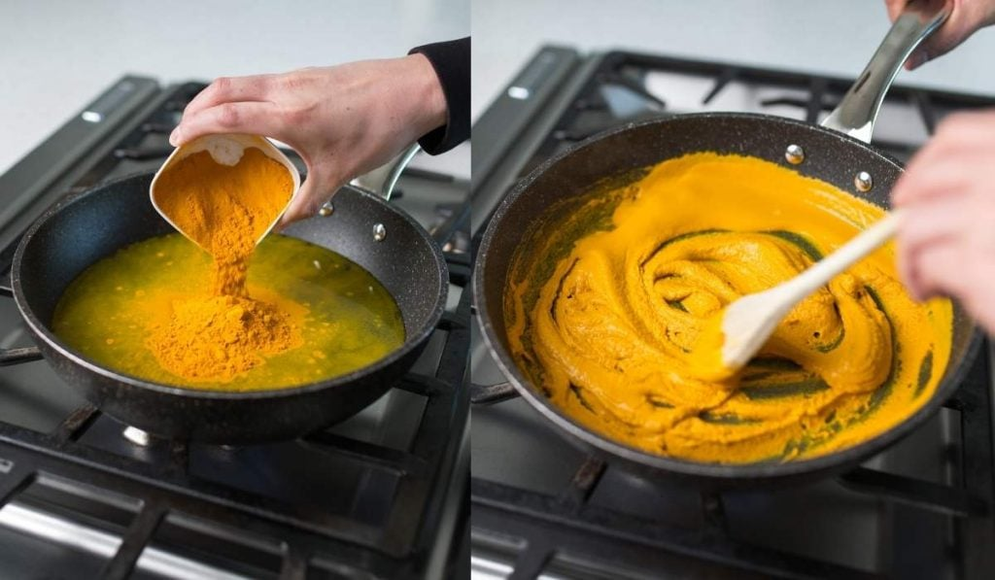Steps 1-2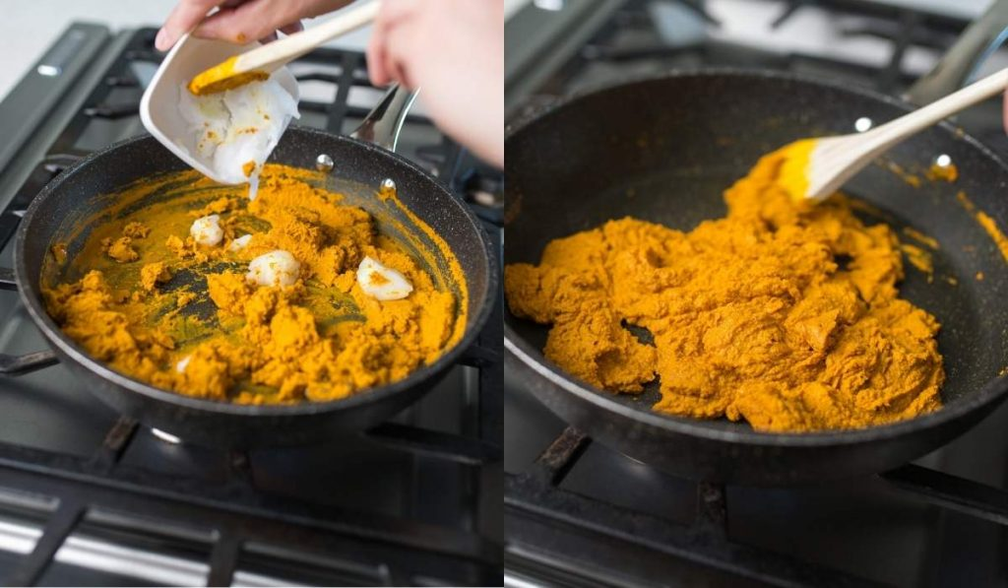Step 4

## HOW TO STORE GOLDEN PASTE

Once it’s cool, put it in a jar and keep it in the fridge. I also put a label on the lid with the date I made it, though it’s usually used up in 10 days or so.

Freeze it in smaller portion sizes if you’re not expecting to use it all within a couple of weeks. I often use silicone ice cube trays to freeze individual feeding portions.

## HOW LONG DOES GOLDEN PASTE FOR DOGS KEEP FOR?

It should keep well for at least 2 weeks, but after 3 weeks, throw away any unused paste. The water in the recipe introduces the chance of mould and bacteria growing in it.

## GIVING TURMERIC GOLDEN PASTE TO YOUR DOG

Some dogs dislike the bitter taste. The easiest way to give golden paste to your dog is mix it on with his dinner.

It can also be stirred into a little kefir.

## HOW MUCH GOLDEN PASTE SHOULD I GIVE MY DOG?

If your dog hasn’t had turmeric before, start with a small amount of golden paste and work up to the following dosages:

* 10lbs dogs 1/4 teaspoon per day
* 20lbs dogs 1/2 teaspoon per day
* 30lbs dogs 3/4 teaspoon per day
* 40lbs dogs 1 teaspoon per day and so on

Turmeric doesn’t stay in the body very long, so it’s best to split the dosage – half in the morning and half in the evening.