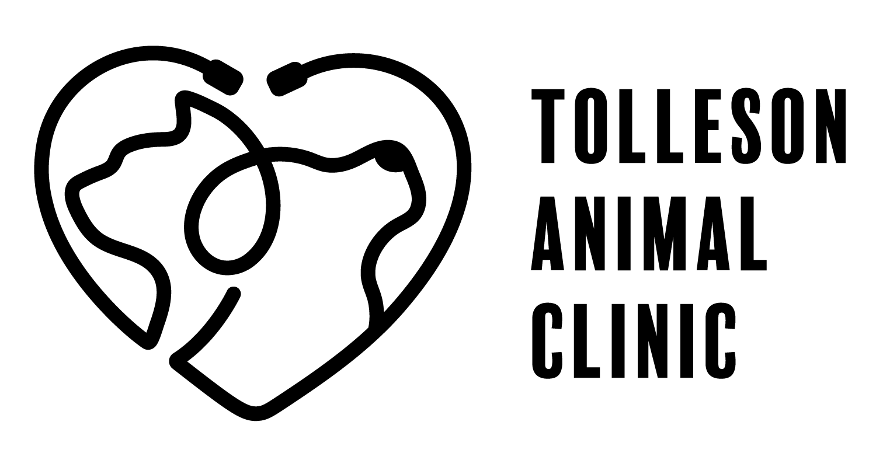
2735 S 99th Avenue Suite G-103
Tolleson, Arizona 85353
Phone: 623-936-7387 | Text: 623-471-7827
Fax:623 936-6295
www.tollesonanimalclinic.com

Comprehensive Oral Health Assessment and Treatment (COHAT) Information

Oral hygiene is an often overlooked but important factor in your pet's overall health. If they have a toothache or sore gums, they're dealing with pain and stress that you may not even know about. If the area is left untreated, bacteria introduced by the problem can enter the bloodstream and affect their heart, kidneys or liver. Veterinarians report that an estimated 85 percent of pets over age 4 are suffering from some form of periodontal disease, a painful oral condition that can lead to tooth loss and infection. The good news? All of these problems are preventable with regular dental cleanings and professional checkups.

Cost | Item
$469  ($99 of this is for blood work done before surgery day) | Comprehensive Oral Health Assessment and Treatment (COHAT)  The procedure takes place while your pet is under anesthesia. During the procedure, your pet will receive fluids via an IV-Catheter and vital signs will be monitored by a skilled technician.  Dental x-rays will also be taken to assess root health.  The COHAT includes: dental cleaning, scaling to remove tartar, polishing to help preclude future tartar accumulation, and fluoride treatment to strengthen the tooth enamel. This is all followed by a thorough examination of each tooth, the gums, and surrounding tissue.  Preoperative Bloodwork  REQUIRED for all pets. This is done before the day of surgery. No more than 2 weeks before the scheduled surgery date.

We require a pre-surgery exam prior to scheduling the surgery. This is so the doctor can take a look at your pet and make sure everything is good to go for surgery. There is no charge for the pre-surgery exam; however, we do have you leave a $100 deposit that will be applied to the surgery cost. The total minimum amount due at your pre-surgery exam is $190.

The range for the dental is $445 - $1500, depending on services performed.

As Maya Angelou said “Hope for the best and be prepared for the worst”

Additional cost information on the back
Required Expenses - Must be paid to Tolleson Animal Clinic before the procedure is performed

Cost | Item
$50 | Rabies Vaccination  An up to date Rabies vaccine is required. If your pet is currently not up to date, we can administer a vaccine during the pre-surgery exam.
$100 | Deposit  This deposit is used to hold your pet’s surgery slot and will be applied to the cost of the procedure.  If you need to cancel or postpone your procedure, let us know 48 hours in advance, otherwise, you forfeit your deposit and will incur an additional deposit of $100 to reschedule.

Additional Charges - Dependent on the condition of your pet’s teeth

Cost | Item
$60 - $700 | Extractions  The veterinarian cannot fully assess how many, if any, teeth need to be removed until after the dental cleaning has begun. Due to the fact that some teeth are more complicated than others to remove, the price will depend on the number and difficulty of extractions performed.  *There are rare exceptions where the cost exceeds $700.
$22 | Suture material  If extractions are necessary, the veterinarian may need to suture the area.
$30 - $50 | Pain Medication  If extractions are required, pain medication will be prescribed for your pet. This price includes one dose administered at the time of the procedure and additional doses that are sent home with the owner.
$30 - $100 | Periodontal Filler  Cementing gel to preserve a tooth for a little longer. It has shown significant reduction in pocket depth and improves overall periodontal health.

Optional Services - Items you may elect to perform while your pet is under anesthesia

$120 | Sealants  SANOS® works by getting into those hard-to-reach places under the gumline, especially around the back teeth. It acts like a clear, self-drying bandage that helps protect against plaque and tartar buildup for up to 6 months!  This is important because while cavities are less common in pets, gum disease is a big concern. Keeping the gumline clean can help prevent problems that might lead to tooth extractions down the road.
$25-$100 | Cerenia  Cerenia, an antiemetic, can reduce nausea, pain, and anesthesia requirements during surgery, leading to a faster recovery time.
$15 | Nail trim  We can more closely trim your pet’s nails while under anesthesia to avoid discomfort for your pet.
$59 | Microchip  If your pet is ever lost, a microchip can help reunite you with your pet. This fee includes the insertion of the microchip and lifetime registration.

