2735 S 99th Avenue Suite G-103
Tolleson, Arizona 85353
Phone:623 936-7387
Fax:623 936-6295
www.tollesonanimalclinic.com

Ear Cleaning Handout

Owner: | Pet: | Date:

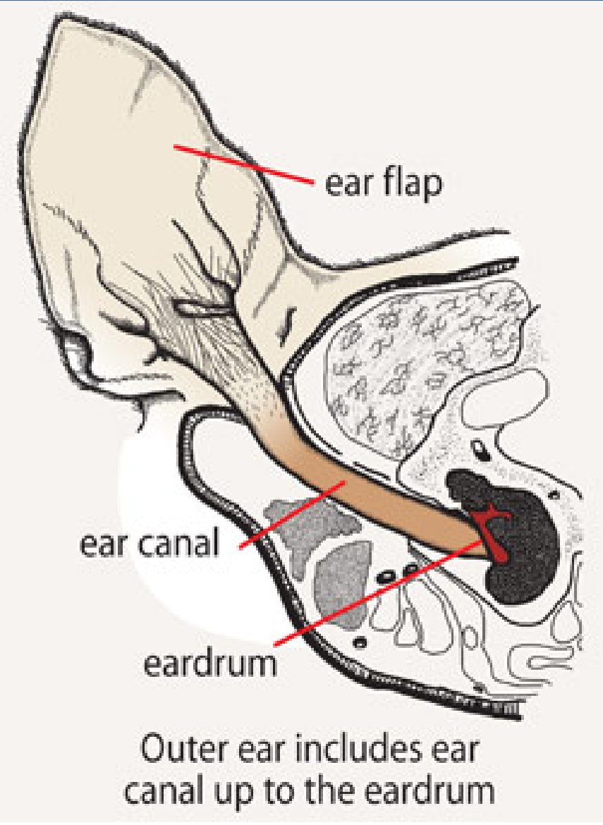
Good ear cleaning techniques are essential for treating your pet’s ear infection and maintaining healthy ear canals. The primary goal of an ear cleaner is to remove excessive discharge or cerumen (wax) from the ear canal with the least amount of trauma to the ear.

1. Warm the cleaning solution to a temperature that is comfortable when tested on the back of your hand. Do this by either leaving the solution in a warm area for a few hours or bathing it in warm water.

2. Apply a generous amount of the warmed cleaning solution into the ear canal. Massage the base of the ear to disperse the cleaning solution deep into the ear canal.

3. Allow your pet to shake its head to remove the solution. This is best done outside to prevent soiling carpet, walls, etc. If there is a lot of debris in the ear, you may have to repeat the application until the cleaning solution is clear of debris.

4. As a final step, you can use a cotton ball to absorb the excess solution from the pinna (ear flap) and external ear canal and to gently wipe away any loose debris from the surface of the ear. Do not use cotton swabs (ie. Q-Tips) for cleaning as they can push cerumen (wax) further into the ear canal. The frequency of cleaning will vary according to your veterinarian’s recommendations.

If you notice excessive head shaking or pain associated with your pet’s ears, or the condition persists after following the prescribed treatment, contact your veterinarian.

