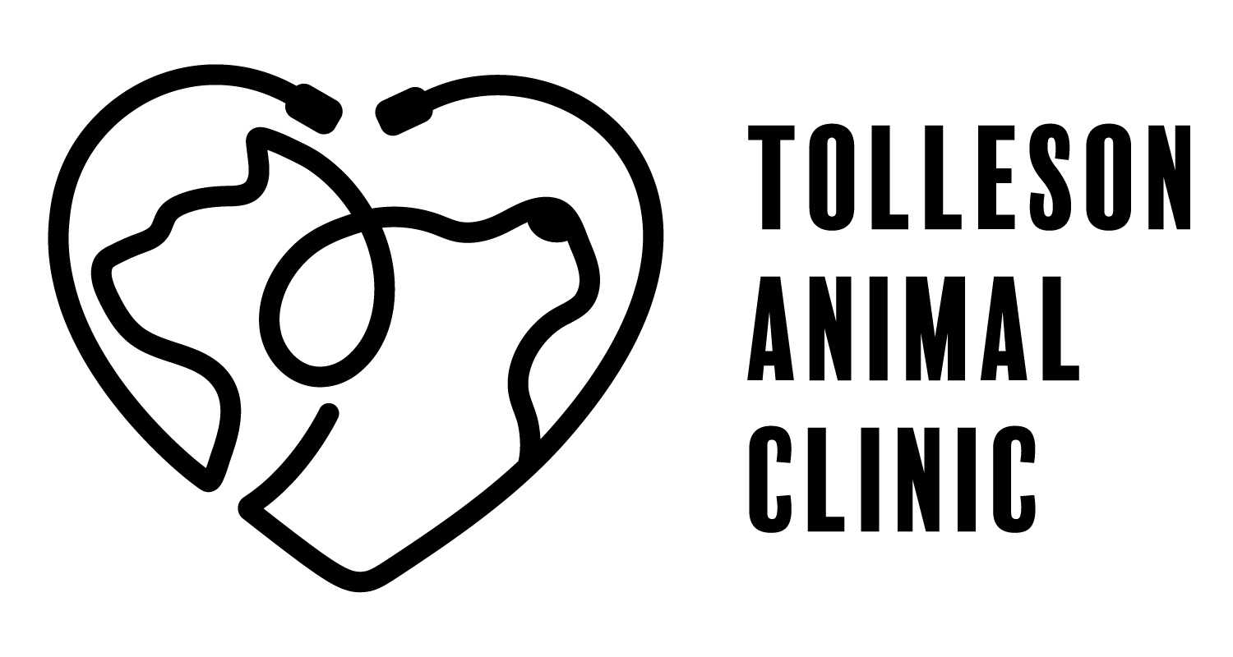
2735 S 99th Avenue Suite G-103
Tolleson, Arizona 85353
Phone:623 936-7387
Fax:623 936-6295
www.tollesonanimalclinic.com

Voucher Information Handout

We partner with Fix.Adopt.Save to provide Spays and Neuters at a lower cost. The pink voucher covers the cost of the surgery; however, it does not cover the additional expenses we require such as pain medication. We will need a pre-surgery exam (this is at no cost; however, we do have you leave a deposit to schedule the surgery) before scheduling the surgery for your pet. This is so the doctor can examine your pet and answer any questions.

Required Expenses - Must be paid to Tolleson Animal Clinic at the time the procedure is performed

Cost | Item
Included with the pink voucher | Rabies Vaccination  (If your pet does not have a current rabies vaccination, one will be required before the procedure). The pink voucher covers the cost of a Rabies vaccine and ONE Distemper/Parvo vaccine. Your pet will need a booster of the Distemper/Parvo vaccine 3-4 weeks after the first one if they’ve never had the vaccine before at an additional cost.
$90 | Preoperative Bloodwork  (REQUIRED for all pets over 3 years of age; optional for all other pets)
$100 | Spay & Neuter Procedure  Spaying takes place while your pet is under anesthesia. During the procedure, your pet will receive fluids via an IV-Catheter and vital signs will be monitored by a skilled technician.  Note: Pets must fast overnight prior to spaying procedure.  Pain medication and an e-collar are included. One dose of pain medication is administered at the time of the procedure and additional doses are sent home with the owner. An e-collar, better known as the cone of shame, is recommended to prevent your pet from licking their incision, causing an infection and/or opening the surgery site.
$100 | Deposit  This deposit is used to hold your pet’s surgery slot and will be applied to the cost of the procedure.  *If you need to cancel or postpone your procedure, let us know 48 hours in advance, otherwise, you forfeit your deposit and will incur an additional deposit of $100 to reschedule.

Additional Charges - Dependent upon your pet meeting specific criteria

$150 | In heat/Pregnancy/Overweight.  A complicated spay requires more time to complete the procedure to help minimize complications after surgery. If your pet's surgery will need added surgical and anesthesia time, you will be charged.

Optional Services - Items you may elect to perform while your pet is under anesthesia

$35 | Phovia  Phovia is LED light therapy that helps reduce healing time up to 50%.
$13 | Nail trim  We can more closely trim your pet’s nails while under anesthesia to avoid discomfort for your pet.
$49 | Microchip  If your pet is ever lost, a microchip can help reunite you with your pet. This fee includes the insertion of the microchip and lifetime registration.

