
Annual
Duran’s Down Home Days
Saturday June 6, & Sunday, June 7, 2026
Gazebo Parks, Waterford Pa

*Sign up for FREE SPACE*
Name: _______________________________________________
Contact Person: ____________________________________________
Phone #--Email:_____________________________________________

I/We would be interested in volunteering in the following area(s) [circle your choice(s)]:

Demonstrating – Games – Staffing/Raffles – Make & Take
Workshops – Set Up/Clean Up Crew – Face Painting
Music/Entertainment – Donation of Product/Services – Other

List details (include space size), available days/times: ____________________________________________________________________________________

This nonprofit works with the Erie VA Medical Center & transports Veterans.

DEADLINE: May 16, 2025
EVENT BENEFITS
Erie VA
Volunteer Transportation Network

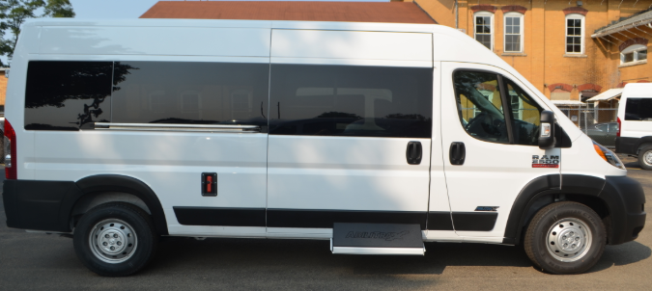
Please return completed forms to:
Duran’s Down Home Days
10532 Rt. 97
Waterford, PA 16441
- For more information, call (814) 490-2179
- Or visit www.duransdownhomedays.com

