
12th Annual
Duran’s Down Home Days
Saturday, Sunday
June 6th, 7th
*** 2026 ***
Gazebo Parks
Waterford, Pa.
On behalf of The Duran Down Home Day’s Team and the charity, we would like to thank our past and future sponsors. Without this support our Down -Home Days would not be as successful. The support from our neighbors and friends has been overwhelming.
So, with that being said,
THANK YOU !!!
SPONSOR Information

OUR 2026 Charity Is:
Erie VA Volunteer Transportation Network who assist in transporting Veterans. In 2025 they logged over 300,000 miles on their wheelchair accessible van and transported over 3,000 Veterans. Proceeds will help them replace their current vehicle.
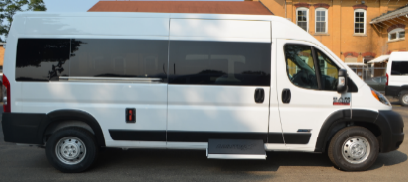

12th Annual Duran’s Down Home Days
Donation Info.
- $250 and up, will get your name on the Sponsor Banner. Please provide your preferred logo and/or message that will be shown.
- Partner Sponsor for a specific feature $250+ (Music/Bands, Cast Iron Chef Challenge, Entertainment/Stage, Security, Raffle prizes).
- Themed Baskets or items for the Vendor Auction are also accepted
- Other Donation (Please indicate dollar amount or worth)

- All options are available and may remain anonymous.
- Receipts are available upon request.
- We are a recognized 501c entity.
- Checks payable to: Duran’s Down-Home Days, 10532 Rt. 97, Waterford, Pa. 16441

Participation Deadline for this event is May 16th, 2026

Name ________________________________________________________________________

Signature _____________________________________________________________________

Address ______________________________________________________________________

Ph# ___________________________

E-Mail ________________________________________

Donation:
Gold Level $500 ______ Silver Level $250 ______ Bronze Level $100 ______

Other _________________________________________________________________________

