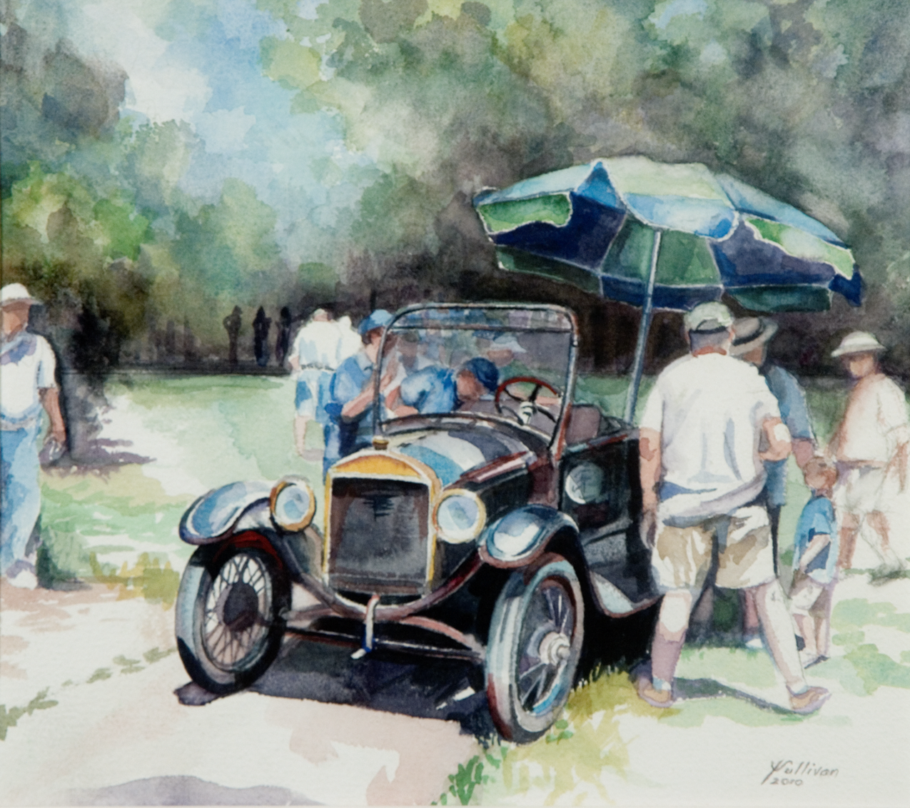
Nation’s Capital Model-T Ford Club
Take-Apart Car Guideline
2011

Table of Contents

1 Introduction 3
2 How They Do It in the Nation’s Capital 3
3 Yearly Operations 4
4 Overview of a Show 4
4.1 Narration of a Show 5
4.2 Team Composition 7
4.3 Disassembly Process 7
4.4 Assembly Process 9
4.5 Rules of the Road 10
4.6 Tools and Their Purpose 11
5 Annual Spring Tune-Up 11
6 Assembly Car Registration and Insurance 11
7 TAC Crew Chief Duties 12
8 Storage 12

Introduction
This booklet provides information on the Nation’s Capital Model-T Ford Club (NCMTFC) Take-Apart Car (TAC). Over the years, beginning in 1966-67, club members have enjoyed working with our TAC car (also called the assembly car). As well, we have entertained and educated thousands of people at car shows up and down the east coast. Through our narration, families and other spectators learn a little about America’s automotive heritage through exposure to Henry Ford’s Model-T.
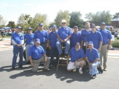
Since inception, TAC shows have raised funds for the club. Club members donated parts, and Ken Poeckert donated the trailer. Some of the early members who worked on the TAC team were: Mel Torney, Joe Canova, Don Olson, Cliff Jenkins, Bob Russell, Bud “Woody” Woodson, and Elmo Wurdeman.
Figure 1Recent TAC Team
This booklet primarily intends to help club members participate in TAC activities. It can serve as a point of departure for new team members, and it can also help new crew chiefs and others who need information. Most club members would agree, however, that hands-on experience is the best guide for learning about the TAC.

How They Do It in the Nation’s Capital
“At a board of directors meeting during the winter of 1966-67, one of the members brought up the subject of a car assembly team. We discussed the matter rather thoroughly and several of us started to say, “I have a frame,” “I have a front end,” “I have a gas tank,” “Herb has a radiator,” and so on. We decided we could assemble enough parts to make a suitable car.
At our next regular meeting we presented the possibility of forming a car assembly team. The idea seemed to catch on and we started listing parts and donors. A Saturday was set to gather parts and we started to clean and paint. The following Saturday we met again to assemble our parts into a car. It was then that we found the frame was sprung and several other parts didn’t fit together like they might. Back on the phone to find other parts. Others were found and painted. On about the third Saturday we had an assembled chassis with an engine that ran and a transmission that worked.
By the time we had a running car put together we could see that we would need six men for the team. Prior to the demonstration, the car would be stripped of its wheels, axles, motor, gas tank, steering wheel, fire wall, radiator, etc., all the parts then placed in a pile and disarranged so as not to look like a car. At a given signal the team would sort the parts, assemble the car, start the engine and drive a few feet to show that it was an operative car.
By now the word was out that we were working on a “take-apart car.” The National Capital Region of the AACA asked us to do the car assembly at one of their summer meets. This we did and the crowd was well-pleased.
During the next summer, several changes were made and parts added. The biggest change was in the wheels. Wire wheels were added so as to eliminate handling of wheel bearings and keys. The following spring a complete pick up body was found for the chassis and this addition makes it look more like a car. Then running boards and fenders complete with lights were added.
With this complete car the team performed again at several local meets and at the Rockville Antique and Classic Car Show last fall as well as at the National AACA spring meet in Winchester, Virginia. At the Rockville meet the team was filmed in action for a later showing on a Washington TV newscast.
Our best assembly time for the chassis was 7 minutes from start to running. Other times range from 8 to 9 minutes. However, with the addition of the body and fenders, etc., this time has become somewhat longer but is still within our originally announced time of 15 minutes.”

Yearly Operations
Various behind the scenes activities support TAC operations throughout the year. Shows need to be planned and scheduled, team members identified, and the car needs to be maintained. During the club’s January planning meeting, the TAC chairperson identifies possible shows and dates, and these become more concrete throughout the spring. At the January or February club meeting, the TAC chairperson explains the planned schedule and asks for a vote from members on supporting these shows. If a show cannot be supported, the chairman informs the sponsoring organization in advance of the event. Usually, we spend a day performing annual maintenance in April or May, and the show season normally runs from June until early October.

Overview of a Show
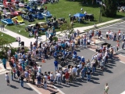
For each show, the crew chief makes sure the car, team, and other necessary resources arrive at the show and the car is delivered to the designated storage location after the show (see TAC Crew Chief Duties below). Normally the car and trailer arrive well before the show. Available team members unload the car and move it to the actual show site. Driving the car a short distance verifies the car is running before disassembly. To help the audience, we post signs giving the assembly time and also put out some literature for people interested in joining our club.
Figure 2 Aerial View of TAC Assembly
The team generally gathers at least two hours before the assembly time to disassemble the car. The crew chief makes sure everyone understands the process and is clear on their assignments. Next, the crew disassembles the car. When the car is disassembled, the audience has a chance to look over the parts, and ask questions.
At assembly time, the narrator gives a running commentary as the team assembles the car (see next section, Narration of a Show). We do two types of show: fast (or timed) assembly and historic or slow (untimed) assembly. In both types of show, the commentary helps the audience understand the history of Model-Ts, and it also gives insight into the various steps of assembly. In the slow shows, the narrator has more time to elaborate and controls the pace of the assembly process. In timed assemblies, the narrator describes the process, but the assembly team controls the speed of assembly.
After assembly, we start the car and drive it a short distance to show that it runs. After the show, we pack up tools and equipment and load the car on the trailer for transport back to its storage location.

Narration of a Show
The narrator needs a public address system. If the hosting organization has a setup we often use it. The club also has a portable bull horn which can serve this purpose. The following offers a sample narration, which can server as a point of departure for a show.
Introduction
"Ladies and gentlemen, you are about to witness a spectacular event. This precision team of highly skilled, aging auto mechanics will assemble the pile of junk that you see scattered about here, into a fine running Ford truck, and drive the vehicle away, all in less than 15 minutes" (if a timed show).
Next, the narrator introduces the show and our team.
For a number of years, Erwin Mack has been our main narrator. For timed shows, Erwin usually recruits a “dishonest” woman from the audience to serve as the time keeper. He introduces his assistant, and she gives a countdown that starts the assembly.
The NCMTFC Take-Apart Car
The 1926 FORD pickup truck used for this event, is normally incorrectly referred to as a car, in most ads. There are very few differences. This vehicle could not take a trip or pass inspection, but it normally starts and runs well. Getting a Model T to run at all can be a problem at times. The art of assembling this one, from a pile of parts to a drive away vehicle, is an accomplishment that always draws applause from the crowd. Team members often show equal surprise at this success.
There are no records available on how many other clubs own take-apart-cars or trucks. This truck has been The Nation’s Capital Model T Ford Club's most successful fund raiser for about 50 years and still provides the club members with a lot of fun.
Historical Notes
The Ford Motor Company first produced its Model-T in September 1908 as the 1909 model.
Ford began using the assembly line in August 1913, to produce the 1914 Model T Ford. Production at that point was 1 car per minute. Ransom E. Olds was the first manufacturer to use assembly line production for his early Curved Dash Oldsmobile. He used a rope to pull the car along as it was assembled.
Ford paid workers a wages were $5 per day for 8 hours of work.
From 1909 through 1913, Model-Ts were available in green, red, gray, or blue paint colors. However the colored paint wouldn’t dry fast enough for increased assembly line production. Beginning in 1914, Ford used standard Japan Black paint, which dried quickly enough to keep up with the production line. Later, Ford again began offering colors in the 1926 & 1927 models because the public wanted choices
In 1917, a black Touring car cost $325, and by 1924 the cost of a stripped down roadster or runabout had dropped to $260, as production costs dropped.
Henry Ford said the Model-T replaced the horse because it doesn’t eat when you don’t use it.
Model-T Technology
The Ford Model T uses a 177-cubic-inch, inline 4-cylinder engine. It is primarily a gasoline engine, but it has multifuel ability and can also burn kerosene or ethanol. It produces 20 HP for a top speed of about 45 mph.
All Model Ts have cranks and after 1919 most had starters. The club’s roadster pickup truck must be cranked to be started
Together the engine & transmission form an integrated unit. Together the weigh 385 lbs., and they share the same lubricating oil and oil pan. The transmission uses a planetary design with bands, a manual version of the modern automatic transmission.
The coil box contains four starting coils that fire the spark plugs. The commutator, similar to more recent distributors, tells each coil when to fire.
Model-Ts have two speeds forward (low and high) and reverse. The lever to the left of the driver applies the parking (or emergency) brake when it is pulled all the way back. In the middle position the car is in neutral, and all the way forward, the car is in high gear.
The three pedals control forward and reverse direction and the main brakes. The left pedal works with the lever to control forward motion. All the way down is low gear, all the way out is high gear, and in the middle position, the car is in neutral. The middle pedal reverses the car, and the rightmost pedal controls the main brake, which is a part of the transmission.
Model Ts have no fuel pump, no water pump, and no oil pump.
On most models, the fuel tank sits on the same level as the carburetor, so fuel may not flow to the engine when climbing steep hills because the fuel tank is lower than the engine. Early mountain drivers learned to keep their tanks full, and they learned to climb some steep hills in reverse gear to keep feeding fuel to the engine. Backing up raised the fuel tank above the engine level. In 1926, Ford corrected this problem by moving the fuel tank and putting it behind the dashboard on cars, but not on large trucks.
Model-Ts were available in many body styles, including two passenger roadsters (or runabouts), roadster pickup trucks and hardtop coups and large TT trucks. Four passenger models included touring cars, two and four-door sedans, and center-door sedans. Bare chassis were also sold separately, and manufacturers made them into depot hacks, school buses, speedsters, and huckster, among other vehicles.
Conclusion
Announce the time for timed shows and thank the audience for their attention.

Team Composition


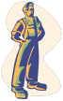
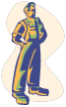
Figure 3 shows the makeup of the typical team. The following Disassembly and Assembly sections refer to the team members shown in the figure. For each show there is also a Crew Chief (See the follow section on Crew Chief Duties). Generally, the Crew Chief also works as a member of the team. We need at least six team members and a narrator to put on a show. The “engineman,” shown in the diagram is an optional seventh team member. If only six team members are available, then they share the work of the engineman.
Wheelman
Wheelman
Rightman
Leftman
Engineman
Announcer
Wheelman
Wheelman
TAC
Figure 3 Team Composition

Disassembly Process
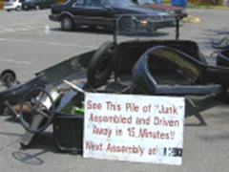
- The crew chief makes sure the car starts and runs before disassembly begins.
Figure 4 TAC Ready for Assembly
- Each team member should get a carpenter’s apron and keep any parts in the apron. Put the same parts back in the same places when we assemble the car.
- Four team members are assigned a corner of the car and stay pretty much with that corner for disassembly and reassembly. Among other assignments “wheelmen” handle the wheels and spring shackles. Dividing the work avoids getting in each other’s way.
Two additional team members work at the right and left front sides. The leftman handles steering column and the rightman handles exhaust pipe, fuel line etc. If available, the “engineman” helps with the radiator, front wheels, and guiding the engine in and out of the frame.
- Rough order of disassembly work.
- Roll the car away from the work area and drain the radiator. Move the car back into position.
- Remove the fenders. The left fender needs to be off of the car sooner and stays off the car longer because of time needed to disassemble/assemble the steering column.
- Drain the radiator, remove it, and get it out of the way. The radiator can be one of the last pieces put back on the car, although the team needs to allow time for adding water.
- Rear wheelmen remove the two large nuts that secure the pickup bed to the chassis. All wheelmen remove the pickup bed (it’s heavy).
- Leftman removes steering column. Left rear wheelman helps to rotate and guide the steering column out of the car. Make sure the key for the steering arm is secure in the steering column. Remove the timing and throttle rods. Rotate the timing rod up and hook it into the battery holder. During disassembly and reassembly be careful with the timing rod and don't force it! If it is bent, it alters the timing, and the car won’t run or it will run poorly. Altered timing could cause the car to kick during cranking and possibly cause serious injuries. The timing rod goes above the lower radiator hose.
- Rightman make sure fuel is off and disconnects the fuel line from the fuel filter.
- All, remove the two nuts that secure the body to the chassis and remove the body from the chassis. Get strongest men at each corner. It’s heavy. Watch out for the running board braces, parking brake, pedals, and rear wheels.
- Rightman install the engine-lifting, pipe fitting in number 4 cylinder. Unplug the electrical connection to the ignition.
- Right and leftman remove the universal joint bolts. (Place oil pan under universal joint to avoid leaking oil on pavement.) Position jacks for lifting the front end
- Rightman removes the exhaust pipe.
- Rear teams lift the rear end with the wheeled dolly, remove wheels, remove spring shackles, and haul rear end out of the way. Position jack stands at center of frame for lifting front end.
- Rear team raises the front end by pushing down on the rear of the frame. Make sure chassis pivots correctly on the jack stands.
- Front team removes the front axle and wheels.
- Lower the front end to the ground.
- Insert the lifting bar in the pipe fitting and remove the engine (need four strongest men—it is heavy). The engineman or an additional team member presses down on the crank and guides the engine as it is carried away from the chassis.
- Pile all the pieces up and display the signs.
- Disassembly complete!

Assembly Process
Listen to the announcer and try to keep synchronized with the narrative. This helps the audience understand the show. In a timed or fast assembly show, the team leads the announcer. In a historic or slow assembly show, the team follows the announcer. When assembly begins, the car frame rests on two jack stands, positioned near the frame’s center.
Perform steps one through twelve in sequence:
- One man lifts the rear of the frame to pivot the front end down and holds the front end on the ground for engine installation.
- Four men lift the engine using the metal lifting bar and install it in the frame. A fifth man guides the engine with the crank and presses down on the crank so engine seats in the front bearing.
- Two men push down on the rear of the frame and hold it on the ground to pivot the front end up for front axle installation.
- The front wheelmen install front axle shackles. Left and right sidemen install eye bolts for the radius rod ball cap. Make sure the drag link stays up to mate with the steering column. If it drops down during assembly, it may be necessary to remove the axle to achieve a proper connection.
- The front wheelmen install front wheels.
- Two rear men lower the front of car by allowing the rear to pivot up on the jack stands.
- One of the rear wheelmen rolls the rear end assembly into place.
- Left and right sidemen insert & fasten universal joint. Rear wheelmen, wait until the universal joint bolts are secure before attempting to mount the spring shackles and wheels. Otherwise the drive shaft may not properly seat.
- Rightman uses the dolly to raise rear axle.
- Rear wheelmen install rear spring shackles.
- Rightman lift the dolly handle all the way up until it hits the frame. Make sure the chassis does not roll away on the dolly.
- Rear wheelmen install rear wheels.
- Put jack stand under left rear axle to ease cranking when the car is started and lower the chassis.
In steps 13 through 18, sub steps (a, b, c, etc.) can be performed simultaneously:
13.a. Remove the dolly.
13.b. Install exhaust system, #4 spark plug, and wire.
14.a. Put body on frame and fasten.
14.b. Install steering column.
14.c. Hook up gas line.
14.d. Hook up wiring.
14.e. Put pickup bed on frame.
14.f. Install fenders & running board – right side first; left side after steering assembly is installed.
14.g. Put gas in gas tank.
14.h Turn on gas shut off.
15.a. Install radiator.
15.b. Hook up throttle & timing rods.
15.c. Put seat in place.
16.a. Put water in radiator
16.b. Put umbrella top on.
17.a. Retard spark.
17.b. Advance throttle.
17.c. Put clutch lever in neutral.
18.a. Turn ignition switch on.
18.b. Choke ¼ pull.
Perform steps 19 through 22 in sequence.
20. Crank engine.
21. Push car off jack stand and drive forward.
22. Back the car up to pick up the tools and signs.
23. Assembly Complete!

Rules of the Road
Rule number 1. If you take a part off, you note how it came off and put it back on the same way.
Rule number 2. The crew chief assigns and divides the duties.
Rule number 3. Each person can only do his assigned section and doesn’t try to help or rush a friend.
The five biggest time loss areas are:
1.The crank holder lifting up instead of pushing down when installing the engine.
2.Installing the drive shaft to the transmission (also dangerous for pinched fingers).
3.Installing the steering column.
4.Pouring water on the timer when filling the radiator.
5.Trying to start the engine without gas.

Tools and Their Purpose
- Two jack stands provide a pivot point for raising the frame during front axle installation. One stand keeps a rear wheel off the ground for easy cranking when starting the engine, and the other stand sometimes serves as a wheel chock.
- A homemade dolly transports the rear axle assembly and raises it for installation of the rear wheels.
- A special three-quarter inch wrench may be used to align the universal joint with the transmission during assembly. Some teams perform alignment by rocking a rear wheel back and forth.
- Large water pump pliers loosen the exhaust packing nut.
- A special pipe fitting and a five foot steel bar lift the engine. The fitting consists of half-inch pipe with a two inch Tee. The half-inch section screws into the number four sparkplug hole while the bar passes through the two inch Tee. Four team members (two on either side) raise and lower the engine.
- An adjustable wrench loosens and tightens the spark plug and pliers help with removing the sparkplug wire.
- Two nine-sixteenth open end and ratchet wrenches tighten the steering column lower nuts and universal joint, ball cap top bolts.
- A flat-blade screwdriver loosens and tightens the water hoses and also the eye bolts used on the front axle, radius-rod ball cup.
- Additional tools include a two gallon gas can, gallon water jugs, speedy dry to clean up any oil spills, and towels and hand cleaner for the crew to use after assembly.

Annual Spring Tune-Up
Each spring the club meets to assess and prepare the TAC and the trailer for the season. Repairs, installations, and/or upgrades are done as needed. Fresh gas is acquired and put in the can.

Assembly Car Registration and Insurance
The club owns the assembly car and its trailer. The car has no title and it is not registered. Thus, it cannot be driven significant distances on public roads. However, the car can be driven short distances between the trailer and the actual show site, generally a few hundred feet. The club carries liability insurance on the car in the event of an injury during a show.
The trailer is registered in Maryland, but the club carries no insurance on the trailer. The towing vehicle provides insurance for the trailer, so the tow vehicle owner should verify that insurance coverage includes towed trailers. Generally, the trailer should remain attached to the towing vehicle from pickup to drop-off at storage sites to ensure the insurance coverage for the trailer remains in force.
Shows are performed outdoors where the car can be operated safely. If other venues are considered for a show (e.g., inside a building), the TAC Chairperson must consider any additional safety risks and plan accordingly.

TAC Crew Chief Duties
Each Event
- Get a team together for each event
- Provide directions to each event and a time and place for team to meet
- Get an announcer
- Get a person to tow the Assembly Car to the event. Mileage is reimbursed by the Club to the person towing. The trailer uses a 2” ball. There is a club owned hitch that can be used. The wiring is the industry standard 2” round plug with 7 flat terminals.
Prior to Each Event:
- Insure all necessary tools are in the Assembly Car
- Insure there are good batteries in the PA system (replace batteries as needed)
- Insure that the starting battery is charged for each event
- Fill radiator before leaving home so that car can be started and warmed prior to disassembly.
- Insure that water jugs are filled for each event. At least 3 gallons per assembly
- Insure there is enough gasoline in the container for each event, one gallon per assembly
- Insure that a pitman arm key is at every event
- Insure that hand cleaner and paper towels are at each event
After Each Event:
- Collect fee from event coordinator or arrange for payment.
- Always try and get a dash plaque for each member of the team.
- Inspect car and trailer after each event to insure all pieces and parts are attached before leaving the event. Check that all tools are with the car prior to leaving the event.
- The person towing should insure that the trailer is properly attached to the tow vehicle and the TAC is secured to the trailer. While people mean well when assisting with attachment, they may not know how to properly attach trailer to tow vehicle or how to tie down the TAC. This is the responsibility of the person towing.
- Return TAC to storage facility and cover with tarp.
- Since the gas valve leaks, the gas tank should be drained after each event. There is a hose in the flat tool box on the trailer for this purpose.
- Make sure that any issues will be addressed before the next event.

Storage
Storage Between Shows:
The Take Apart Car is covered with a tarp and is stored in a safe location between shows. A lock is placed on the trailer ball and the wheels are blocked. Support items are stored in the truck bed.
Winter storage:
The Assembly Car is stored during the winter in a covered area. The PA system battery is stored in a heated location. The water and gas are removed from the TAC for storage.

Cliff Jenkins. How They Do It In The Nation’s Capital. Model T Times. September-October 1969
Jim Golden. “The Take-Apart Car.” Unpublished University of Maryland paper, circa 2005
Jim Golden. Email, June 3, 2011

