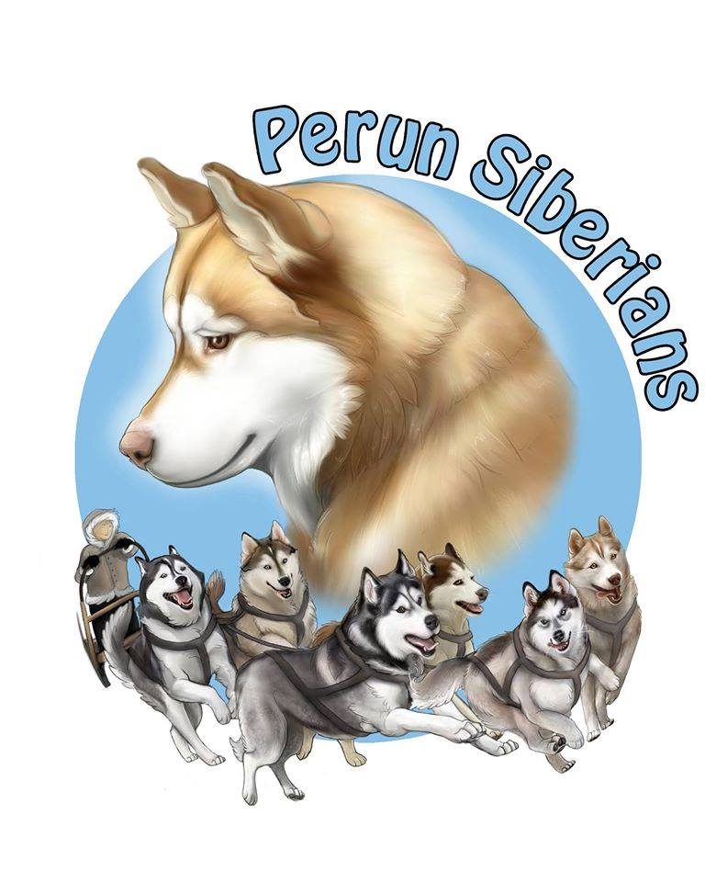
Perun Siberian Huskies
192 Conchie Rd. Tweed, ON K0K 3J0
perunsiberians@hotmail.com | (905) 242 - 8578
Perun Siberians Pet/Performance Puppy Contract

Registered name of dog:
Call name of dog:
Sex:
DOB:
Parents:
Litter:
Microchip #:
Breeder/Seller:
Buyer:
Buyer address:
Buyer contact information:

Purchase price: $1200
Payment must be made in Canadian Dollars by cash, cheque, interact e-transfer, or certified money order.

This contract is as follows:

1. Puppy has been microchipped, vaccinated once and dewormed at least 3 times by Perun Siberian Huskies prior to the puppy going home.

2. This is a pet/performance puppy and NOT a breeding candidate. As such, puppy must be spayed/neutered between the age of 18 and 24 months unless (1) a male puppy is found to be a cryptorchid by a licensed veterinarian, in which case, he shall be neutered at the discretion of a veterinarian, or (2), the buyer is not confident that they are able to maintain an intact pet without a breeding occuring, in which case a female shall be spayed 2 months after the conclusion of her first season, and a male shall be neutered after he has reached 9 months of age.
2a. In the event of any life-threatening illness related to either the uterus or ovaries of a female puppy, she shall be spayed as soon as possible. In the case of any exception, Perun Siberian Huskies provides no warranty to conditions caused by the spaying/neutering before growth plates are closed; including, but not limited to: hip dysplasia, cruciate ligament tears, endocrine system disorders and irregularities, and cancer. Under no circumstances shall puppy be bred at any age in their life. Puppy is also sold on a CKC non-breeding agreement.
3. Puppy has started on a raw food diet. It is strongly recommended to maintain such diet for the health of the puppy; or to feed a high quality, grain-free kibble.
4. Puppy shall be given adequate exercise, a clean living environment, plenty of mental stimulation, plenty of toys, fresh water at all times, access to veterinary care when needed, and lots of socialization out in public places. It is highly encouraged to socialize as much as possible. It is also recommended to attend training classes not only for training, but to build a bond and socialize.
5. If under any circumstance, puppy must be re-homed, Perun Siberian Huskies must be informed immediately. Perun Siberian Huskies shall have first rights to the ownership of said puppy. Perun Siberian Huskies is prepared to assist in finding a new home for puppy, or take back full ownership of puppy. UNDER NO CIRCUMSTANCE SHALL PUPPY BE SURRENDERED TO A SHELTER OR RESCUE ORGANIZATION, OR DESTROYED WITHOUT A WARRANT FROM ANIMAL CONTROL OR A VETERINARIAN DEEMING PUPPY UNSAFE.
6. Puppy is microchipped. Perun Siberian Huskies shall always remain a contact on the microchip. If puppy is picked up by animal control more than twice over the lifetime of the puppy, Perun Siberian Huskies shall regain possession of the puppy until such time as suitable containment is installed. At Perun Siberian Huskies’ discretion, puppy shall be released back to buyer after suitable containment is installed.
7. Buyer shall have puppy vet checked within 72 hours of sale in order for 2 year health guarantee to be effective. 2 year health guarantee shall be null and void if spay/neuter recommendations are not followed. Perun Siberian Huskies guarantees puppy to be free of genetic health disorders for the first 2 years of life. If puppy is to be diagnosed with a disorder deemed to be genetic by a veterinarian, proof of such shall be provided to Perun Siberian Huskies within 72 hours of diagnosis. Perun Siberian Huskies reserves the right to request a second opinion by another veterinarian, as well as Perun Siberian Huskies’ veterinarian, at Perun Siberian Huskies’ expense. Buyer shall be refunded ONE HALF (1/2) of the purchase price upon proof of spay/neuter being received if the above conditions are met. Buyer may keep puppy; or return puppy to Perun Siberian Huskies. If both parties agree, buyer may purchase a puppy with first pick of pet/perfomance quality from the next litter for the price of ONE HALF (1/2) the pet/performance price. Perun Siberian Huskies shall not be responsible for any veterinary bills incurred by the buyer.
8. A home visit may be conducted prior to purchase. This is to ensure a safe, and healthy environment for the puppy. Perun Siberian Huskies reserves the right to conduct a home visit at any time after the purchase of the puppy, without warning, as many times as Perun Siberian Huskies sees fit. Should Perun Siberian Huskies find anything upon a home visit that Perun Siberian Huskies does not find suitable for puppy, buyer shall be given 10 days to remedy the situation, or else puppy becomes the property of Perun Siberian Huskies, and shall be removed by Perun Siberian Huskies, and no refund given to the buyer.
9. Keeping in regular contact (twice per year at a minimum) with Perun Siberian Huskies is necessary. Picture or video updates are greatly appreciated. Any notification of accomplishments is highly encouraged!
The undersigned have read and understood the contract and agree to it’s terms and conditions
___________________________________________________________
Purchaser Date
___________________________________________________________
Purchaser Signature Date
___________________________________________________________
Purchaser Date
___________________________________________________________
Purchaser Signature Date
___________________________________________________________
Breeder/Seller Signature Date
___________________________________________________________
Witness Signature Date

