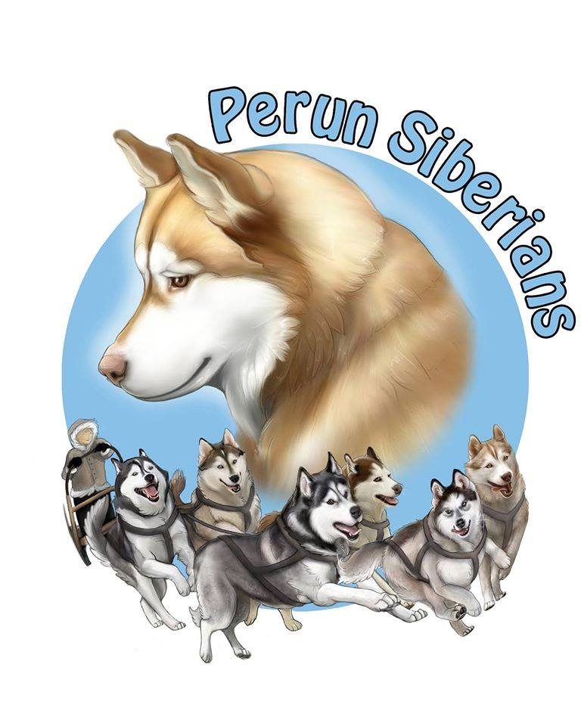
Perun Siberian Huskies
192 Conchie Rd. Tweed, ON K0K 3J0
perunsiberians@hotmail.com | (905) 242 - 8578
Perun Siberians Show Potential Puppy Contract

Registered name of dog:
Call name of dog:
Sex:
DOB:
Parents:
Litter:
Microchip #:
Breeder/Seller:
Buyer:
Buyer address:
Buyer contact information:

Purchase price: $1500
Payment must be made in Canadian Dollars by cash, cheque, interact e-transfer, or certified money order.

This contract is as follows:

1. Puppy has been fully vaccinated and dewormed by Perun Siberian Huskies prior to the puppy going home.

2. Puppy is a show POTENTIAL puppy and as such must receive hip certification by the appropriate Veterinary Association at the appropriate age and annual eye certification by a board certified opthalmologist; and prior to any breeding taking place.
2a. In the event the puppy is diagnosed with either hip dysplasia or a proven hereditary eye problem known to affect the Siberian Husky, the buyer will have the puppy spayed/neutered and the buyer will ensure that the puppy does not reproduce. The seller will provide a replacement puppy from the first litter with an available show potential puppy. The buyer may keep the puppy; or place the puppy in a pet home with assistance from Perun Siberian Huskies; or return the puppy to Perun Siberian Huskies.
2b. Show POTENTIAL only guarantees that the puppy is free from disqualifying faults according to the Canadian Kennel Club breed standard for the Siberian Husky. In the event of disqualifying fault, puppy shall be spayed/neutered as per 2a, and a replacement offered as per 2a.
3. Puppy has started on a raw food diet. It is strongly recommended to maintain such diet for the health of the puppy; or to feed a high quality, grain-free kibble.
4. Puppy shall be given adequate exercise, a clean living environment, plenty of mental stimulation, plenty of toys, fresh water at all times, access to veterinary care when needed, and lots of socialization out in public places. It is highly encouraged to socialize as much as possible. It is also recommended to attend training classes not only for training, but to build a bond and socialize.
5. If under any circumstance, puppy must be re-homed, Perun Siberian Huskies must be informed immediately. Perun Siberian Huskies shall have first rights to the ownership of said puppy. Perun Siberian Huskies is prepared to assist in finding a new home for puppy, or take back full ownership of puppy. UNDER NO CIRCUMSTANCE SHALL PUPPY BE SURRENDERED TO A SHELTER OR RESCUE ORGANIZATION, OR DESTROYED WITHOUT A WARRANT FROM ANIMAL CONTROL OR A VETERINARIAN DEEMING PUPPY UNSAFE.
6. Puppy is microchipped. Perun Siberian Huskies shall always remain a contact on the microchip. If puppy is picked up by animal control more than twice over the lifetime of the puppy, Perun Siberian Huskies shall regain possession of the puppy until such time as suitable containment is installed. At Perun Siberian Huskies’ discretion, puppy shall be released back to buyer after suitable containment is installed.
7. Buyer shall have puppy vet checked within 72 hours of sale in order for 2 year health guarantee to be effective. Perun Siberian Huskies guarantees puppy to be free of genetic health disorders for the first 2 years of life. If puppy is to be diagnosed with a disorder deemed to be genetic; limited to hips and eyes, by a veterinarian, proof of such shall be provided to Perun Siberian Huskies within 72 hours of diagnosis. Perun Siberian Huskies reserves the right to request a second opinion by another veterinarian, as well as Perun Siberian Huskies’ veterinarian, at Perun Siberian Huskies’ expense. Perun Siberian Huskies shall not be responsible for any veterinary bills incurred by the buyer.
8. A home visit may be conducted prior to purchase. This is to ensure a safe, and healthy environment for the puppy. Perun Siberian Huskies reserves the right to conduct a home visit at any time after the purchase of the puppy, without warning, as many times as Perun Siberian Huskies sees fit. Should Perun Siberian Huskies find anything upon a home visit that Perun Siberian Huskies does not find suitable for puppy, buyer shall be given 10 days to remedy the situation, or else puppy becomes the property of Perun Siberian Huskies, and shall be removed by Perun Siberian Huskies, and no refund given to the buyer.
9. Keeping in regular contact with Perun Siberian Huskies is necessary. Picture or video updates are greatly appreciated. Any notification of wins is highly encouraged!
10. Perun Siberian Huskies reserves the right to breed said puppy (female) or use for stud (male) as Perun Siberian Huskies sees fit; up to a maximum of 3 times (female). Perun Siberian Huskies shall choose the stud/dam. No breeding shall take place until hip and eye certifications are completed and passed with a GOOD or better and NORMAL/CLEAR, as per section 2. All expenses directly related to the breeding are the responsibility of Perun Siberian Huskies. Perun Siberian Huskies shall house the puppy (female) for the entire duration of whelping; plus 2 weeks prior to whelping at no charge. Buyers may visit regularly during the whelping process. Perun Siberian Huskies shall house the puppy (male) for the duration of the mating process at no charge. Buyers may visit during the mating process; or bring the puppy (male) for each mating.
11. If puppy is sold on co-ownership the buyer may owner-handler, hire an agent of their choosing; or Perun Siberians can show the puppy as the buyer’s agent free of charge. Entry fees are the responsibility of the buyer.
The undersigned have read and understood the contract and agree to it’s terms and conditions
___________________________________________________________
Purchaser Date
___________________________________________________________
Purchaser Signature Date
___________________________________________________________
Purchaser Date
___________________________________________________________
Purchaser Signature Date
___________________________________________________________
Breeder/Seller Signature Date
___________________________________________________________
Witness Signature Date

