Join us on Saturday, March 15, 2025, for our St. Patrick’s Weekend Water Pong Tournament. Free to enter, $150 first place prize! Must be 21 or over to play. Games start at 8pm. Limited to 12 teams. Double elimination.
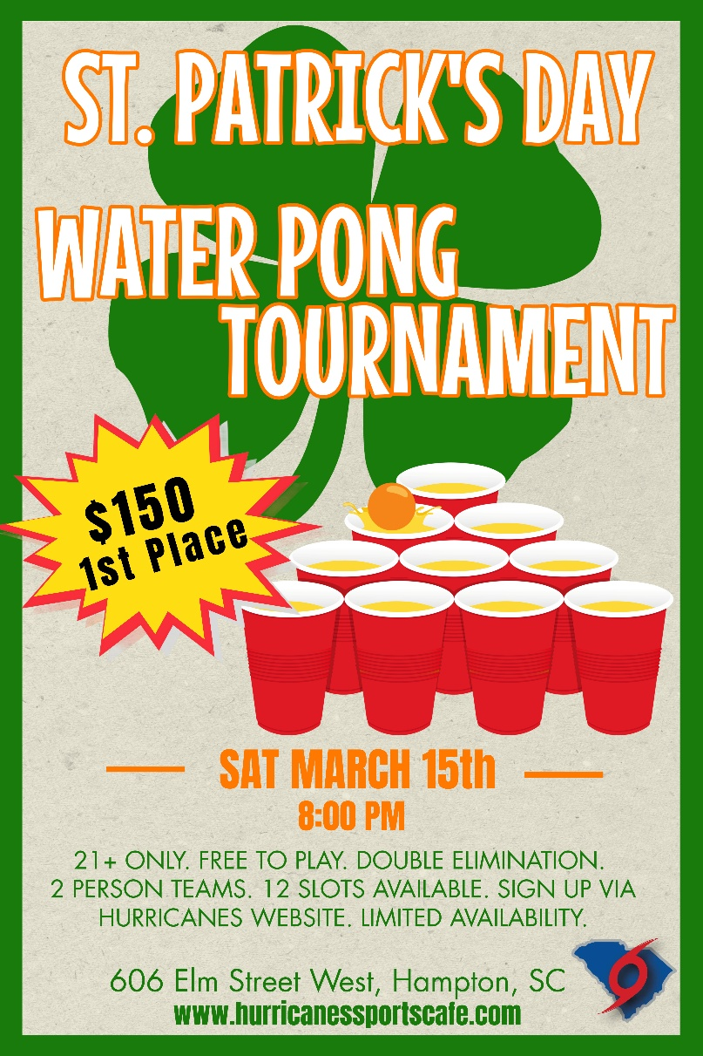
Tons of food and drink specials! Draft Beer, Green Beer, Shot Specials, Jello Shots

TEAM INFORMATION
First Player
Second Player
Team Name
Both Over 21?

email form to austin@hurricanessportscafe.com or drop off at the restaurant

