Become a Midwest Biosolids Association (MBA) sponsor TODAY! Have your company’s information listed and support MBA events. A variety of sponsorship levels and opportunities are available including a ‘la carte options.

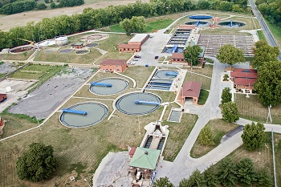

**Premier Sponsor**

|  |  |
| --- | --- |
| **Premier Sponsor -** Includes Brown Level Annual Conference Sponsorship, Individual Annual Conference Event Sponsorship (Your choice of Reception, Sessions, AM or PM Break, Breakfast, Lunch, or Keynote), Full Communication a ‘la carte sponsorship, **and** Recognition at Business Meeting. | $3,000 |

**Annual Conference Sponsorship Options**

|  |  |
| --- | --- |
| **BROWN LEVEL** – Includes Annual Conference amenities: Medium logo on program, 1/2 page listing in conference program, three free registrations and booth, your choice of remaining after Premier above (Reception, Sessions, AM or PM Break, Breakfast, Lunch, or Keynote) | $1,750 |
| **YELLOW LEVEL** – Includes Annual Conference amenities: Small logo on program, 1/4 page listing in conference program, and two free registrations | $1,250 |
| **BLUE LEVEL** - Includes Annual Conference amenities: Small logo on program and one free registration | $750 |

**A ‘La Carte Options**

|  |  |
| --- | --- |
| **MBA Website** – Your LOGO and hyperlink will be on the MBA Home Page | $300 |
| **Email** – Your LOGO will appear at the bottom of all MBA email templates | $300 |
| **Webinar** – Your LOGO will appear at the beginning of all webinars | $300 |
| **Full Communication –** Includes website, E-Mail, and Webinar sponsorship | $750 |

**Contact Information**

|  |  |
| --- | --- |
| Company |  |
| Billing Address |  |
| Contact Name |  |
| Phone |  |

**Payment**

|  |
| --- |
| Check Enclosed |
| Bill Me |
| Pay by Credit Card (Do not provide cc# on form) |
| Email address to send Credit Card Payment Link |

Please make check payable to MBA and email or mail with registration form to:

Midwest Biosolids Association

ATTN: Penny Williams

241 North 5th Street, Springfield, IL 62701

[staff@MWBiosolids.org](mailto:staff@MWBiosolids.org)