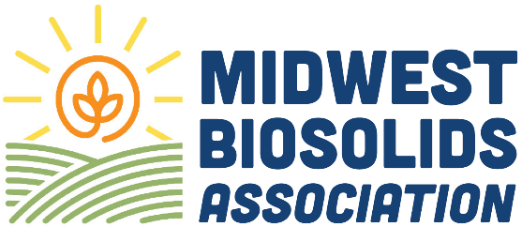
Become a Midwest Biosolids Association (MBA) sponsor TODAY! Have your company’s information listed and support MBA events. A variety of sponsorship levels and opportunities are available.
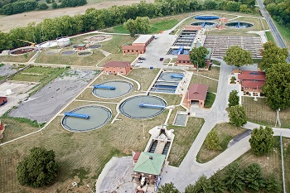
Premier Sponsor
Premier Sponsor – Largest logo placement on all materials (website, signage, badges), 15 minutes of fame speaking slot (during lunch), Premium exhibit booth (largest size, best location), Full-page ad in program guide, Branded conference item (lanyard, badges, notebooks, tote bags, etc.., (first-come, first- served), 4 complimentary registrations, First choice to sponsor a signature event (opening reception, awards gala, break) | $5,000
Annual Conference Sponsorship Options
BROWN LEVEL – Large logo placement on event signage and website, Premium exhibit booth (second largest tier), Half page program ad, Branded conference item (notebooks, tote bags, etc.., (first- come, first-served), 3 complimentary registrations, Logo included in event emails & social media, Option to sponsor a signature event (opening reception, awards gala, break) | $2,500
YELLOW LEVEL – Medium-sized logo, exhibit booth, Quarter-page program ad, Opportunity to include swag in conference bags, 2 complimentary registrations, Acknowledgement during general session | $1,750
BLUE LEVEL – Logo on website and program, Social media acknowledgement, 1 complimentary registration, Name listed on sponsor slide during general session. | $1,000

Contact Information
Company
Billing Address
Contact Name
Phone
Payment
Check Enclosed
Bill Me
Pay by Credit Card (Do not provide cc# on form)
Email address to send Credit Card Payment Link
Please make check payable to MBA and email or mail with registration form to:
Midwest Biosolids Association
ATTN: Robin Dobbins
241 North 5th Street, Springfield, IL 62701
staff@MWBiosolids.org

