“But thanks be to God, which giveth us the victory!”
Good morning! I’m excited about the service this morning! I hope you came prepared to praise the Lord and enjoy some great singing, fellowship, and edification!
If you are visiting this morning, please help yourself to some snacks and join us for our Thanksgiving Potluck after the service.
I want to say a great big thank you to everyone who helped set up the community building, brought food, or otherwise helped make the dinner a success. I also want to thank the music ministry members who practiced the songs at home and at church. You guys are awesome!
I’m not sure which way things will go with the pandemic and the governor’s position on social and family gatherings. He has hinted at greater oversight and more restrictions if the number of new cases continues to rise. This puts us in a tough spot, and I encourage you to continue praying about the situation. People usually have strong feelings about this one way or the other. Be careful about how you approach the subjects with friends and family – you certainly don’t want to damage these important relationships. Treat the person in a way that honors Jesus, even if you disagree with him/her.
Tammy and I want to say thank you for praying about our house selling/closing in November. We are excited to say that it all worked out – we have an official closing date of 11/30 and that gives us time to use the proceeds of the sale to use as a down payment for the new land and home we’re building. It was an exercise in trusting God and asking others to join us in praying for something we really wanted and not necessarily needed.
Psalms 37:4 Delight thyself also in the LORD; and he shall give thee the desires of thine heart.
We’re a long way from the end of the journey, but really getting excited now that things are moving. Please pray that everything continues to go as planned during the next several months! Thank you! - Pastor Joel

Sunday, November 15, 2020

Today’s Hymns
In My Heart There Rings a Melody #191
Heaven Came Down #215

Please join the wonderful ladies of VBC for a great time of fellowship! Let Tammy know if you can attend! I believe there is a sign-up sheet next to the snack table.

November 21st @VBC

There will be food, games, and a Christmas craft! The fun starts at 5:00 PM at the church.

Saturday,
December 5th

6:00 PM

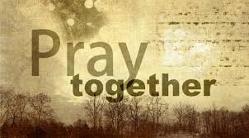
Sunday Evenings 5:00 PM
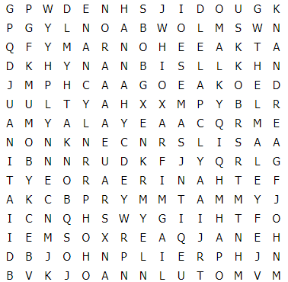

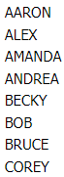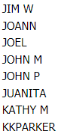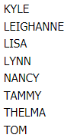

Sunday Morning Church Service Sunday Evening Prayer Meeting
TIME: 10:30 – 11:45 AM TIME: 5:00 – 6:00 PM
Wednesday Bible Study
TIME: 7:00 – 8:15 PM

Location
150 E. Columbus Street, Lithopolis, Ohio 43136

