“But thanks be to God, which giveth us the victory!”
Good morning! Thanks for joining us today! If you are visiting VBC this morning, or if it’s been a while since your last visit, please make sure we get a chance to briefly talk after the service. I’d love to connect or reconnect with you!
The ladies fellowship looked like it was a lot of fun. There were a lot of snacks and treats and they all looked so pretty in their dishes and arrangements! Not exactly what you’d see at a mens’ activity . A special thank you to Leigh Anne for leading the activity and arranging all the decorations and food.
I’d also like to express my gratitude to everyone who made last week’s potluck successful. It’s amazing how much work these things take and we are so blessed to have folks in our church who jump right in and set up, tear down, and clean up. You know who you are and I want to say thank you!
Don’t forget our Christmas Party is right around the corner! Make sure to pick up the gift(s) for the White Elephant game. If you forget or are low on funds or bring visitors, don’t worry – we’ll have extra gifts for you or your guest(s) to use. The Christmas Party is always a special time and a lot of fun.
You may also want to start asking your friends and family to join you for a special Christmas Eve Service. This year, Christmas falls on a Friday so we will move our Wednesday Service to Thursday. I look forward to this time every year. Please make plans to join us for the candlelight service.
- Pastor Joel
Sunday Evenings 5:00 PM

Sunday, November 22, 2020

Today’s Hymns
Crown Him with Many Crowns #160
Have Thine Own Way #306

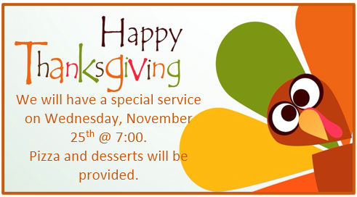

Saturday,
December 5th

5:00 PM

Please bring a $10 gift for each of those in your group for the White Elephant game!

Sunday Morning Church Service Sunday Evening Prayer Meeting
TIME: 10:30 – 11:45 AM TIME: 5:00 – 6:00 PM
Wednesday Bible Study
TIME: 7:00 – 8:15 PM

Location
150 E. Columbus Street, Lithopolis, Ohio 43136

