“But thanks be to God, which giveth us the victory!”
Good morning! Hasn’t the weather been amazing this week! It looks like it will continue for a few more days. I’m glad you’re here this morning to worship the Lord and fellowship with your church family.
If this is your first time or first time in a long time, please make yourself at home! The folks at VBC are very happy to have you with us today. I’ll try to spend a few moments before or after the service introducing myself and getting to know you a little or maybe catch up if you’re a returning visitor.
This week has been a roller coaster with the election results. So many questions about the way things went and how some things were even possible. Too many things that don’t add up. Regardless, nothing happens without the Lord allowing it or arranging it. I want to encourage you to remember that our hope is in Jesus and at the end of the day it doesn’t matter who lives in the White House on Pennsylvania Avenue. Don’t lose heart or hope. God is still in control.
Please be careful how you respond to the election – whether you are democrat, republican, or whatever political affiliation you claim, the most important affiliation is the one with Jesus. Make sure that you stay balanced and that you don’t let the situation or people bring out the old carnal man that we are to crucify daily. Don’t get dragged into fights, resist the temptation to argue, debate, or otherwise jeopardize your testimony.
Trust me, people will be watching to see how we (born-again believers) react to what’s going on around us. Our response should be to pray and ask the Lord to give us strength to resist temptation and overcome the challenges thrown our way.
Colossians 3:17 And whatsoever ye do in word or deed, do all in the name of the Lord Jesus, giving thanks to God and the Father by him.
- Pastor Joel

Sunday, November 8, 2020

Today’s Hymns
Only Trust Him #277
Amazing Grace #244

November 21st @VBC

Please join the wonderful ladies of VBC for a great time of fellowship! Let Tammy know if you can attend! I believe there is a sign-up sheet next to the snack table.

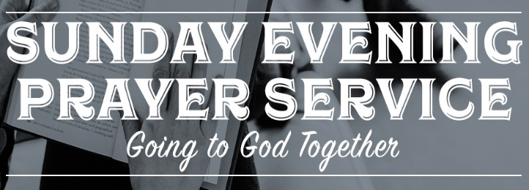
Sunday Evenings 5:00 PM

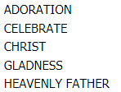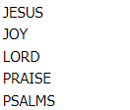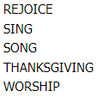

Sunday Morning Church Service Sunday Evening Prayer Meeting
TIME: 10:30 – 11:45 AM TIME: 5:00 – 6:00 PM
Wednesday Bible Study
TIME: 7:00 – 8:15 PM

Location
150 E. Columbus Street, Lithopolis, Ohio 43136

