December 15, 2024

Greetings Family,

We hope this letter friends you happy, healthy and blessed. We are pleased our Glover Family Reunion will be held in Pawley’s Island, South Carolina. We are busy planning and preparing for your visit on July 31- Aug. 3, 2025. We encourage our family, especially those who will travel from across the country and St. Lucia to come and enjoy the entire weekend.
We have booked the beautiful Litchfield Beach and Golf Resort again this year. This location affords us easy access to all the sights and sounds of Myrtle Beach, yet offers a secluded, “away from it all” feeling.
We have secured a group rate. Rates for our group are as follows:
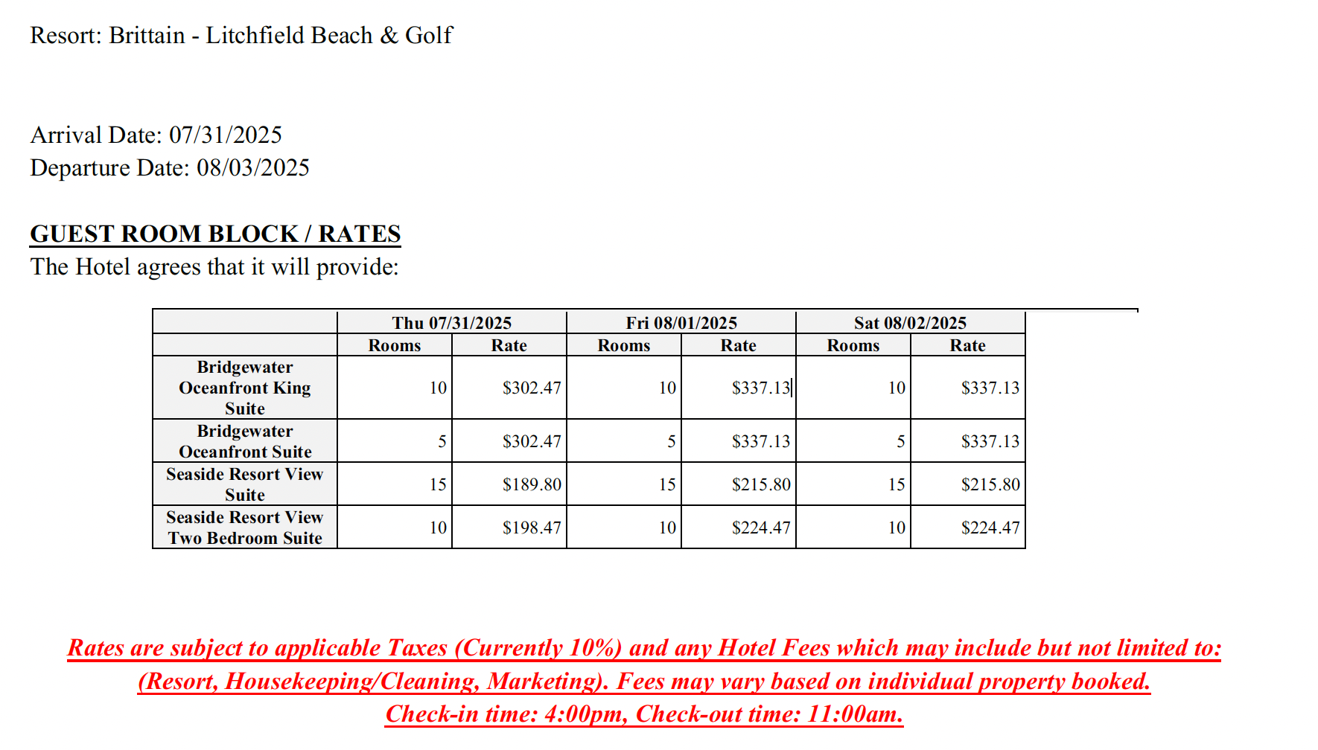
Free parking and complimentary airport shuttle services are available to guests. Please call the reservations department at 877-854-6358 and refer to the “Glover Family Reunion” to get the block rate/discount. July is prime time for beach vacations and the resort may book quicker than normal. Please make every attempt to make your reservations by April, 2015. The block will be held 90 days prior to arrival date. There is no guarantee on resort rates after this date. We recommend that you make your reservations early.
A first night deposit will be requested at time of reservation.
The Cancellation Policy is as follows: Reservations that are not cancelled prior to fourteen (14) days prior to arrival will forfeit their one-night deposit. Therefore, if you must cancel, please do so fifteen days prior to the arrival date.
We have been working hard planning and preparing a fun filled weekend for you with a number of events. We are looking for total participation from all our family. There will be a lot of activities that you can participate in from golfing, fishing, swimming, surfing or just digging your feet in the sand. So look forward to more information to come.
Please send wedding, stork, graduation, memorial and/or congratulatory news to: Mrs. Mae Glover, 579 Cut Off Road, Orangeburg, SC 29115. For those of you that are tech savvy, please feel free to text the same to Chelsea or Tiffany. If for any reason we have missed sending a family member this information, please let us know immediately so we may contact them as soon as possible.
We are excited that everyone will be returning to South Carolina where our heritage began and are looking forward to seeing everyone. Keep our family ties together, forever! Be There!!!
Family, we love each of you and look forward to celebrating life, legacy and laughter with in you in 2025. If you have any questions, feel free to reach out to us.

Warm Wishes,
Chelsea A. Glover
Chelsea A. Glover
2024-2025 Southern Glover Family Reunion President
(803) 378- 8456 / chelsea@jtbpa.com

Tiffany Felder Jones, Vice-President
(803)747-0581 / tiffanyjasmine23@yahoo.com

