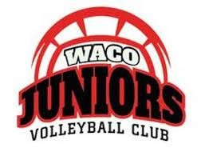

BRONZE LEVEL: Donation in any amount – Full amount goes to the player
SILVER LEVEL: $100 Sponsorship (includes company name/logo and website link on the Waco Juniors website for one year) - $75 goes to player and $25 goes to club
GOLD LEVEL: $300 Sponsorship (includes silver level plus company name/logo on a bronze/platinum sponsors banner - $200 goes to player and $100 goes to club
PLATINUM LEVEL: $600 Sponsorship (includes silver and gold levels plus one year of advertisement of your company name/logo on a sponsor group banner at Waco Juniors facility for one year serving practices, clinics, private lessons, tournaments, etc) - $400 goes to the player and $200 goes to club
DIAMOND LEVEL: $750 Sponsorship (includes silver, gold and platinum level plus your company name/logo on a 3’X5’ personal banner at Waco Juniors facility for one year serving practices, clinics, private lessons, tournaments, etc) - $550 goes to the player and $200 goes to club [$1000 for a 5’X10’ banner - $700 to player and $300 to club]

