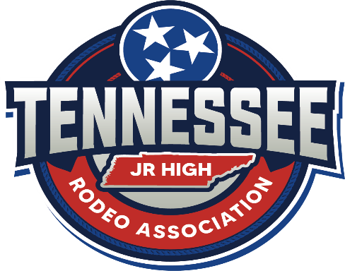

Tennessee Junior High School Rodeo Association Sponsorship Form
*Junior Sponsor*
______ This will be a sponsorship in support of our organization in any amount. We appreciate any and all donations in the support of our Tennessee Junior High School Rodeo Association! Your name/company name will be featured in the sponsor section of our website.
*Fundraiser Sponsor*
______ This sponsorship would include the donation of any items or services to be used for fundraising for our Junior High School Rodeo. Items will be used for silent auction, raffle, or awards. We can arrange pickup for any donations. Your name/company name will be featured in the sponsorship section of our website.
Please complete form and send to:
Tennessee Junior High Rodeo Association
4749 Old Sowell Mill Pike
Columbia, TN 38401
For questions please Contact: Ashley Paris at (618) 977-5674
Company Name: ____________________________
Address: _________________________________
Phone: __________________________________
Amount/Item Donated: _____________________

