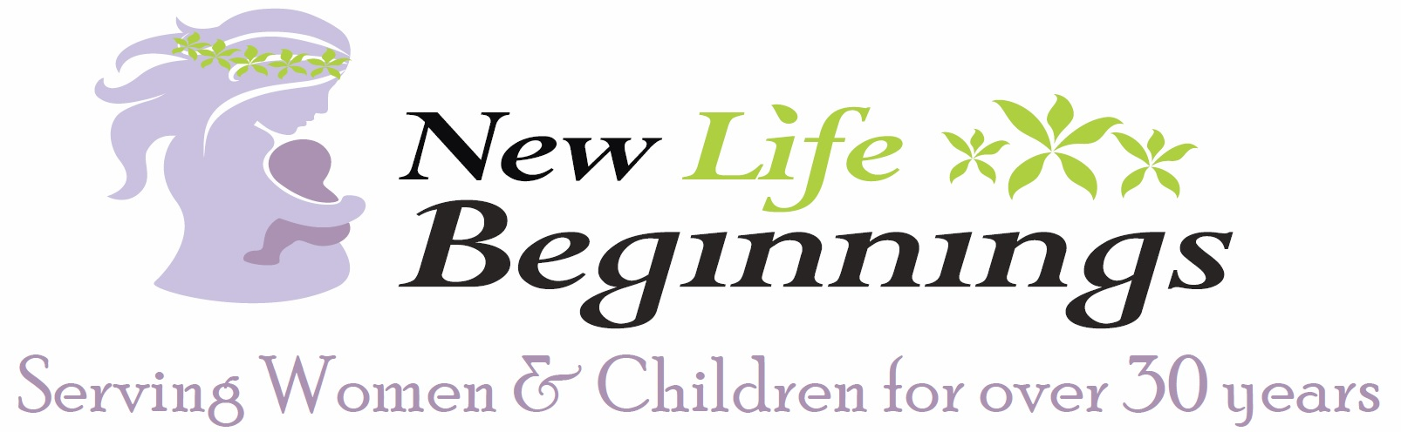

June 2018

Dear Community Member:

New Life Beginnings, Inc. was established in 1984 in Long Beach to serve a diverse population of women who come to us battered, abused, homeless, pregnant, and some with children by their side.

On Thursday, October 18, 2018, we will be raising funds at our annual banquet at 4122 Ann Arbor Road, Lakewood, CA 90712. This annual event is very important to us, and the funds raised allow us to continue to assist homeless, pregnant moms and their children year round. NLB runs completely on private donations and takes no aid from the government so every dollar given goes for the care, education and growth of the participants in the program.

Our Home is so blessed by our community and friends and we ask for your support, that you join us this year - with your much-valued donations that will move the hearts and raise the paddles during the auction.

How can you partner with us? Please complete and return the enclosed Donation Form, along with your donation, by September 17, 2018. Or, you can contact us at (562) 590-1538 or events@newlb.org and you can view our event information at www.newlb.org. Know too that your donation will receive acknowledgement the night of the event.

We are so appreciative of your support. In the past 34 years, we have been able to help thousands of families. We can’t thank you enough for your partnering with us now and ongoing, to continue to impact homeless women and children’s lives in our community.

Best Regards,

Rebecca Younger Ashley Rodriguez
Founder and President Banquet Event Chairperson, Director

