**THE AOC ASSOCIATE EXPERT NEWSLETTER DECEMBER 2023**



**THE COLLEGE COLLECTIVE IS RUNNER UP IN THE LEADERSHIP AWARDS 2023**

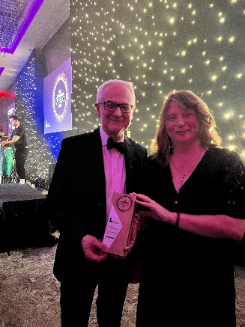

We are delighted to announce that The College Collective was announced as the Runner Up in The Leadership Awards 2023 for Most Innovative Institute Approved programme. The Awards are led by the Institute of Leadership.

This recognition is entirely due to you, our AoC Associate Experts and partner colleges- congratulations!

**THE COLLEGE COLLECTIVE APPROACH- UPDATE ON MATCHING**

Nearly all of our current 22 colleges have been on-boarded. We are still just waiting for a few more details from a couple of colleges already signed up.

Our AoC Associate Experts are being matched with partner colleges. Around 65 have been matched so far, but we are still seeking to fill some needs. We have Experts ready to help!

**WE HAVE EXPERTS TO SUPPORT YOU!**

Please get in touch with Kate Webb if your College would like support on **Student Personal Development** or **IT Infrastructure, ESOL, Safeguarding, Data Protection or Curriculum Quality Improvement.**

**MORE SUCCESS FOR OUR MEMBERS**

Some of our partner colleges have been celebrating success in the AoC Beacon Awards. In November, the following Partner Colleges found out they were Finalists:

Suffolk New College and New City College (Education for Sustainable Development)

Middlesbrough College (Excellence in Careers and Enterprise)

Coleg Cambria and Bridgwater & Taunton College (Support for Students)

New City College (Widening Participation)

East Kent Colleges Group (Excellence in Governance)

Good luck to all finalists, and also well done to other partner colleges who received Commended status including College of West Anglia and Barking & Dagenham College.

It was also fantastic news for three of our Partner Colleges who won Queens Anniversary Prizes for FE: Bridgwater & Taunton College, City College Plymouth, Hopwood Hall College and University Centre.

**AOC ASSOCIATE EXPERT NETWORKING UPDATE**

An important part of the project is the opportunities for networking. Over 40 Experts attended the AoC Conference this year as part of the benefits for Partner Colleges.

**The next virtual Network is: 12 Noon, 8TH December 2023**

Thanks also to the team including Alan Pease, Ben Robinson, Edd Brown, Gerry McDonald and Riikka Vihriälä who presented their powerful stories of impact at our BreakOut session at the Conference.

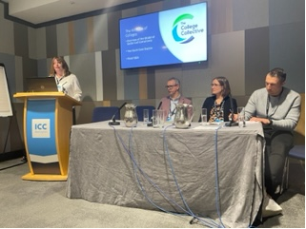

**YOUR EXPERT ‘TO-DO’ LIST**

1. Please access and complete your Institute of Leadership modules once you are enrolled. You will receive an email from membership@leadership.global with your log-in details. These are a significant benefit of this programme. On completion you will receive a certificate, post nominals and access to Professional Membership of The Institute of Leadership for 12 months.
2. Please make sure that you contact Kate, Simon or Graham if you have any problems contacting your partner college.
3. Once support has begun, please respond to Amie’s reminders and submit the records of your conversations and agreed aims and objectives. All templates can be found in the Handbook.

**THE COLLEGE COLLECTIVE TEAMS SITE**

The Teams site for the 2023/24 College Collective is now live and can be accessed via the link here. The site is designed to be a central hub for member Colleges and Experts where you will find all the College Collective key information and documents, as well as it being a place to share and collaborate. Please contact Amie if you have any feedback, queries or questions regarding the site, or if you would like a private channel created to progress work with your matched peer.