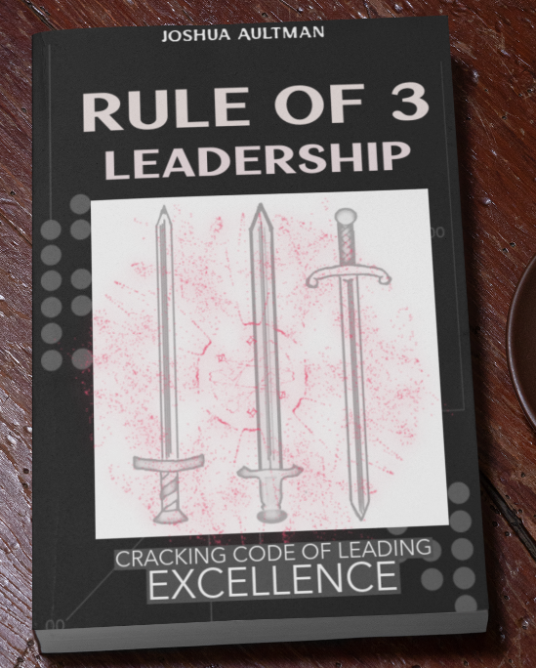
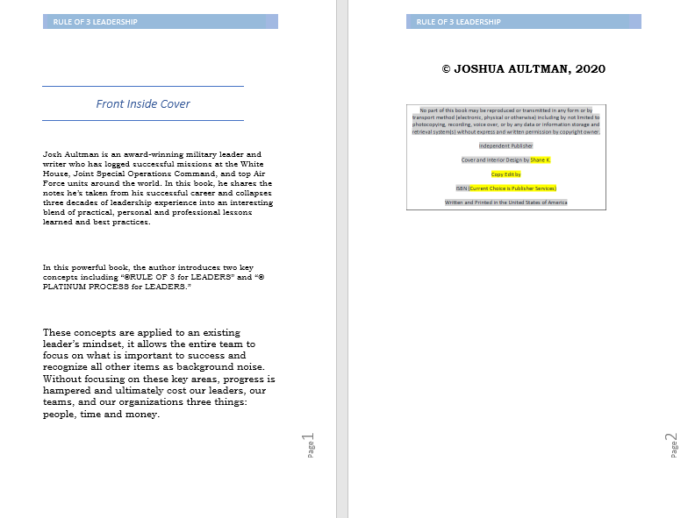

CHAPTER 1: RULE OF 3 APPLIED TO LEADERS
As a constant student of leadership, I value my time spent in various special operations units, the White House, and leading many other elite teams immensely. Over the course of two decades, I uncovered the fact that there are many definitions of “leadership” that exist out there. I also learned that few people know how to lead effectively – especially at multiple levels. As a technologist leader, I was in many transformative teams as part of the introduction of “cyber” into the military construct. This has generated a lot of ideas. And now, the adoption of the Space Force has provided a new venue for what leadership is.
I’ve found a secret that works every time. I will share it with you, but we should first establish a common ground of understanding.
As children, we crawl, walk, and run through phases of life that some call childhood, adolescence, and adulthood. Then, we track life in hours, minutes, and seconds as the days, months, and years bring us a guarantee of life, taxes, and eventually death.
In all the sentences you’ve just ready above, notice that three things are being tied together to complete a full thought-chain. If we pay attention, we realize that there are lots of examples of three things being tied together for a sound that is pleasant to the ears, easy to consume, and even easier to understand. This is common in life today, and is sometimes referred to in public speaking as “the Rule of 3”.
My background of leadership principles and leadership styles comes through application, practice, and what the military commonly refers to as “training and education”. I have served with, for, and in direct support of some of our nation’s top military and political leaders in locations spanning the entire globe. I also took notes of my experience, and thanks to that, I’ve noticed that almost all successful projects started with plans that were carried out in patterns of three.
When it comes to leadership, the magic number (3) also applies. Before we get into the specifics of the leadership side of this principle, however, let’s explore a few more reasons why we people respond to leaders who employ a Rule of 3 approach.

The Rule of 3 defined
As a general concept, the Rule of 3 states that our brains can actively engage and focus on three things at a time. Oftentimes, any focus on more than three topics will turn into noise and stress. To study this effect, you need look no further than things such as phone number sequences, impactful speeches, and advertisements. You will find that our minds are conditioned to absorb things in the sequence of three. When we do things without actively thinking about them, it is normally a function of our subconscious. And as a subconscious rule, many of us have patterned ourselves to limit communications like thoughts, correspondence, and tasks into cycles of three. This can almost be likened to a song, because it is like music to our ears (good music) most of the time.
A classic example of this rule comes in the form of phone numbers in the United States. After being asked for a person’s phone number, many people will respond with three series of numbers in this rhythm: #, #, # (PAUSE) #, #, # (PAUSE) #, #, # (PAUSE) #. I often overhear this at the grocery store, when a customer provides their phone number to the cashier.
This rule is often associated with speeches and advertisements. These practices habitually loop three things together in order to make things more desirable or believable, because our minds need three focus areas to obtain a full picture of a situation, status, and solution. Grouping things in series of threes is a tactic that is often taught to debate teams, politicians, advertisers, public affairs officers, and other professionals.
Common life examples of exercising the Rule of 3 are also found in everyday life. You hear things grouped and patterned into three things that get broadcasted to the public or targeted audiences in advertisements, politics, and even in entertainment. For our examples, we’re going to dive into childhood, sports, and some other common principles so that we can further elaborate on this powerful rule-set.

Childhood

We are conditioned from an early age to look for three options when we are faced with a problem. There are many children’s stories that include three subjects.
Growing up, I was told about the Three Little Pigs who worked to keep their houses from being blown down by a tyrant wolf. In the classic book that I watched as a movie The Wizard of Oz, the main character Dorothy had to click her heels together three times and say “there is no place like home”, following after her adventure involving “Lions, Tigers, and Bears…” - well, oh my.
This is a commonality shared among stories from all around the world and across the ages. How many wishes are generally granted in fables? The Boy Who Cried Wolf three times before finally being eaten by the wolf is a common story derived from Ancient Greece . In the Irish folklore story The Black Horse, the youngest of three brothers has to pass three tests before his magical horse turns into a person and grants him nobility. My personal favorite example of this phenomenon is what many refer to as the Goldie-locks Principle. How many bears? How many choices? How many decisions?

GOLDIE-LOCKS PRINCIPLE

The lesson in the story of Goldie-locks and the Three Bears can be distilled down to a common saying - “third time’s the charm”. The story seemingly loops a child into choices to be made, and each time, there are three options for her to choose from. Goldie-locks finds and tries three chairs, three bowls, and three beds. She doesn’t stop until she finds the one that is “just right”. When used as a principle, this offers a way to look at problems differently. When you look at the bears as being solution providers, you can then begin to look for solutions.

LESSON LEARNED: Look for multiple choices before making a decision.
In my Air Force career, whenever we found ourselves faced with big issues, we would take a similar approach, in which we looked at potential solutions and put thought into the top three Courses of Action (COAs). COAs (pronounced as one word: “kō-uh”) would provide what we proposed as a solution, who would lead it, and the resources involved in the execution of each option. In many cases, the solution would result from the leader stating that they liked parts of each COA. In those instances, we would often combine the good parts of each option in order to find a solution that seemed “just right”. We dubbed this a “hybrid COA solution”.
Always remember the lessons learned from childhood stories. One takeaway from Goldie-locks and COAs is the fact that you probably already have what you need to achieve your desired end-state. In other words, look for what you can do with what is in front of you… because one of these solutions is probably “just right”.
The first hybrid COA master I met was Reid Novotny. While I was working for him at what is now Joint Base Pearl Harbor-Hickam in Hawaii, he was the first one to ask resourcing questions that polished our top three options before they went to higher-level decisionmakers as COAs. Very rarely did one of Reid’s COAs ever become a hybrid, because he always drove his leaders to look deeply at what was currently available. The questions he asked pushed all of us to work together, find the best solution, and then present them to him for an initial draft, a pre-run, and final draft. He combined many of our options before they ultimately became solutions. This deep dive allowed his teams to solve for many problems without needing to bring it up to our bosses.
Final thought on COAs - everybody likes to follow a winner. Success will make way for more success. Find a “quick win” in your COA options to start the winning cycle. Even if the entire plan isn’t chosen, your teams will still be able to move out on these quick wins while the larger decision is being made. This starts the wins early and allows for adopting the actual decision.
BEST PRACTICE: When making a big decision, assess your resources and pull together at least three Courses of Action (COAs) for consideration. *(See the Applied Lessons section of this book to practice your COA building skills)

SPORTS

When I was a child in elementary school, we would hold a “sport day” twice a year. On these special days, we’d compete in activities for gold, silver, and bronze positions. Why? They were the only ones recognized, just like the Olympics.
During that same period, my friends and I were beginning to actually take team sports seriously. I remembered one rule very early --- three strikes, and you’re out. The number three was immediately placed into my mind as an important number to remember, because I did not want to strike out and fail the team.
Later on, in basketball, I was taught that the long shots are worth three points. Again, three is important, because it helps the team win. In the game of golf, the short holes are Par-3, and have the highest probability of a hole-in-one. Needless to say, the Rule of 3 promulgates sports. It starts at the personal level, goes to the team, and affects the end-state. Repeatedly, the number three came up, but I never thought about how it was conditioning my thoughts and cognition. A great example of how this works is in the case of American football.

FOOTBALL THREES

American football is very popular, and for good reason. According to a quick Google search, over 102 million viewers watched the Super Bowl in 2020. Football players put their blood, sweat, and tears into offense, defense, and special teams in efforts to win, lose, or tie a game. Here, each individual has to do their part for the team. And although games have been won on the backs of good offense, defense, and special teams - the chances of a win go up drastically if all three of these internal football team components are strong.
This all starts with the players first. But it’s not just about the players. The Pro Bowl, the all-star game that highlights the best individual players from each team, only got 8% the number of viewers as the Super Bowl. Again, Google search results show only 7.97 million viewers for the Pro Bowl. This number is low, compared to the game that hosts the best teams in the sport. The Pro Bowl game is certainly filled with great players from each of the teams, but the teamwork isn’t as spectacular to watch as it is in the Super Bowl.
In the game of football, players have to do their parts, with player actions being amplified via other offensive, defensive, and special team members as they execute plays. Lastly, coaches combine all of these efforts into an overall strategy. In the end, we get an outcome when the game-clock hits zero. Everything is linked.

MILITARY TEAMS COMPARED TO SPORTS
Although one of our military teams could successfully accomplish a lot on its own, military might will function better if functional teams work together for a common goal. Linking the tactical, operational, and strategic operations plans together provides all components with the knowledge of how they will contribute to the fight. History has shown that when we take a winning team from one battlefield to another, on a consistent battle rhythm, then the fight cannot be sustained at a consistent and winning level over long periods of time. In this respect, military and sports teams are a lot alike. But teamwork is still a key component to success.

LESSON LEARNED: “Teamwork makes the dream work”. Being a team member is continuous, keep up the communications for a successful outcome.
One of the best teambuilders I’ve ever had the pleasure of working with was Scott H. Scott, who is a branch chief and technology leader at a prestigious special operations unit. Whenever he would see people working together, making progress, he would smile and recite a common saying - “Teamwork makes the dream work”. The more I heard that phrase, as well as the pleasing laugher of the people who heard it, the better I felt about the sprint deadlines he’d set for them. Everyone knew that Scott was serious about being part of a winning team, and they all did their part when he engaged them. He was a teambuilder, and he proved it multiple times during the few years I had the pleasure to work with him. He worked tirelessly to ensure that the other 3 divisions of our organization were on the same page, and worked harder for those who worked with our organization to keep us all on the same team. His main method of communication was face-to-face, but he would send emails, chats, texts, and update near-real time dashboards in order to ensure that everyone knew what was going on at the “doer” level. During the COVID-19 period, he quickly asked the question – “what is going to be our team’s main communication platform?” We decided to emphasize a solution that was at around 80% ready, and it quickly pulled everyone together onto ONE platform in under 24 hours. Scott knew we couldn’t be a winning team without communication. When everyone understands where we are going, they all work hard to get us to mission accomplishment. I loved watching his teams integrate new technology while at the same time assisting others in pulling down the technologies we were replacing. It all came together like clockwork, and nothing could stop our success.

When branches of the United States Department of Defense (DoD) have linked together with their sister-services, a powerful combination of lethality or humanitarian support has been employed towards the nation’s missions. Combining the Army’s ground forces and intelligence with the Air Force’s ability to deliver immediate effects from overhead and sustainment is one quick example that keenly illustrates this point. The Coast Guard and Navy/Marines work together across the coast for huge wins that range all the way from lethality from the sea to civilian-sailor saving efforts. The combinations of what the DoD employs depend on the environment and the mission at hand, but the premise remains the same.
Additionally, when the DoD links together with other departments of the government, the government is stronger. Strong examples of partnership can be found across all of the three-letter organizations in the U.S. government. Sharing processes, techniques, and procedures provides an enormous advantage to our government.
Lastly, when our government links together with other nations’ governments, we continue to win at a greater scale. Past examples prove this; from the Peloponnesian War to the wars that continue even during the writing of this very book, you can see how history places emphasis nations abilities to team up toward a common enemy. If history is written by the victors (and it is), then it shows that if you build a great team – you have a greater chance of having plans that lead to wins.
Before we exit out of this thought, let’s circle back to teaming. The Air Force runs like many of the other components of the military, with regard to cycles. When first introduced, it was called an Air Expeditionary Force (AEF) “bucket”. Each member was assigned an AEF bucket in which they would work through training (prepping), mission (operational), and rest (personal) cycles. This cycle is known to all individuals, teams, and organizations, and allowed for planning at home, school, and work.
BEST PRACTICE: Make time for preparation, operations/execution, and personal breaks in your daily life – success is normally found through the prioritization and knowledge of personal limits.
You are the only one who leads in terms of what happens during your life. In order to become an effective team member, I’ve discovered that you need to spend time preparing, executing, and finding time for yourself. These are common practices of people who contribute, in a continuous manner, to the success of their team. The next section will dive deeper into some other common practices that highlight the Rule of 3.

COMMON PRACTICES

There are a lot of common practices out there that exist to explain the fact that good things happen in threes. Some of these practices are so common they are ubiquitous, and tend to go largely unnoticed to most people. Some great examples of this can be found in breakfast, lunch, and dinner, as they are related to the morning, afternoon, and evening. How about a “beginning, middle, and end” to a song, book, or movie? Below are some examples that I have seen implemented with little effort that ended up increasing productivity.

STOPLIGHT

At work, many people can generally be expected to do only what is expected of them, and nothing more. My assortation is that people will do more – they just have not been challenged to excel. There are multiple examples that we all have, in which delays are produced more than results are. In my experience, the real culprit to this phenomenon is commonly attributed to a failure in communication. Using an easy-to-understand graphic helps to spike questions and boost intrigue. This is where having a stoplight can be of use.
LESSON LEARNED: Use one commonly-available stoplight chart to expedite your status of a project, product, or service.
While assigned at Joint Base Charleston in South Carolina, our Commander had responsibilities similar to those of a city mayor, and he wanted more awareness of the things he was charged with leading. Colonel Rockie Wilson, the incoming Commander, asked for roadmaps in Civil Engineering, Contracting, Logistics, Security Forces, Manpower, Services, and Communications. “Where are we now and what are we doing to improve?”
Since this is a grandiose amount of data, he asked for it to be simplified; something that he could review with the top leadership, a status report that would be easy to consume with no more than a glance. He also saved time, because he only dove into what needed his attention. He directed us to place the items he wanted to track onto a stoplight chart. The end result was fast to update, provided all of us with more awareness, and afforded all of us time, because we were able to all absorb the information - in a quicker fashion.
So, how do we do this?
Green, amber, red – the colors of a stoplight. These simple colors, or even dots on a slideshow or monitor for display, can be arranged for quick consumption of readiness or schedules.
Green, the color of “go”, is used to signify that there are no issues. The green color requires less updates, and less frequently, than any other color. It still must be asked about, but the concern and responsibilities are assigned by those who maintain and operate the function.
Amber always needs an explanation. The color change may end up just being a numbers thing, or it could be an opportunity to assume some risk. Either way, more information is required, and it is needed more frequently.
Red is the color of attention. Red means “stop” at a light, and warrants a few questions. Red needs an explanation and a plan for how we are going to get better. Red items need updates whenever the situation changes. Always ask about red items; they are pointed out as being issues because they believe that the leader can assist with them – and they will tell you how if you ask.
This simple practice can be applied to any ongoing endeavor. I’ve even seen these turned into updates that blend the colors together. A green and yellow, for instance – or a yellow and red, to signify that something is getting better, but is still pending something that is outside of our control. This, too, can be confusing. Stick to the basics, and these updates will help raise awareness of real issues across multiple teams.

BEST PRACTICE: Review the status of your “Big Rocks” as much as possible (see more on Big Rocks in Chapter 3).
For added behavioral reactions, implementing them in a digital environment gets you more results. With all the technology available today, the average person has the ability to consume more information each day – and most days, they do. That makes it harder for leaders to capture people’s attention that is being demanded from other sources like social media, internet videos, and professional productions. The thing that ties all this together is a digital background. This has become more familiar to people as they age, and it’s all the kids today know. Why not use digital re-enforcement through a TV at work or social media for your simple stoplight product?

CONTINUOUS IMPROVEMENT

Learn, Practice, Master is a process cycle that can be seen in the making of many professionals. In the beginning, even if one has talent, a learning phase is applied in order to baseline knowledge and establish basic theories and rules. When I was studying martial arts, I greatly admired the black belts. Not because of their skills, but because they had the basics down. Proving they had the basics was what had gotten them the black belt. Just doing the basics is enough to win fights, in many cases. Once a person has a general knowledge base, they can begin practicing.
Practice, well, just makes you practiced. And even perfect practice may not make perfect. Practice can, however, equate to making you better. The goal of practice is to become better than a previous version of yourself. To improve my environment, I always began with practicing my questions.
The U.S. Air Force is charged to
fly, fight, and win…
in
air, space, and cyberspace…
with
Integrity, Service and Excellence.
How many flights were needed, and how many did we take? How many Airmen did we send forward to the fight? Do we need to send more, or less? How much effect did we have with our efforts in Air, Space, and Cyberspace? I was always amazed at how many things I found out, once I asked the right questions.
Mastery comes with opportunity, and happens over time. This process is applied in professional upgrades in the Air Force, and also correlates with rank structure for a majority of our military members. In the United States Army, Air Force, and Space Force, the tiers of rank for enlisted members are defined in what is known as the Junior Enlisted Corps, Non-Commissioned Officer Corps, and Senior Non-Commissioned Officer Corps. The Officers of the Army, Air Force, Marine Corps, and Space Force all have Company Grades, Field Grades, and Senior Leaders. The United States Navy has even more clear-cut tier structures and rules. And while each service may have different names for each tier, the basic understanding is that you will be taught how to do your job, you will do it, and you will then ensure that others know how to do the job you did.

LESSON LEARNED: You either track progress, or you lack progress.

Specific to the Air Force, there are a lot of Rules of 3 that are applied to an Airman’s culture. As an organization, the Air Force is charged to Fly, Fight, and Win… in Air, Space, and Cyberspace… with Integrity, Service, and Excellence. That is three sets of threes. It’s no wonder why the United States boasts the strongest Air Force in the world. All of these areas are monitored.
All of these missions are expected to be carried out with Integrity first, Service before Self, and Excellence. If any of the three fails at the individual level, then the service will force you out.
If all of these efforts were not tracked, then would the U.S. Air Force still have the ability to focus on anything, anywhere, anytime? Each of these commonalities points to the foundational idea of this book.

KEY POINT AND BEST PRACTICE:
As a leader, your three most important things are People, Time, and Money.

The RULE of 3 LEADERSHIP © principles are also further refined into a course that is offered on www.leaders-kit.com and is described as the M3-LEADERSHIP MODEL ©. Be sure to check out the course, but rest assured that this book also offers fantastic insight on this model in Chapter 5.
Binding all of these concepts together, we will uncover what is being described as the PLATINUM PROCESS for LEADERS. Executive summary, aka spoiler alert – it’s the order of the M3 leadership model, and follows the flow of this book. In order to get there, fundamental concepts must be in place, or else pieces of the big picture won’t be in place. That said, let’s begin with the most important focus area of leadership: people.

Gallo, C., 2012. Thomas Jefferson, Steve Jobs, and the rule of 3.
Forests, E. and Trees, F., 1853. Historical, Legendary, and Descriptive. pp. 189-90
Fleming, V., Garland, J., Morgan, F., Bolger, R. and Langley, N., 2005. The wizard of Oz. Turner Entertainment.
Tails and Travel memories.com. (2016). The three wishes, a tale from Sweden. Available at: http://talesandtravelmemories.com/wp-content/uploads/2016/04/Sweden.pdf -- tale of wood nymph (Accessed: 15 August 2020)
Homer. (2015) The Boy who cried wolf. Available at: https://www.youtube.com/watch?v=ntswPN4Ed4A (Accessed: 15 August 2020).
Ancient History Encyclopedia, Horgan 2014, Aesop’s fables
Yeats, W., 1993. Writings on Irish folklore, legend and myth. Penguin UK.
Southey, R., 1837. The story of the three bears. The doctor, 4.
Reid Novotny. (2020). Interview by Author. 14 August 2020.
Google search “Number of super bowl viewers 2020.” Source: Syracuse.com/Sports/2020/02/2020-super-bowl-ratings-102-million-viewer-up-from-last-year.html. Accessed February 2020.
Google search “Number of pro bowl viewers 2020.” Source: Christina Gough, Feb 10, 2020. https://www.statista.com/statisitics/229081/people-who-watched-the-nfl-pro-bowl-on-tv-within-the-last-12-months-usa/
Scott H. (2020). Interview by Author. 15 November 2020.
Rockie Wilson. (2020). Interview with Author. 16 March 2020.

