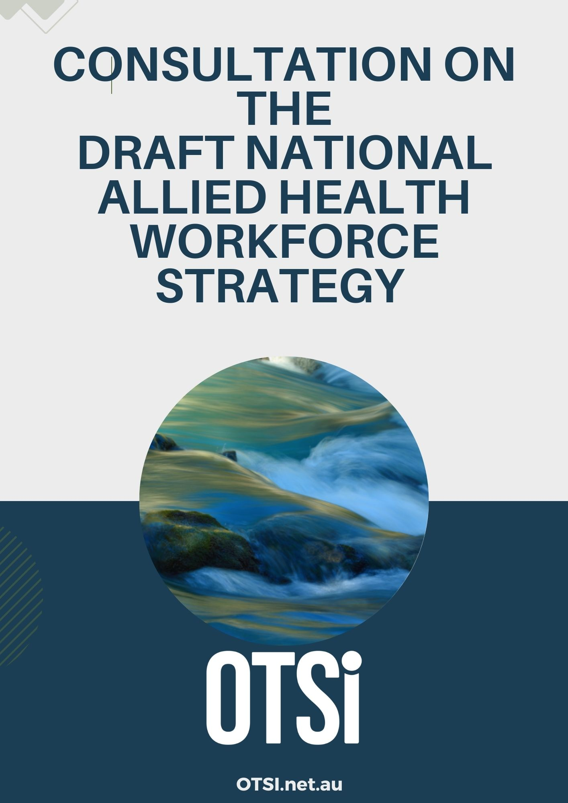
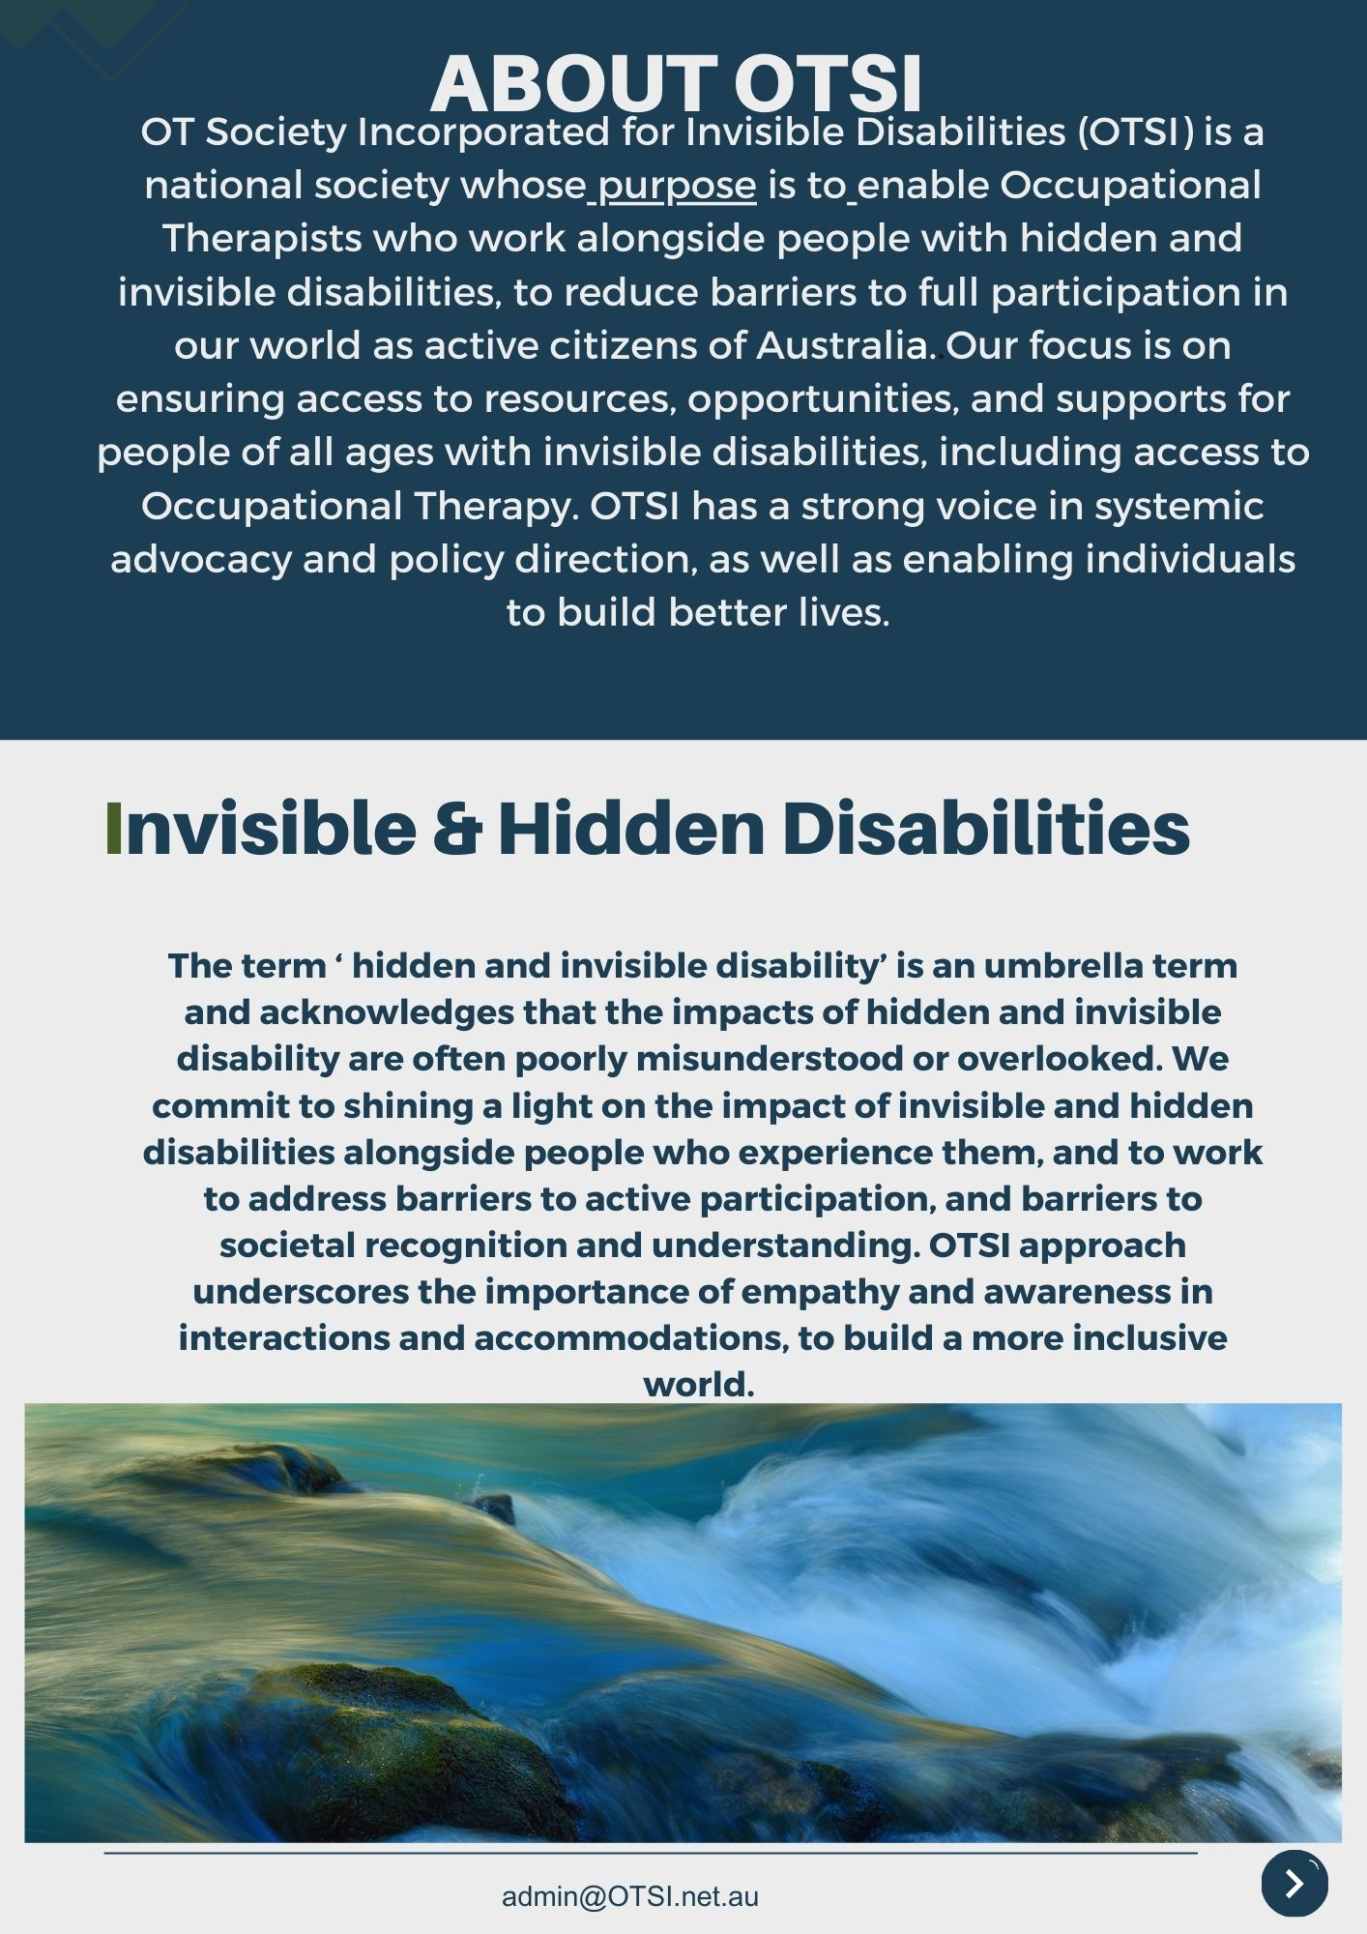
03/03/2025

INTRODUCTION

The Occupational Therapy Society for Invisible and Hidden Disabilities (OTSi) welcomes the opportunity to provide a submission to the National Allied Health Workforce Strategy.

RESPONSE TO CONSULTATION QUESTIONS:

PART ONE: INTRODUCTION
The Introduction outlines the need for a national strategy by highlighting both an increased demand for allied health services, as well as the known workforce shortages and maldistribution issues across Australia (page 6-10).
Is there anything missing in the Introduction that could assist in explaining the rationale for a National Allied Health Workforce Strategy?
Yes
Missing from the introduction is an acknowledgement of some important contextual factors critical to any workforce strategy. Over the past decade with the introduction of the NDIS, allied health professionals have increasingly been employed and enjoyed working in private practices of all sizes. This has been in order to meet the needs of NDIS participants while also working to their full scope of practice and their own work preferences.
This highly significant factor will have a very large impact on the Allied health workforce strategy. Many allied health professional groups (including OT, PT, Psychology, speech Pathology, Exercise Physiology, and other professional allied health groups) have established practices that work for them and their clients and they have not only largely been sustained but the number of allied health service providers has grown exponentially over this time and continues to grow. They are voting with their feet.
This market dynamic has also encouraged the re-entry of often highly experienced senior Allied health professionals into work, who were otherwise either not working or working in other fields, thus increasing supply of Allied health workforce. For example women juggling caring responsibilities and wishing to work part time with flexibility.
The impact of the covid-19 pandemic and extensive work from home orders in many States and the consequent mainstreaming of working from home, delivery of allied health services and team meetings etc via telehealth online platforms has further encouraged private AHP practices.
It is important context in the Introduction to acknowledge gender issues, health and wellbeing issues and changes in work preferences and requirements over the last decade. These factors will have a very large impact on any strategy to build a sustainable allied health workforce
Without the acknowledgement of a large segment of the allied health workforce working in the private practice space by choice - in increasing numbers and sustaining work in those practises - it is to ignore the value and benefits to AHPs of that model and therefore to not appreciate the factors impacting workforce supply

Further - with aging Population and growing chronic disease in Australia and therefore demand for Primary care allied health services growing, it must be acknowledged that maldistribution occurs when the employment value proposition for working in one sector is higher than in other areas. Therefore any strategy must acknowledge the benefits and costs to Allied health professionals of working in particular sectors and note what it looks like now. Where are the gaps and shortages and inequity around service availability right now. Where and how are AHPs working now? Why is this is the case ? Variables considered by AHPs would include obvious considerations like location, type of work, clinical area, remuneration, flexibility, support and professional development to name a few

The Introduction also provides a Vision outlining what the Strategy hopes to achieve over the next 10 years (page 9).
Do you agree with the Vision statement?
Agree
PART TWO: POLICY CONTEXTS
The allied health workforce operates in a complex policy context. The Draft Strategy highlights three policy contexts (page 11-13), reflecting the influence they have and the opportunities and challenges they present to the five Priorities discussed in the Strategy. Please ensure you read this section of the Draft Strategy before answering the questions below.
Are there other policy contexts that should be considered?
Yes
1. Women's budget statement 2024-2025, Minister for Finance, Minister for Women, Treasurer of Commonwealth

2. National strategy to achieve gender equality. March 2023. Department of the prime minister and Cabinet

3. National Women's health strategy Dept Health and Aged Care 2020-2032. p 14 " Reduce gender inequality: women carry a disproportionate burden of care and often do not prioritise their own health needs. Additionally gender pay gaps and less time spent in the workforce can lead to lower retirement incomes financial insecurity and increasing rates of homelessness for older women."

4. Working for Women: A strategy for Gender Equality March 2024.

Reforms to regulation
Agree

Future workforce capabilities
Disagree
The recognition of multidisciplinary and integrated team-based models of care is well established. However, it is also important to acknowledge that these models can, and are, being effectively implemented within a sole trader or small business, private practice framework. This can be enhanced and further developed with appropriate incentives and payments through Medicare, other government or private funding methods. Recognizing this approach expands opportunities for the allied health workforce, ensuring that access to multidisciplinary care is not limited to larger organizations within established teams.

Cross-sectoral policy alignment
Cross-sectoral policy alignment is a logical and broadly beneficial approach; however, it presents significant potential allied health workforce supply and sustainability risks as well as quality risks, if it leads to overall reductions in wages or employment conditions for some AHPs. It is recommended that policy alignment be pursued in a manner that maximises benefits and the employment value proposition for the allied health workforce. For instance, if a particular policy or sector establishes a higher level of remuneration or fee structures for a group of AHPs should be ‘aligned or harmonized’ accordingly to equalise benefits. Similarly, if another policy provides greater flexibility, alignment should prioritize maintaining or enhancing such conditions rather than diminish them. In essence, policy and sector alignment should aim to elevate standards and value to the AHP as an indicator of the value and recognition of the qualifications and experience of the AHP and attract and retain the workforce and improve distribution and equity – a key plank of this strategy. Allied Health professionals are often paid different awards too eg Health Professionals and Support Services Award 2020 (HPSS Award) or Social, Community, Home Care and Disability Services Industry Award 2020 (SCHADS Award):

PART THREE: PRIORITIES
The Draft Strategy includes five Priorities that call out the need to plan for, train, grow, distribute and retain a diverse workforce that meets future demand for allied health services (page 14-34). The underlying challenges that give rise to the Priorities have informed each priority’s objective and actions. Please ensure you read this section of the Draft Strategy before answering the questions below.
Do you agree with the Priorities and their associated actions?
Enhance the impact of allied health professionals
Agree
Improve national allied health workforce data and planning
Disagree
We acknowledge the importance of collecting workforce data on allied health professionals and support the initiative. However, we strongly recommend that data collection efforts be expanded to capture more detailed and comprehensive insights so that AHPs are not considered inappropriately as one uniform homogenous group, including:
- External and Anonymous Workforce Exit Surveys: These should be conducted to gather in-depth information on the reasons professionals leave their positions.
- Discipline-Specific Data: A more granular approach should be taken to analyse workforce trends for each allied health discipline.
- Lived Experience of Neurodiversity, Medical Conditions, and Disability: Data collection should include workforce accommodations and needs, such as fatigue levels, sensory requirements, and accessibility considerations. This should encompass both visible and invisible disabilities, including conditions such as Long COVID, Myalgic Encephalomyelitis/Chronic Fatigue Syndrome (ME/CFS), chronic pain, and other conditions that impact work capacity.
- Carer Responsibilities: Understanding workforce needs related to caregiving responsibilities is essential.
- Workforce Flexibility Needs: A clearer understanding of the flexibility required by allied health professionals should be captured.
- Workforce Settings: More detailed information should be collected, such as the number of occupational therapists (OTs) working in Medicare Locals and other specific settings.

Workforce Data and Utilization
The 2019 National Health Workforce Survey provided valuable insights into the distribution of occupational therapists across different work settings. However, this data has not been updated in a publicly accessible format. The 2019 findings included:
- 23.5% of OTs worked in group, solo, locum, or other private practice settings.
- 22.4% were employed in outpatient or other community healthcare services.
- 8.6% worked in hospitals (public or private).
- 8.5% were employed in disability services.
- 6.4% worked in residential aged care facilities.
- 4.7% were engaged in rehabilitation or physical development services.
- 15.9% worked in other settings, including domiciliary services, other residential healthcare facilities, and Aboriginal health services.
When adjusted for full-time equivalence (38 hours per week), 55.5% of clinicians worked in the private sector in their principal role in 2019
This percentage is likely grown to over 60% - a significant number of those in their own businesses.

Survey data from August 2024 Occupational therapy community of practice (11k members)
n = 630 OTs responded to the survey.
Survey results show the following :
1. employment arrangements
- 37% are solo private practitioners embedded in their local communities
- Additionally 24% are in practices of less than 5 clinicians
- Additionally 24% are in practices with between 5-25 employees
So approximately 85% of OT respondents from the Community of practice are working in small business private practice. The remaining approximately 15% work for larger organisations of 25 or more employees
2. Drivers for working in small business private practice
- 57% - work/life balance and flexibility
- 54% - I can use greater scope of OT practise compared to other work roles
- 23% - learning opportunities
- 23% - innovative practice opportunities
- 20% - I am a parent / carer and work can be shaped to balance those responsibilities
- 9% - remuneration

Current Data Gaps in Policy and Reform
Despite the availability of this workforce data, it does not appear to be effectively utilized in the ongoing aged care, NDIS, foundational supports, and mental health reforms. The 2019 data indicates that the majority of OTs work in private practice. However, current reforms assume that OTs will transition into other sectors without sufficient data to support this assumption.
Notably, many OTs have indicated that due to their need for workplace flexibility, they may transition to support worker roles rather than move into newly proposed service models, such as Medicare Mental Health Locals (MMHLs) and non-government services.
For instance, in the Medicare Mental Health Locals model, there is a critical need for data collection on:
- The number of OTs employed in these settings.
- The scope of OT roles within these services.
- Recruitment barriers (e.g., why positions remain unfilled).
- Retention factors (e.g., reasons for workforce attrition).
Currently, there is no publicly available data on the demand for OTs within Medicare Mental Health Locals. Furthermore, while recent funding grants have been allocated to support the recruitment of psychologists and psychiatrists for these services, OTs were notably excluded from these grants.

Workforce Planning and Data-Driven Policy Development
To ensure effective workforce planning, particularly in newly developed or expanded programs, it is crucial to proactively collect data on the roles and needs of allied health professionals. Specific areas requiring urgent research include:
- NDIS Allied Health Roles: Evaluating the effectiveness of allied health professionals in capacity-building interventions within the NDIS.
- Attracting Allied Health Professionals: Conducting national surveys to identify the factors that influence allied health professionals' employment decisions, rather than relying on assumptions.
- Income Comparisons: Assessing whether OTs in private practice earn significantly higher incomes compared to their counterparts in public health, to determine whether financial incentives are the primary driver for sector transitions.
- Workplace Preferences: A recent unpublished survey within the OT community indicated that workplace flexibility was the leading reason for professionals choosing private practice, whereas financial incentives ranked as the least influential factor. These findings contradict common assumptions and highlight the need for robust data collection.
- Exit Surveys at a National Level: While some local organizations conduct exit surveys, a national-level approach is necessary to capture broader workforce trends.
- Impact of NDIS Funding Reductions: There is likely to be a significant shift of allied health professionals away from NDIS roles due to funding constraints. Urgent workforce planning is needed to address this large-scale change, including an analysis of the workforce's future needs.
- Retention Challenges: Some OTs are considering leaving the profession entirely and transitioning into support worker roles. Understanding the drivers of this shift is crucial for workforce sustainability.
A comprehensive and data-driven approach to workforce planning is essential for the sustainability of allied health professions. Without detailed, updated, and publicly available workforce data, there is a risk that policy reforms may fail to address the actual needs of allied health professionals. We strongly recommend that national data collection efforts be expanded and utilised effectively to inform future policy and workforce strategies.
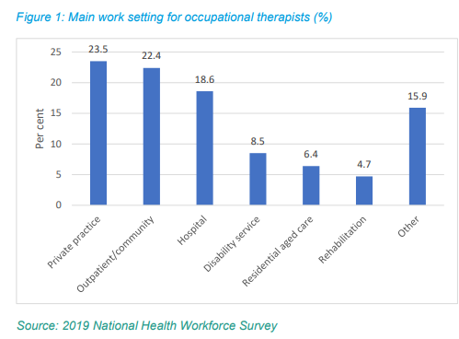
Build a sustainable allied health workforce
Neither Agree nor Disagree
Action 3.2
High ATARs are indicative of high achieving students with a desire to work in the AHPs.
Why should a strategy of lowering the price of degrees be employed instead of salaries being made more competitive (or income though private practices)? This would much better align with other government policy objectives around gender gap and women’s workforce participation.
Action 3.4 and 3.5 are the strongest actions for priority 3. From an occupational therapy perspective everything suggested so far in this submission describes what must be considered when developing a workforce strategy to attract, support, retain/reduce attrition of occupational therapists when considering the need for services to be supplied. It is a risk to focus too heavily on turning the tap on – Training more new allied health professionals - if you are not repairing holes in the bucket – Not providing the conditions for experienced senior allied health professionals to remain practising in a way that works for them. Private practice and the flexibility and scope of practice opportunities it brings is working for OTs and other AHPs.
We are supportive of the research noting that younger allied health professionals want flexible work conditions and opportunities to achieve work-life balance (Yeoh et al. 2024) however we recommend that this research is also applied and considered as valuable for all age groups given the context for this strategy and the current state of work of Occupational Therapists. Note previous statistics supplied within this submission to emphasise this point. Work-life balance is a core concept and value within the OT frame of reference which also results in OTs themselves, many of whom are women juggling other occupations, striving to achieve this in their personal lives and participate economically.
The definition and detail around flexible work conditions needs to be carefully considered as there are often assumptions that this is merely referring to work from home or flexible hours. There are further important considerations for flexible work conditions including:
- Flexibility in hours and when they are worked
- Medical or disability accommodations offered eg sensory needs, opportunity to rest in between work hours
- Planning for sick children
- Planning or families where the parenting needs regularly change eg looking after the children one week a fortnight. The workplace accommodation could then be increased hours on the week without the parenting responsibilities.
- Planning for options for changed hours or flexible work for people with fluctuating capacity such as chronic fatigue Eg creation of short term flexible work eg 10 hour job per week with flexible times to be spread out over many days for an experienced OT to provide supervision
Or flexible hours eg Saturday work to cater for a parent who is sharing childcare responsibilities.
Work that caters for disability health needs eg editing or auditing of OT reports could suit someone with disability
Grow, support and retain the Aboriginal and Torres Strait Islander allied health workforce
Agree
Grow, support and retain the rural and remote allied health workforce.
Disagree
The OT workforce is the beating-heart of service provision in local communities and is an invaluable resource in responding to local needs, in a flexible and nuanced manner. This workforce has largely been overlooked and excluded from national consultation on both disability and mental health policy, which has primarily engaged national peaks representing national providers and consumers. The workforce tends to not be unionised or collectively represented at a national level, further disadvantaging them in current policy reform. They are the people who roll up their sleeves every day and keep communities together and connected. They are the life-blood of care in every community in Australia. They have enormous local impact and footprint, but do not have a strong advocacy or union voice.
Local services provided by small businesses are largely staffed by a female workforce, a sizeable proportion of which also hold unpaid caring roles outside of paid disability-sector work. Their engagement in the workforce is made possible by the flexible nature of the NDIS. Workforce reports highlight that 20% of the NDIS workforce were not working prior to the NDIS. The NDIS enabled female carers to join the workforce and to innovate very local and place-based responses to local issues. This submission contends that this workforce will be severely disadvantaged, if not lost, due to current disability and mental health reform. With the loss of this workforce, the innovative mental health and disability services and responses they have built over the last 10 years of the NDIS will also be lost. Mental Health and disability sector reform are both signalling a preference for large, national providers offering homogenous service responses.
We ask that workforce planning for allied health undergo immediate planning in ensuring this enormous loss of workforce and skill does not occur. We propose that there is a project to map local networks of small and medium sized service providers who have to date provided NDIS responses, with a view to harnessing the skill, expertise and innovation of this cohort, enabling them to transition to new opportunities that will allow them to continue serving local communities. These organisations include allied health, peer and niche support providers, and dynamic combinations of workforce tailored to local needs. These provider groups must be prioritised in the commissioning of services and models to cater to local needs, and to meet community expectations for quality, and to adequately meet the needs of target groups.
To effectively grow, support, and retain OTs in rural and remote areas, it is essential to gather specific OT-related data. Some OTs express interest in short-term contracts in these regions, often motivated by travel opportunities. By strategically coordinating these positions, it would be possible to maximise this interest, facilitate structured handovers, and enhance support among locum OTs, ultimately improving service continuity and professional collaboration.
Do the five Priorities cover the key allied health workforce issues that can be addressed at a national level?
No
Do you consent to your submission being published?
Yes
Would you like your name or your organisation’s name to be published alongside your submission on the consultation hub?
Yes

