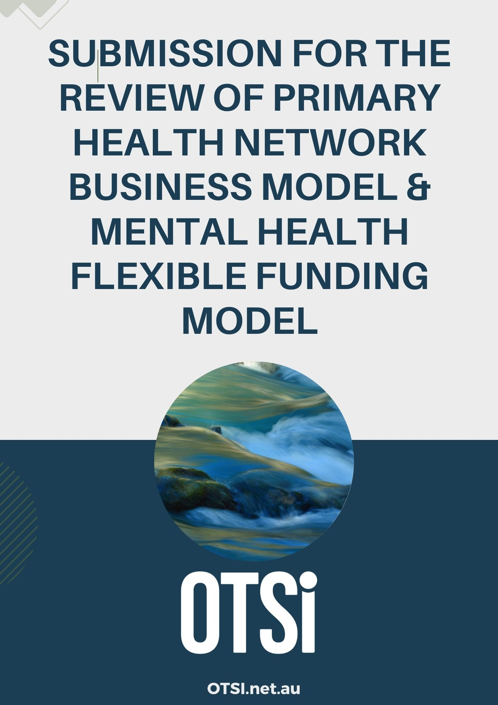

INTRODUCTION

The Occupational Therapy Society for Invisible and Hidden Disabilities (OTSi) welcomes the opportunity to provide a submission to the PHN consultation. PHNs are integral to community health and place-based responses to local health issues; and in supporting local workforces to respond to local health and well-being issues. OTSI strongly encourages governments to invest in PHNs for the future of the health of Australian communities.

ABOUT OTSi

OTSI is a national society whose purpose is to enable occupational therapists who work alongside people with invisible and hidden disabilities, to reduce barriers to full participation in our world as active citizens of Australia.
Our focus is ensuring access to resources, opportunities, and supports for people with invisible disabilities of all ages, including access to occupational therapy. OTSI has a strong voice in systemic advocacy and policy direction, as well as enabling individuals to build better lives.

ABOUT INVISIBLE AND HIDDEN DISABILITIES
The term ‘invisible disability’ is an umbrella term and includes disability arising from long-term severe and enduring mental health issues. The term acknowledges that the impacts of hidden disabilities are often poorly misunderstood or overlooked. OTSi is committed to shining a light on the impact of invisible and hidden disabilities alongside people who experience them, and to work to address barriers to active participation, and barriers to societal recognition and understanding. The OTSi approach underscores the importance of empathy and awareness in interactions and accommodations, to build a more inclusive world.

Place-based and local responses to the needs of people living with invisible disability are essential to ensure these groups can have their needs met in meaningful and targeted manner. Localised responses underpin connected, inclusive communities and ensure mainstream and primary care services recognise the nuance required to meet the needs of minority groups.

RESPONSE TO CONSULTATION QUESTIONS:

1. Are the roles of PHNs clear and understood by stakeholders, including your own
organisation? How will the relative importance of the different roles need to evolve to
meet broader changes in health policy and delivery?

The role of PHNs is often most clear to those groups who are directly engaged with them – health professionals and local organisations often have a strong engagement and connection to local PHNs. The role may not always be clear to the broader community, as the PHN role has an enabling focus for the workforce and service delivery, rather than directly providing services.
This submission intentionally focuses on a proposed role for PHNs, in light of the significant policy change ahead in both the mental health and disability space. We draw attention to the very significant segment of the national NDIS workforce that is comprised of both small businesses and sole-traders, and take the position that this workforce has evolved to meet highly localised and place-based needs, particularly for people experiencing psychosocial and invisible disability.
This workforce is the beating-heart of service provision in local communities and is an invaluable resource in responding to local needs, in a flexible and nuanced manner. This workforce has largely been overlooked and excluded from national consultation on both disability and mental health policy, which has primarily engaged national peaks representing national providers and consumers. The workforce tends to not be unionised or collectively represented at a national level, further disadvantaging them in current policy reform. They are the people who roll up their sleeves every day and keep communities together and connected. They are the life-blood of care in every community in Australia. They have enormous local impact and footprint, but do not have a strong advocacy or union voice.
Local services provided by small businesses are largely staffed by a female workforce, a sizeable proportion of which also hold unpaid caring roles outside of paid disability-sector work. Their engagement in the workforce is made possible by the flexible nature of the NDIS. Workforce reports highlight that 20% of the NDIS workforce were not working prior to the NDIS. The NDIS enabled female carers to join the workforce and to innovate very local and place-based responses to local issues. This submission contends that this workforce will be severely disadvantaged, if not lost, due to current disability and mental health reform. With the loss of this workforce, the innovative mental health and disability services and responses they have built over the last 10 years of the NDIS will also be lost. Mental Health and disability sector reform are both signalling a preference for large, national providers offering homogenous service responses.
We ask PHNs to consider establishing a pivotal role in ensuring this enormous loss of workforce and skill does not occur. We propose that PHNs embark on a project to map local networks of small and medium sized service providers who have to date provided NDIS responses, with a view to harnessing the skill, expertise and innovation of this cohort, enabling them to transition to new opportunities that will allow them to continue serving local communities. These organisations include allied health, niche support providers, and dynamic combinations of workforce tailored to local needs. These provider groups must be prioritised by PHNs in the commissioning of local mental health services and other service-responses to cater to local needs, and to meet community expectations for quality, and to adequately meet the needs of target groups.
2. Is the governance of PHNs and the broader PHN Program appropriate, efficient and
effective?
PHN governance must remain independent of service-providers. This is critical to the role of PHNs in objectively monitoring and responding to local-level need. Clinical Council and Community Advisory Committee must remain reflective of the communities they service and include whole-of-community representation – including lived experience, primary and acute care sectors, GPs, allied health providers, Local and Hospital Networks (LHNs).

5. What is the role of PHNs in commissioning services through the mental health flexible
funding stream within the mental health and suicide prevention system, and how effective
has it been? How could that role evolve to be more efficient and effective?
There has never been a more important time for the development of more effective primary mental health care services for people living with severe mental illness, and for people living with other forms of invisible disability, including neurodiversity. The Analysis of unmet need for psychosocial supports outside of the National Disability Insurance Scheme published in August 2024, identifies over 230,000 people requiring psychosocial support outside the NDIS.
OTSi calls for the recognition of the profound impact severe mental illness, psychosocial disability, and other invisible conditions have on daily lives. The profound impact persists between acute episodes and is currently not adequately addressed by systems outside the NDIS.
PHN MHFSS should play a key role in responding to these impacts and unmet needs through commissioned services, including allied health services, at local levels. Potential risks due to the development of the stepped-care ecosystem and introduction of the NDIS early intervention pathway, are significant and must be explored to avoid creating further barriers to accessing support. These risks include the potential complexity and gate-keeping a multi-tiered system with multiple funding streams across Federal and State funding systems, will bring. An integrated system recognising the whole-of-workforce will be needed to ensure the broader ecosystem can realise the vision of a safer step-up, step-down approach. This will be required if people are shifting between support levels, including foundational supports, targeted foundational supports, early intervention, and the NDIS.
PHN MHFSS could play a key role in ensuring local needs are addressed effectively though local responses that harness the available workforce across public, NGO and provide providers. This could be achieved be significantly expanding and adapting the current Commonwealth psychosocial support program through integrating models described in Section 5.2 below.

5.2. What further changes in mental health and suicide prevention system do you predict,
and how could the role of the MHFFS adapt to support these changes effectively?
NDIS reform is likely to mean the threshold for NDIS access will be higher, meaning fewer people with severe mental illness resulting in psychosocial disability, will become participants. Should non-individualised NDIS early intervention be made a wholesale part of the NDIS response to psychosocial disability, we propose that there is a strong case for ‘psychosocial early intervention in Scheme (PEIS) to be commissioned via PHNs, in a manner that is in tune with local needs and available local providers, recognising the value of both public, NGO and private providers, of all sizes. This would meet the NDIS review recommendations for PEIS; and allow for the establishment of local provider panels with the capacity and resources to meet the needs of people living with severe mental illness and associated psychosocial disability. This would enable NDIS participants on PEIS to maintain a level of choice and control of providers. Further, targeted foundational supports in the community should be commissioned locally through PHN MHFSS enabling local and tailored responses to community needs.
There are very significant and under-recognised complexities experienced by those who live with substantial psychosocial disability, that contribute to reduced lifespan of 20 years compared to the average Australian . For example, alongside mental health impacts, current research highlights the high rates of persistent disability experienced by the cohort identifying with an impairment of schizophrenia, which includes two-thirds with a cognitive impairment; 24% experience hearing impairment; 26-70% of people experiencing vision, or visual processing, difficulties with functional impact, impacting literacy and social engagement; motor skills and gait difficulties; and a 2.5 fold increase in lifetime risk of developing early-onset dementia. An individual experiencing one or a combination of these issues, who has not met NDIS access criteria, will require access to a skilled allied health workforce commissioned through PHN MHFFS.
Allied health professionals can provide expertise and skilled, regulated services to people living with severe mental illness living in the community. There are approximately 3000 occupational therapists nationwide with expertise in mental health currently servicing the NDIS psychosocial disability cohort of over 60,000. These therapists are employed primarily in small and medium sized business in local communities and have built extensive innovative service-responses tailored to local needs. It is essential this workforce is considered as the PEIS is developed and targeted foundational supports are rolled out. OTSi recommend that PEIS and targeted foundational supports are commissioned through PHNs, to enable inclusion of this workforce in the service-provision models of the future.
In the Australian context, the current continuum of mental health care, from mental health promotion to primary care, early intervention through to intensive and acute services, is under reform. ‘Stepped care’ is the model of choice for the future of mental health system design. Stepped care is defined as an evidence-based, staged system comprising a hierarchy of interventions, from the least to the most intensive, matched to the individual’s needs. While there are multiple levels within a stepped care approach, they do not operate in silos or as one directional steps, but rather offer a spectrum of service interventions (Australian Government Response to Contributing Lives, Thriving Communities - Review of Mental Health Programmes and Services, 2014). The concept of stepped care is central to mental health care reform in Australia. PHN MHFSS can and should play an integral role in the provision of stepped care. PHN MHFFS could play a leading role in the commissioning of PEIS and targeted foundational support for people with severe mental illness and psychosocial disability, outside the NDIS. Mental health occupational therapists understand the interface between tiers, bring skill and expertise, and can contribute substantially to a stepped care approach to build and improve mental health care nationally.
Occupational therapists with mental health expertise can provide tailored interventions to individuals experiencing mental health difficulties across the lifespan, with outcomes focused on occupational, social and economic participation. Mental health occupational therapists offer a substantial and unique contribution to the support, enablement and care of people experiencing mental health difficulties, across the spectrum of services that comprise the Australian mental health system. OTSi propose a Focused Functional Intervention (FFI) model delivered by occupational therapists, be included in services commissioned through PHN MHFFS, for delivering a NEIS, targeted foundational supports, or other FFS (See appendix 1 for detailed description of Focused Functional Intervention).
Further, we highlight that the Allied Health Assistant role is an underutilised and cost-effective resource, that could be developed to ensure the implementation of evidence-based interventions while maximising the reach of the allied health workforce and expanding quality services through delegation frameworks overseen by experienced therapists. The role of an Allied Health Assistant (AHA) is a growing, but at present significantly underutilised, skilled resource. We believe that the increased use of allied health assistants presents a significant opportunity for the PHN MHFFS that can be developed to ensure the implementation of evidence-based interventions while maximising the reach of the allied health workforce. The Allied Health Assistant workforce represent an opportunity due to their sharp focus on capacity building and the in-built clinical governance and delegation framework provided by the supervising Allied health professional. Important to note here the extensive benefits to individualised capacity building, risk reduction and access to workforce supply – in a cost-effective manner. It makes sense that AHAs should be used extensively alongside skilled occupational therapists to service people living with severe mental illness and psychosocial disability, through PHN MHFFS.

5.6. What changes to the funding allocation under the MHFFS could better support PHNs
in addressing evolving needs and achieving program objectives effectively?
OTSi recommend that PEIS and targeted foundational supports are commissioned through PHN MHFFS, to enable inclusion of a broad workforce, including current NDIS allied health and other providers, in the service-provision models of the future. PEIS and targeted foundational support funding for severe mental illness and psychosocial disability, could be channelled directly to communities in a responsive and tailored manner if delivered through PHNs. This would mean innovative and diverse service responses overseen by an independent PHN monitoring local needs, trends, and gaps.

APPENDIX 1

Occupational Therapist delivered Focused Functional Interventions (FFI)

SUMMARY

THE ISSUE:

Significant proportions of people with severe mental illness and psychosocial disability cannot currently access evidence-based interventions to enhance functional capacity, delivered by occupational therapists. There is significant identified need to enable these cohorts to live full lives and to participate in our communities, through building functional skills, and addressing disability-related participation barriers.

This issue is compounded by:
- A high threshold to access NDIS, and increased rates of revocation of NDIS access
- The absence of function-focused foundational supports in the community
- The limited nature of existing primary care and Medicare items to address functional capacity for these cohorts, and the cost-prohibitive nature of Medicare co-payment systems.

THE IMPACTS:
- Reduced social and economic participation
- Barriers to community access, engagement and to living an independent life
- Increased risk of requiring more intensive mental health and disability supports, sooner

THE RECOMMENDATION

Provide access to evidence-based interventions focused on building and enhancing functional capacity, for the identified cohorts. This could be achieved by:
- Build a program of occupational therapy panelled providers to deliver FFI through PHN MHFFS.
- OR Create a foundational support package focused on occupational therapy delivered Focused Functional Interventions; or an enhanced program through an Early Intervention pathways
- OR Create an escalate pathway to access a foundational support package focused on occupational therapy delivered Focused Functional Interventions through mainstream systems and services.
- OR The introduction of a new Medicare item centralising Focused Functional Interventions

FOCUSED FUNCTIONAL INTERVENTIONS:

A significant and growing evidence base exists for the following interventions, which can be adapted in an age and disability appropriate manner.
- Executive functioning and cognitive strategies/approaches
- Lifestyle re-design/time-use/occupational balance
- Social functioning and social prescribing
- Routine development and life-skill development
- Vocational – work and study engagement
- Creativity-based strategies
- Sensory based strategies

THE OCCUPATIONAL THERAPY WORKFORCE

Occupational therapy is a person-centred, outcomes-based and participation-focused, profession with current national reach, including to people with severe mental illness and psychosocial disability. Occupational Therapists are degree qualified (Bachelor and/or Masters and Doctorates) and regulated by the AHPRA.

TARGET GROUPS:

These interventions are required across the lifespan, including for people with severe mental illness and psychosocial disability, and other forms of disability including neurodivergence.

POLICY DRIVERS:
- There is an URGENT need to build foundational supports in the community for, the groups identified above.
- NDIS reform highlights an intention to focus on people with the most severe disabilities and an unintended consequence may be a higher threshold for NDIS access, meaning that cohorts who experience functional impact of a range of disabilities cannot access the NDIS. Currently there are unprecedented rates on NDIS eligibility reassessment meaning significant numbers of people are losing access to 28 days-notice.
- The Australian government is yet to respond to the Senate ADHD Inquiry, which was completed over 1 year ago.
- The recently published Unmet needs analysis identifies extensive unmet psychosocial need within Australian communities.
- Existing Medicare items such as Better Access to Mental Health, target mental -health specific interventions or ‘focused psychological strategies’, and do not focus on building functional capacity.

